CREDITS
Imaxe | Autor | Título | Ligazón | Licenza
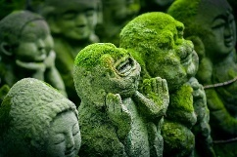 | Jordy Meow | kyoto | https://pixabay.com/es/photos/kyoto-japón-estatua-jizo-japonéss-1976538/ | CC0
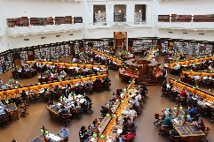 | Andrew Tan | La Trobe Library | https://pixabay.com/es/photos/biblioteca-la-trobe-estudiar-1400312/ | CC0
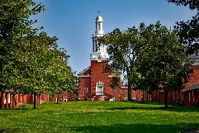 | David Mark | Yale University | https://pixabay.com/es/photos/universidad-de-yale-paisaje-1604156/ | CC0
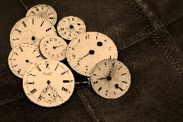 | Coleur | Watches | https://pixabay.com/es/photos/relojes-viejo-antiguo-1204696/ | CC0
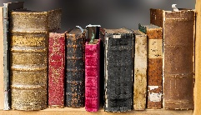 | Blende-12 | book | https://pixabay.com/es/photos/libro-leer-viejo-literatura-libros-1659717/ | CC0
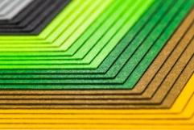 | Alexander Stein | documentos colores | https://pixabay.com/es/photos/colorido-documentos-tonos-colores-182220/ | CC0
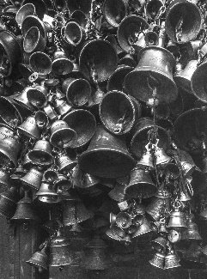 | Shahouraav Shreshtha | Bells | https://unsplash.com/es/fotos/mXHbrbpL2bU | CC0
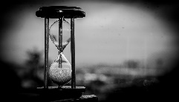 | Eduin Escobar | Time | https://pixabay.com/es/photos/tiempo-reloj-reloj-de-arena-hora-1817725/ | CC0
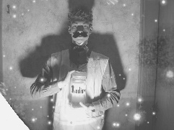 | Alexander Thelen | Radium | https://pixabay.com/es/photos/radio-anticuado-iluminado-bigote-1005499 | CC0
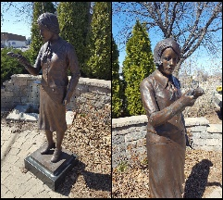 | Matt Polomex | Radium Girls | https://www.flickr.com/photos/polomex/33653400346/in/photolist-TgQtss-2mKtfws-DoMdsQ-2nxfLmf-A9ThCu-UjMo-CZRTJ2-2mKwryZ-91xzYY-Uo9fjE-2iAEVJb-2iAJWRC-2iAHySi-2iAJWiD-w9nxqr-D7eSN5-DevyNx-8jQtK7-DymDFi-pbTSrN-DoMcUq-ctTvC9-akEZ5T-oJ3Pj3-2mH7zUz-2mKeF7v-2hPL1es-cuxqSw-iJ7Mw4-oL33Sb-Uo9er7-DoMcsJ-oL583p-eCcv5N-otA4TW-zhjMxd-oKP1qn-oL5bWM-otz9Jg-oL3pqW-2iAHzaY-oL5jiR-otA8XX-2hPLEvX-8rzgpD-2iAEVWv-2hPMFaM-2mNSVKk-2hPJZ7U-2neYdMK | CC BY-NC-SA 2.0
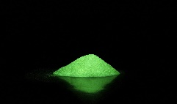 | Simisi1 | fosforescencia | https://pixabay.com/es/photos/fosforescencia-polvo-la-luz-verde-2532701/ | CC0
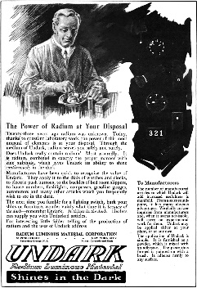 | (desconocido) | Undark-Radium Girls | https://en.wikipedia.org/wiki/Undark#/media/File:Undark_(Radium_Girls)_advertisement,_1921,_retouched.png | Dominio público
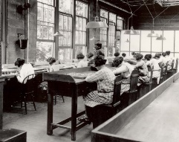 | (desconocido) | All women or girls using radium paint with no protection or warnings in 1922 | https://en.wikipedia.org/wiki/Radium_Girls#/media/File:All_women_or_girls_using_radium_paint_with_no_protection_or_warnings_in_1922,_from-_USRadiumGirls-Argonne1,ca1922-23-150dpi_(cropped).jpg | Dominio público
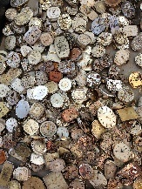 | Heather Zabriskie | Watchmaker’s junkyard | https://unsplash.com/photos/yBzrPGLjMQw | CC0
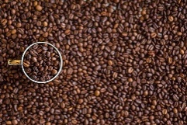 | Negative-space | Granos de café | https://pixabay.com/es/photos/café-granos-de-café-copa-taza-1324126/ | CC0
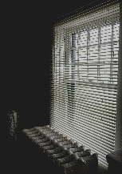 | Tim Busch | It’s a window again | https://unsplash.com/photos/Kv2bafbvsGw | CC0
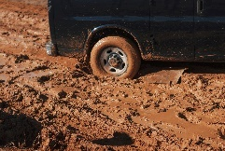 | Aubrey Odom | Coche na lama | https://unsplash.com/photos/uxUUENpp01I | CC0
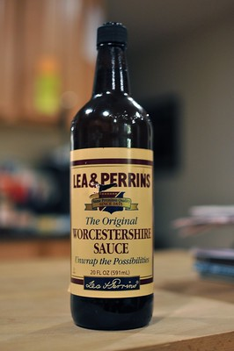 | Peter Baron | Worcestershire Sace | https://www.flickr.com/photos/40155618@N05/4310460620 | CC BY-NC-SA 2.0
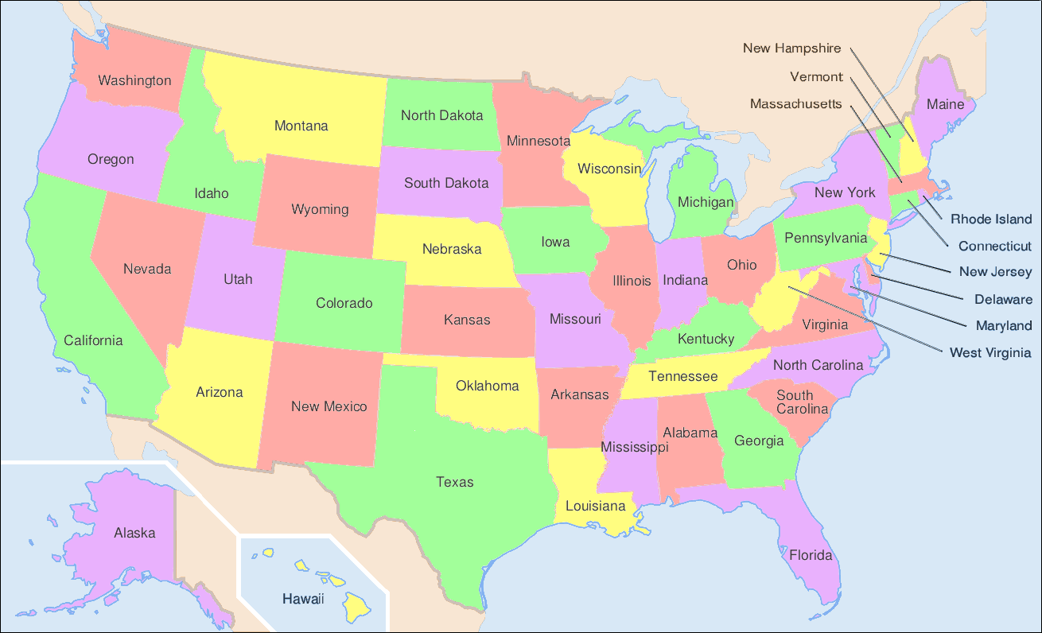 | Wapcaplet | Map of the US showing states | https://en.wikipedia.org/wiki/List_of_states_and_territories_of_the_United_States#/media/File:Map_of_USA_with_state_and_territory_names_2.png | CC BY-SA 3.0
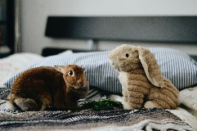 | Jennifer Chen | Real bunny next to stuffd bunny | https://unsplash.com/es/fotos/aB3wYypke8M | CC0
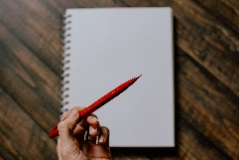 | Kelly Sikkema | Red pen | https://unsplash.com/es/fotos/Plso5cHu9w0 | CC0
 | Priscilla Du Preez | Girls talking | https://unsplash.com/es/fotos/cIfLUEZYLVg | CC0
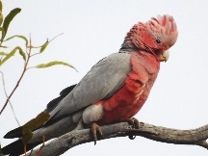 | jjjj56cp | Galah in the Outback | https://www.flickr.com/photos/25171569@N02/32780501656 | CC BY-NC-SA 2.0
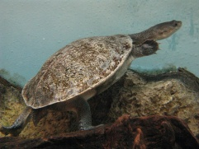 | I. Kenpei | Chelodina | https://commons.wikimedia.org/wiki/Category:Chelodina#/media/File:Chelodina_sp1.jpg | CC BY-SA 3.0
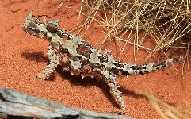 | Stu’s Images | Moloch horridus (thorny devil) | https://commons.wikimedia.org/wiki/Category:Moloch_horridus#/media/File:Moloch_horridus,_Thorny_Devil,_Alice_Springs.jpg | CC BY-SA 4.0
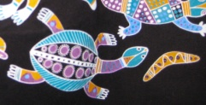 | RubyGoes | Dolphin dreaming tote bag | https://www.flickr.com/photos/61997808@N00/4785493749 | CC BY-SA 2.0
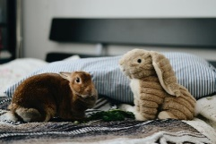 | Jennifer Chen | Rabbits on bed | https://unsplash.com/photos/aB3wYypke8M | CC0
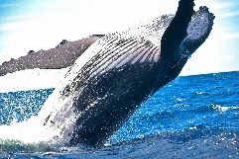 | Oexels | Whale | https://pixabay.com/es/photos/ballena-mam%c3%adfero-animal-1850235 | CC0
 | Gert Altmann | Social media | https://pixabay.com/es/illustrations/medios-de-comunicaci%c3%b3n-social-1989152/ | CC0
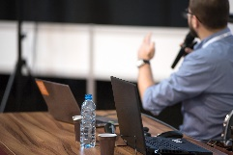 | Photomic | Conference | https://pixabay.com/es/photos/conferencia-formaci%c3%b3n-presentaci%c3%b3n-3248255/ | CC0
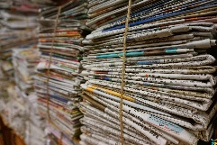 | Pexels | Bundle | https://pixabay.com/es/photos/manojo-cuerda-de-yute-peri%c3%b3dico-1853667/ | CC0
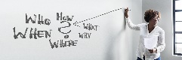 | Gert Altmann | Business | https://pixabay.com/es/photos/negocio-oficina-formaci%c3%b3n-problema-3694993/ | CC0
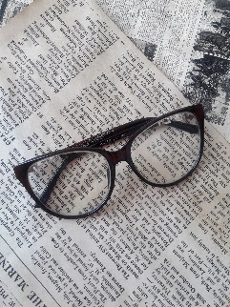 | Green Lana | Paper | https://pixabay.com/es/photos/papel-peri%c3%b3dico-libro-texto-3054758/ | CC0
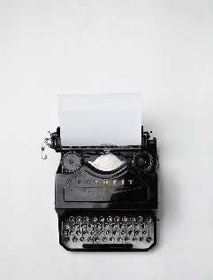 | Florian Klauer | Typewriter | https://unsplash.com/es/fotos/mk7D-4UCfmg | CC0
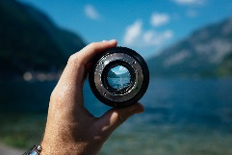 | Paul Skorupskas | lens | https://unsplash.com/es/fotos/7KLa-xLbSXA | CC0
 | Jeff Djevdet (speedpropertybuyers.co.uk) | UK News Brexit Headlines 22nd June 2016 | https://www.flickr.com/photos/jeffdjevdet/28163449080 | CC0
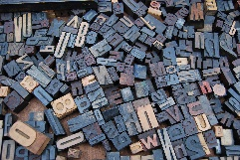 | Amador Loureiro | Print types | https://unsplash.com/es/fotos/BVyNlchWqzs | CC0
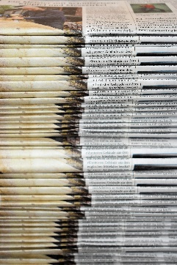 | Waldemar Bradt | Newspapers | https://unsplash.com/es/fotos/JYPDh4ter10 | CC0
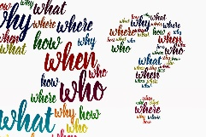 | Gert Altmann | News questions | https://pixabay.com/es/illustrations/signo-de-interrogaci%c3%b3n-pregunta-4873541/ | CC0
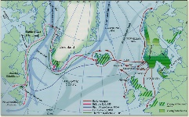 | Michael Duma | The Viking Voyages | http://www.webexhibits.org/vinland/zoom.php?i=images/middle-voyages-map-2.jpg&j=The+Viking+Voyages. | CC-BY-SA-3.0
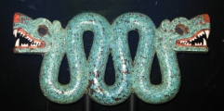 | Jeni | aztec double headed serpent turquoise chest ornament | https://en.wikipedia.org/wiki/A_History_of_the_World_in_100_Objects#/media/File:Double_headed_turquoise_serpentAztecbritish_museum.jpg | CC BY-SA 4.0
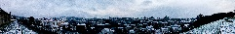 | regueifeiro | Nevada en Compostela | https://gl.wikipedia.org/wiki/Ficheiro:Nevada_en_Compostela_(Panoramica).jpg | CC BY 2.0

