CREDITS
Imaxe | Autor | Título | Ligazón | Licenza
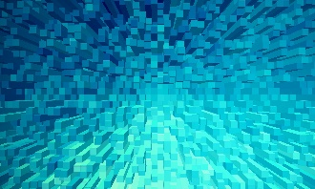 | Nadejda Bostanova | Fondo azul | https://pixabay.com/es/illustrations/de-fondo-blu-formas-extruir-1572602/ | CC0
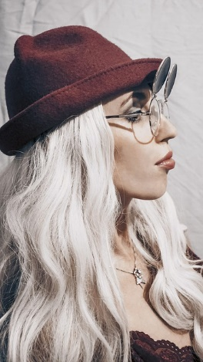 | Maria Saveleva | Girl | https://pixabay.com/es/photos/ni%C3%B1a-persona-gafas-rubia-cabello-4755130/ | CC0
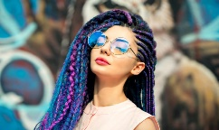 | Maxim Potkim | Girl | https://unsplash.com/photos/xXCAFv1jkDA | CC0
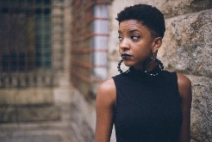 | Pexels | Afro-American Girl | https://pixabay.com/es/photos/ni%C3%B1a-negro-afroamericanas-modelo-1868930/ | CC0
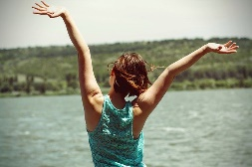 | xxolaxx | Happiness | https://pixabay.com/es/photos/la-felicidad-reverso-mujer-joven-824419/ | CC0
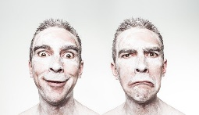 | Ryan McGuire | Emotions | https://pixabay.com/es/photos/emociones-hombre-feliz-triste-cara-371238/ | CC0
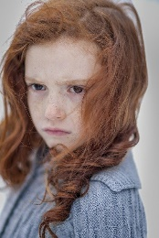 | Mihai Parashiv | Child portrait | https://pixabay.com/photos/child-portrait-girl-person-2162410/ | CC0
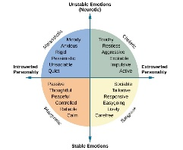 | Openstax | Eysencks’ model | https://openstax.org/books/psychology/pages/11-7-trait-theorists#Figure_11_04_Quadrants | CC BY
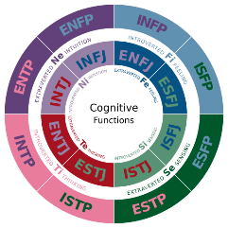 | Jake Beech | Cognitive functions | https://commons.wikimedia.org/wiki/File:Cognitive_Functions.svg | CC0
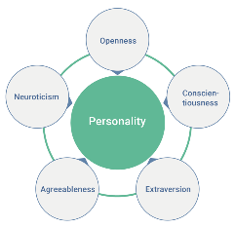 | Ana Tunikova | Big Five | https://commons.wikimedia.org/wiki/File:Wiki-grafik_peats-de_big_five_ENG.png | CC BY
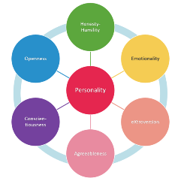 | MissLunaRose12 | HEXACO | https://commons.wikimedia.org/wiki/File:HEXACO_1.png | CC BY-SA
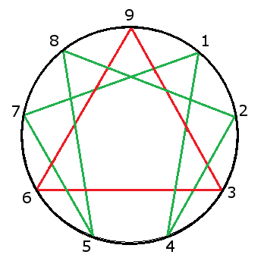 | Amphiareo | Eneagrama | https://commons.wikimedia.org/wiki/File:Enneagram.png | CC BY-SA
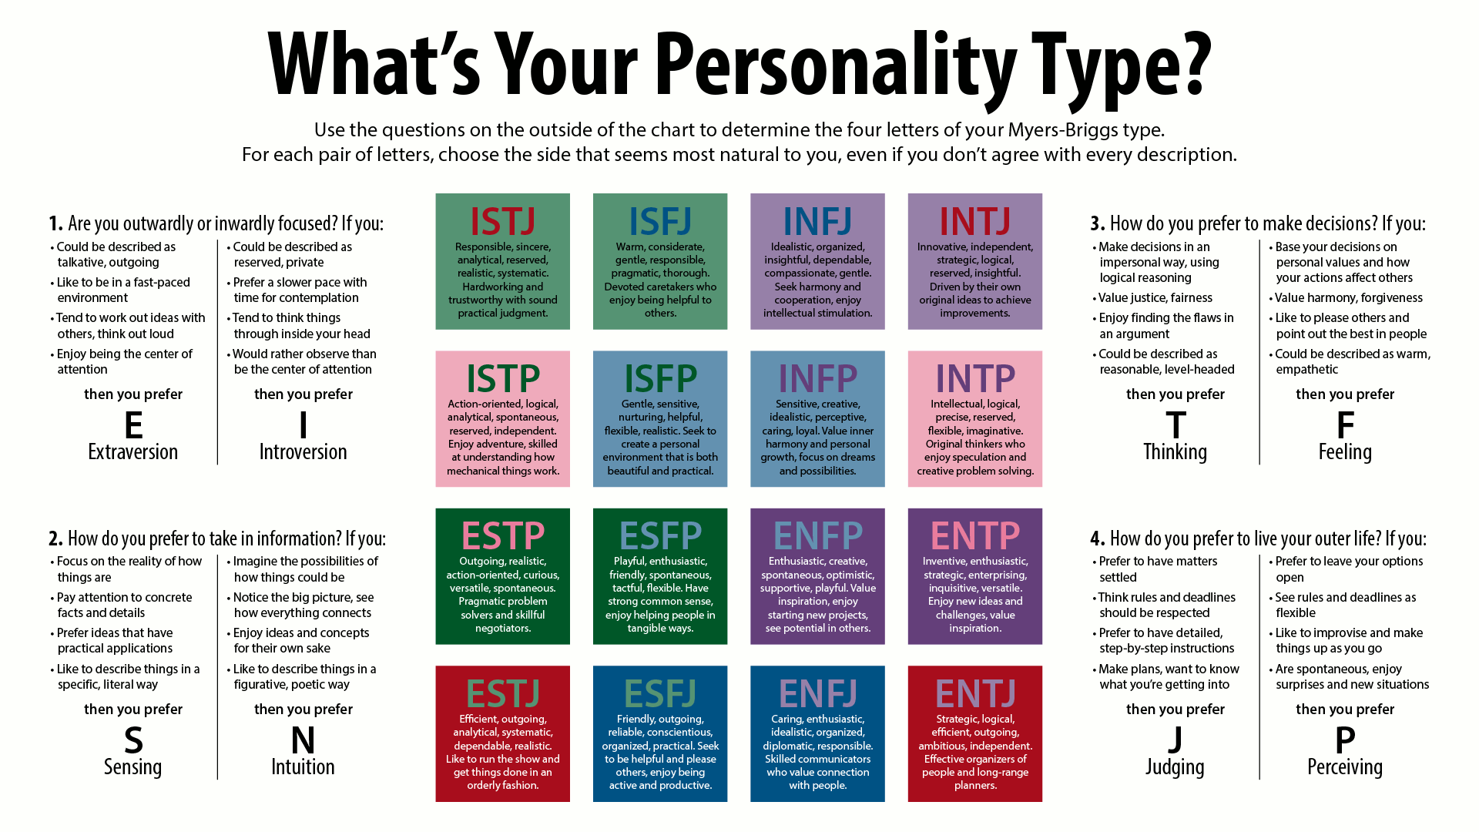 | Jake Beech | Myers-Briggs Type | https://commons.wikimedia.org/wiki/File:Cognitive_Functions.svg#/media/File:MyersBriggsTypes.png | CC BY-SA
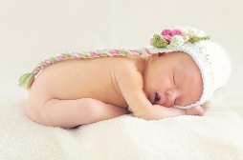 | Tawny Nina Botha | Baby | https://pixabay.com/es/photos/beb%C3%A9-reci%C3%A9n-nacido-desnuda-ni%C3%B1a-784609/ | CC0
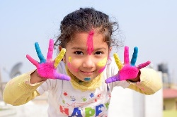 | Phrasant Sharma | Child | https://pixabay.com/es/photos/ni%C3%B1o-colores-nepal-india-dedo-3194977/ | CC0
 | Momental | Boy | https://pixabay.com/es/photos/chico-adolescente-j%C3%B3venes-macho-2420289/ | CC0
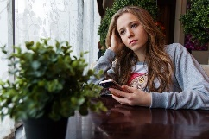 | Anastasia Gepp | Girl | https://pixabay.com/es/photos/ni%C3%B1a-adolescente-caf%C3%A9-smartphone-1848477/ | CC0
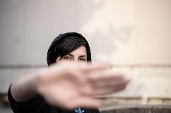 | Ana Krech | Teenager | https://pixabay.com/es/photos/adolescente-sudadera-con-capucha-5842706/ | CC0
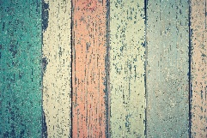 | Pexels | Hardwood | https://pixabay.com/es/photos/frondosas-antiguos-tel%C3%B3n-de-fondo-1851071/ | CC0
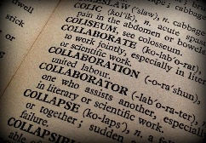 | Dianne Hope | Collaboration | https://pixabay.com/es/photos/colaboraci%C3%B3n-colaborador-libro-1106196/ | CC0
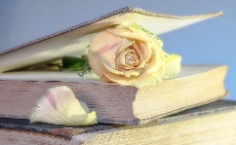 | Myriams-Fotos | Rose | https://pixabay.com/es/photos/rose-libro-viejo-libro-flor-2101475/ | CC0
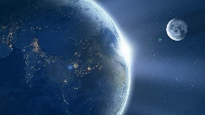 | Comfreak | The Earth | https://pixabay.com/es/photos/la-tierra-luna-ache-sunrise-1388003/ | CC0
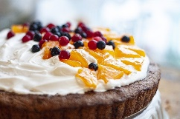 | Svetlanabar | Cake | https://pixabay.com/es/photos/pastel-tarta-bayas-crema-4910417/ | CC0
 | Gerd Altmann | Background | https://pixabay.com/es/illustrations/fondo-curso-resumen-patr%C3%B3n-l%C3%ADneas-784356/ | CC0
 | Gerd Altmann | Cloud | https://pixabay.com/es/illustrations/nube-blog-tweet-como-compartir-709092/ | CC0
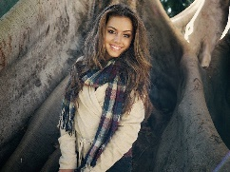 | DzeeShah | Woman | https://pixabay.com/es/photos/mujer-morena-retrato-modelo-1274361/ | CC0
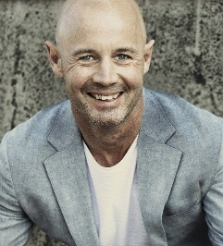 | Shawrypa | Man | https://pixabay.com/es/photos/hombre-sonrisa-negrita-elegante-1690965/ | CC0
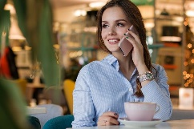 | Anastasya Gepp | Woman | https://pixabay.com/es/photos/mujer-personas-caf%C3%A9-retrato-3083379/ | CC0
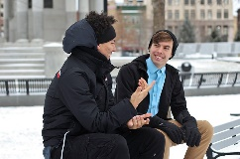 | Free-Photos | Friends | https://pixabay.com/es/photos/amigos-masculina-hombres-fuera-1209740/ | CC0
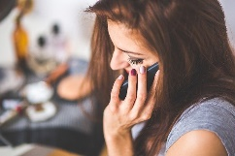 | Karolina Grabowska | Woman | https://pixabay.com/es/photos/mujer-ni%C3%B1a-dama-joven-hablar-791874/ | CC0
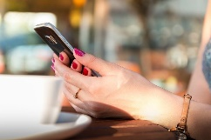 | Pexels | Hands | https://pixabay.com/es/photos/manos-explotaci%C3%B3n-smartphone-chat-1853302/ | CC0
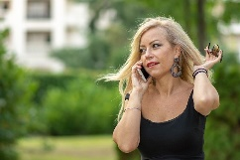 | Christo Anestev | Speaking on the phone | https://pixabay.com/es/photos/hablando-en-el-m%C3%B3vil-m%C3%B3viles-mujer-3730397/ | CC0
 | Idshivam09 | Man | https://pixabay.com/es/photos/hombre-llamada-de-tel%C3%A9fono-5465718/ | CC0
 | Jake Beech | Myers-Briggs Types | https://commons.wikimedia.org/wiki/File:MyersBriggsTypes.png | CC BY
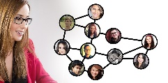 | Gerd Altmann | Woman | https://pixabay.com/es/illustrations/mujer-la-cara-fotomontaje-1594711/ | CC0
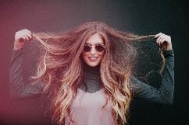 | Stock Snap | Woman | https://pixabay.com/es/photos/mujer-retrato-modelo-la-moda-2593366/ | CC0
 | Pexels | Happy | https://pixabay.com/es/photos/feliz-hombre-adulto-ciudad-cara-1836445/ | CC0
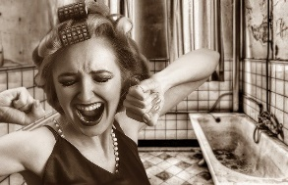 | S. Hermann & F. Richter | Woman | https://pixabay.com/es/photos/mujer-chica-los-rulos-peinado-3170568/ | CC0
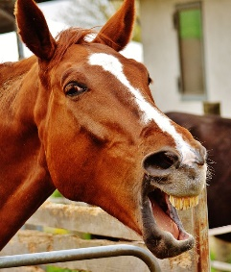 | Alexas Fotos | Horse | https://pixabay.com/es/photos/caballo-gracioso-re%C3%ADr-animales-1333937/ | CC0
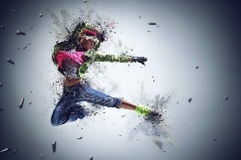 | Art Tower | Girl | https://pixabay.com/es/photos/ni%C3%B1a-mujer-mujeres-danza-saltar-3691314/ | CC0
 | FireFX | Man | https://pixabay.com/es/photos/hombre-libro-pulgares-arriba-5909095/ | CC0
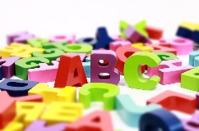 | Gerd Altmann | Alphabet | https://pixabay.com/es/illustrations/orden-alfab%C3%A9tico-abc-carta-aprender-1219546/ | CC0
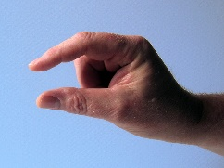 | Gerd Altmann | Hand | https://pixabay.com/es/photos/mano-dedo-pulgar-dedo-%C3%ADndice-66631/ | CC0
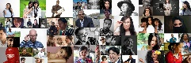 | Gerd Altmann | Personal | https://pixabay.com/es/photos/personales-red-3139194/ | CC0
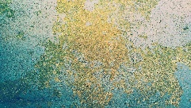 | Pexels | Abstract | https://pixabay.com/es/photos/resumen-tel%C3%B3n-de-fondo-de-fondo-1850416/ | CC0
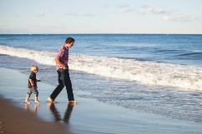 | Danielle MacInnes | Father and son | https://unsplash.com/photos/RqgWDJFq6i0 | CC0
 | Windows | Success | https://unsplash.com/photos/kRWY72TKB0Y | CC0

