CREDITS
Imaxe | Autor | Título | Ligazón | Licenza
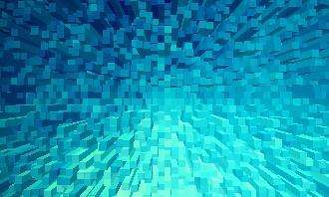 | Nadejda Bostanova | Fondo azul | https://pixabay.com/es/illustrations/de-fondo-blu-formas-extruir-1572602/ | CC0
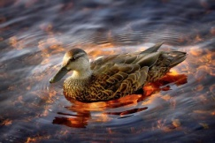 | Alain Audet | Duck | https://pixabay.com/es/photos/pato-pato-negro-lago-naturaleza-5398029/ | CC0
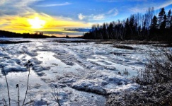 | Alain Audet | Landscape | https://pixabay.com/es/photos/paisaje-naturaleza-nieve-hielo-4789111/ | CC0
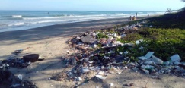 | Sergeitovmakov | Pollution | https://pixabay.com/es/photos/contaminaci%c3%b3n-basura-oceano-4855507/ | CC0
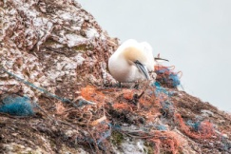 | A_Different_Perspective | Safety net | https://pixabay.com/es/photos/red-de-seguridad-geisternetz-3289549/ | CC0
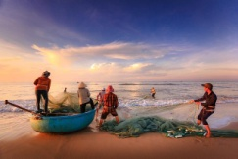 | Quangpraha | Fishermen | https://pixabay.com/es/photos/pescadores-playa-bote-pesca-mar-2983615/ | CC0
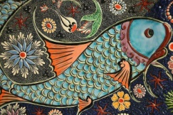 | GLady | Mosaic | https://pixabay.com/es/photos/mosaico-pez-loseta-arte-cer%c3%a1mico-200864/ | CC0
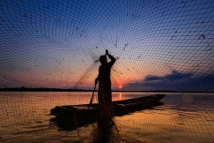 | chanwity | Man | https://pixabay.com/es/photos/hombre-red-de-pesca-lago-atardecer-6342665/ | CC0
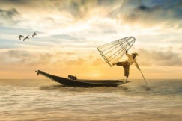 | Miriams-fotos | Fisherman | https://pixabay.com/es/photos/pescador-barco-de-pesca-bote-pesca-2739115/ | CC0
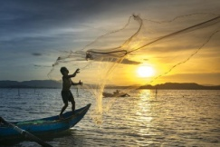 | Quangpraha | Fishing | https://pixabay.com/es/photos/pesca-pescador-atardecer-mar-3062034/ | CC0
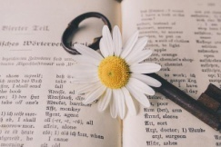 | suju-foto | Key | https://pixabay.com/es/photos/clave-viejo-flor-nost%c3%a1lgico-5105878/ | CC0
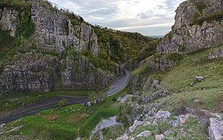 | Wikipedia | Cheddar Gorge | https://en.wikipedia.org/wiki/Cheddar_Gorge#/media/File:Cheddar_Gorge,_Somerset,_UK_-_Diliff.jpg | CC BY-SA 3.0
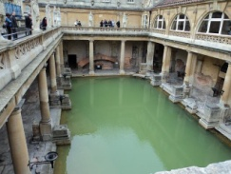 | loseitlady | England | https://pixabay.com/es/photos/inglaterra-reino-unido-ba%c3%b1o-170402/ | CC0
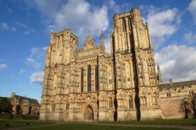 | Giselleinmotion | Somerset | https://pixabay.com/es/photos/somerset-catedral-pozos-hist%c3%b3rico-5078400/ | CC0
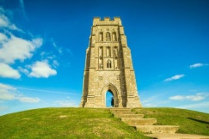 | diego_torres | Glastonbury | https://pixabay.com/es/photos/glastonbury-el-edificio-monumento-857590/ | CC0
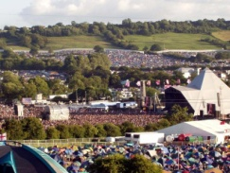 | Logan1138~commonswiki | Glasto pyramid stage and site from 2003l | https://es.wikipedia.org/wiki/Festival_de_Glastonbury#/media/Archivo:Glastofriday2003.jpg | CC0
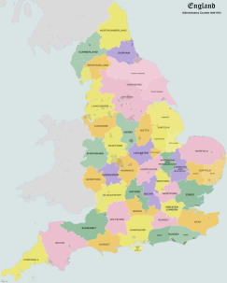 | XrysD | Map of the English Administrative Counties from 1965-74 | https://en.wikipedia.org/wiki/Administrative_counties_of_England#/media/File:England_Admin_Counties_1965-1974.png | CC0
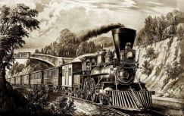 | Currier & Ives | English: The Express Train by Currier & Ives | https://upload.wikimedia.org/wikipedia/commons/b/b1/Vintage_image_of_steam_train.jpg | CC0
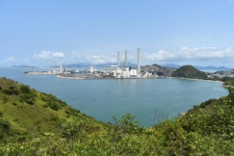 | yung-shue-wan | AdamHillTravel | https://pixabay.com/es/photos/yung-shue-wan-lamma-island-hong-kong-5157441/ | CC0
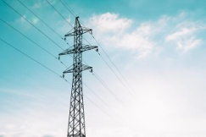 | pexels | power lines | https://pixabay.com/es/photos/l%c3%adneas-de-energ%c3%ada-cables-torre-1868352/ | CC0
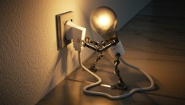 | ColiN00B | lightbulb | https://pixabay.com/es/photos/bombilla-ocurrencia-creatividad-3104355/ | CC0
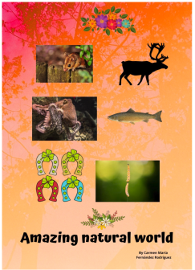 | Carmen María Fernández Rodríguez (Canva derived from varios sources) | Amazing natural world |  | CC0
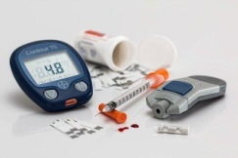 | stevepb | diabetes | https://pixabay.com/es/photos/diabetes-az%c3%bacar-en-la-sangre-528678/ | CC0
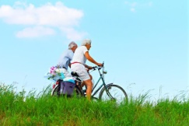 | MabelAmber | person | https://pixabay.com/es/photos/persona-hombre-mujer-gente-pareja-3553814/ | CC0
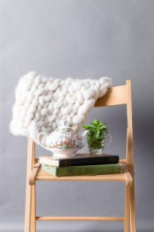 | Daria-Yakovleva | chair | https://pixabay.com/es/photos/silla-habitaci%c3%b3n-la-pared-4788242/ | CC0
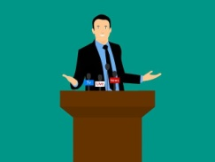 | mohamed_hassan | public speaking | https://pixabay.com/es/illustrations/hablar-en-p%c3%bablico-altavoz-hombre-3159217/ | CC0
 | RobbinHiggins | person | https://pixabay.com/es/photos/persona-pulgares-arriba-sonriente-2385787/ | CC0
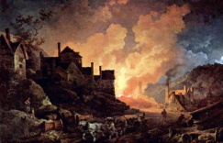 | Phillip Jakob Loutherbourg | Coalbrookdale at night | https://ndla.no/en/subject:1:a81148de-fb95-4e41-b000-57b268337e2d/topic:1:70402e78-cf06-4146-9728-6fd146a2b6fd/topic:1:2356d6df-ea84-4541-9d7e-d90996800ad2/resource:92708a28-0b44-4d4a-8f23-30d0fb7f3734 | CC BY-SA 4.0
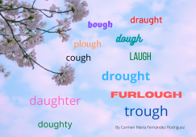 | Carmen María Fernández Rodríguez (Canva) | augh ough words |  | CC0
 | geralt | embroidery | https://pixabay.com/es/illustrations/bordado-irrespetuoso-smilies-gota-496003/ | CC0
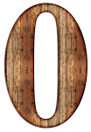 | ractapopulous | number | https://pixabay.com/es/illustrations/n%c3%bamero-cero-d%c3%adgito-antecedentes-2052194/ | CC0
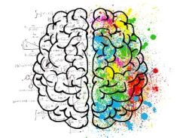 | ElisaRiva | brain | https://pixabay.com/es/illustrations/cerebro-mente-psicolog%c3%ada-ocurrencia-2062057/ | CC0
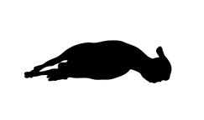 | BedexpStock | sheep | https://pixabay.com/es/vectors/oveja-animal-de-pie-granja-cordero-2672667/ | CC0
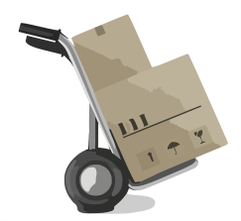 |  | moving | https://pixabay.com/es/vectors/moviente-caja-reubicaci%c3%b3n-gente-312082/ | CC0
  Cliker-Free-Vector-Images
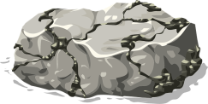 |  | rocks | https://pixabay.com/es/vectors/rocas-monta%c3%b1a-naturaleza-roca-gris-576664/ | CC0
  OpenClipart-Vectors
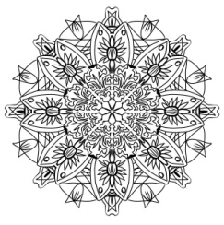 | KaylinArt | drawing | https://pixabay.com/es/illustrations/dibujo-l%c3%a1piz-patr%c3%b3n-2151084/ | CC0
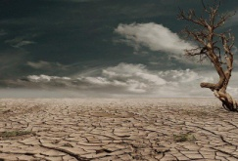 | _Marion | desert | https://pixabay.com/es/photos/desierto-sequ%c3%ada-deshidratado-%c3%a1rido-279862/ | CC0
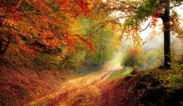 | Valiphotos | road | https://pixabay.com/es/photos/la-carretera-bosque-oto%c3%b1o-temporada-1072823/ | CC0
 | GDJ | administration | https://pixabay.com/es/vectors/administraci%c3%b3n-arquitectura-arte-2031346/ | CC0
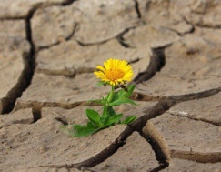 | klimkin | flower | https://pixabay.com/es/photos/flor-la-vida-flor-amarilla-grieta-887443/ | CC0
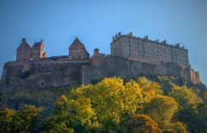 | Walkerssk | edinburgh | https://pixabay.com/es/photos/edimburgo-castillo-997077/ | CC0
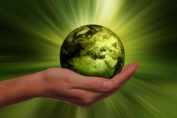 | geralt | sustainability | https://pixabay.com/es/photos/sustentabilidad-energ%c3%ada-globo-3300869/ | CC0
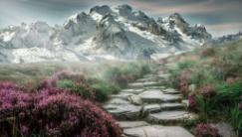 | kinkate | Rock in between grass and flower | https://www.pexels.com/photo/rock-in-between-grass-and-flower-368260/ | CC0
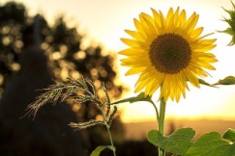 | mploscar | sunflower | https://pixabay.com/es/photos/girasol-flor-planta-p%c3%a9talos-1127174/ | CC0
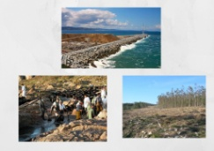 | Carmen María Fernández Rodríguez (Canva derived from varios sources) | environmental changes |  | CC0
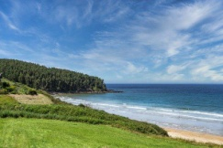 | ELG21 | nature | https://pixabay.com/es/photos/naturaleza-playa-al-aire-libre-6565499/ | CC0

