Recycling
We are certainly more conscious of the carbon footprint we are leaving and, overall, people are making more of an effort to recycle. However, there is still a lot more work to be done.
There are 7 billion people on the planet and each of these people produce, on average 4.4 pounds of garbage per day. In one day, the world population increases by 200, 000 people. In one week, this is nearly the population of Brisbane, Australia. In one month, this reaches the population figure of Philadelphia, USA, and in six months, the population of Venezuela. Within one year we match the population count of Italy, with people to spare.
At this rate, it takes the world 25 years to double in population.
On average, the world recycles only about 30% of the waste they produce. Waste produced by the population is responsible for releasing 600 million tons of methane into the air each year. As landfills begin to overflow, and as rainwater begins to wash the expanded landfill toxics into the world’s water supply, these emissions will generate serious health risks. Already, 2 million tonnes of sewage, industrial and agricultural waste are discharged into the world’s water each day.
Recycling can reduce greenhouse gas emissions by up to 75% and recycling paper alone can reduce water pollution by 35%.
There is a lot of speculation surrounding the issue of recycling. Some say that recycling consumes more energy than it saves, whilst others say that recycling your home waste is a waste of time as it all ends up on the same landfill anyway.
To this I say that it is proven that to recycle glass takes much less energy than it does to create it from raw materials, as the manufacturers require a much lower temperature in their furnaces. The same can be said for aluminium, the energy involved in mining Bauxite, transportation, extraction then preparing it for creating products far exceeds the amount of energy required to break down an aluminium can for reuse.
As for those who speculate that their attempt at recycling in undermined by councils simply dumping it all on the same landfill. I put this to you, is it not better to recycle anyway and take the chance that it is being reused than it is to just throw everything in one bin where it would definitely end up on a landfill?
With the pressures of population and waste coming together at once we must look to recycling to maintain our natural resources. If we do not the planet will not be a pleasant place to live.

Nouns
carbon footprint
the world population
the population figures
rainwater
landfill toxics
serious health risks
greenhouse gas emissions
a waste of time
raw materials
the pressures of population
a pleasant place
natural resources

Adjectives
responsible for
proven
definitely

Verbs and idioms
to recycle
to spare
to overflow
discharged
reduce water pollution
preparing it for
to break down
speculate

Protect Natural Resources, Utilize Solar Electric Power
by: John Daviz
Solar energy, wind energy, geothermal energy, hydropower and biomass are some of the renewable sources of energy. Using of renewable sources of energy is good because these sources offer an environmentally friendly option than utilizing fossil fuels. There will be an improve energy security and energy independence if people use renewable source of energy. Also, renewable sources of energy are the cleanest and safest energy sources.
The well-known source of energy which is the solar energy is an environment-friendly and endless renewable source of energy. Solar power doesn’t result in the emission of harmful carbon dioxide unlike the use of fossil fuels. The sun will be the unlimited source of energy and with right technologies can provide sufficient electricity that could be used in every single household or even in commercial and industrial properties.
The use of solar power has a positive effect in the environment because taking advantage of solar energy does not contribute to climate change, acid rains or any kind of pollution. When transformed from solar radiations, solar energy may possibly be converted to thermal energy or electric power. This may also be employed in a number of applications like in agriculture and analysis. At present, solar power is being utilized in two areas namely for the production of thermal energy which can heat up water and producing of electric power by utilizing the photovoltaic cell.
Photovoltaic cells or PV cells captures solar energy then transforming it into electricity. These cells convert sunlight into electricity by employing the energy developed when photons from sunlight push electrons into greater state of energy. Yet solar power is not only limited to thermal energy and electricity simply because currently, numerous devices which are powered by solar energy exist in the market.
Solar energy is an excellent source of supplying power to homes and companies and by utilizing solar power you’re not merely protecting the environment from becoming polluted but also you are saving the rest of the earth’s natural resources. Capturing solar energy does not contribute any pollution and does not harm the atmosphere. One of the factors why many individuals are still hesitant to make use of solar power is because it is expensive. The initial investment of installing solar power system for a home is expensive and aside from that solar power still wants to boost its deficiency. The need of big location of space is another reason why people aren’t taking into consideration solar power.
(SOURCE: http://www.articlecity.com/articles/environment_and_going_green/article_1156.shtml)

Waste Management and Recycling
by: Robs
Waste Management is the undisputed world leader in nearly all facets of waste treatment, including low-level nuclear, chemical, and asbestos cleanup; and daily garbage removal, waste reduction, and recycling. Waste Management has expanded its operations both technically and geographically, acquiring a host of sophisticated suppliers of trash-to-energy plants, pollution control equipment, and recycling services, while signing contracts with municipalities from Buenos Aires to Hong Kong. The company has frequently been attacked by governmental agencies and environmental groups for a variety of alleged failings, but its phenomenal growth and strenuous efforts in the recycling and pollution-control areas make it likely that in the future Waste Management will be perceived as a hero rather than villain by the world’s increasingly polluted cities. Waste Management, it seems, is well on the way to becoming the planet’s garbage collector. It was an exceedingly good time to join the waste-treatment industry. Not only was the national economy at the peak of its postwar prosperity, the U.S. consumer was just then beginning to be inundated with a wave of new packaging and convenience items designed to be used once and thrown away. The nation’s production of garbage was growing much faster even than its population, and companies such as Ace Scavenger found themselves in great demand.
The company responded with characteristic energy. At each of its nine chemical dumps, WMI installed environmental-compliance officers with power to override the decisions of local plant managers. These watchdog foremen reported to WMI’s new environmental-management head, Walter C. Barber, a former acting chief of the EPA. In addition, the Chemical Waste subsidiary in charge of most of the troubled sites was provided with a new president, Jerry E. Dempsey, former president of Borg-Warner Corporation. To smooth relations with Congress, WMI hired Frank B. Moore as its chief lobbyist. Moore had previously served as President Jimmy Carter’s liaison officer with Congress. Finally, WMI adopted new advertising campaigns stressing the company’s services on behalf of the environment and customers alike.
While such moves had not satisfied critics such as Greenpeace International, it appeared that WMI learned a lesson from its legal battles and took some pains to adopt more safety measures. As proof of its progress in these areas, WMI can point to the long-term contracts it won in the late 1980s to handle much of the waste from Portland, Oregon; and Seattle, Washington; two cities known for their strong environmental commitment. In both cases, the municipalities found that WMI’s experience and resources made it the best choice for waste problems of great magnitude. Recycling is processing used materials (waste) into new products to prevent waste of potentially useful materials, reduce the consumption of fresh raw materials, reduce energy usage, reduce air pollution (from incineration) and water pollution (from landfilling) by reducing the need for “conventional” waste disposal, and lower greenhouse gas emissions as compared to virgin production. Recycling is a key component of modern waste reduction and is the third component of the “Reduce, Reuse, Recycle” waste hierarchy.
Recyclable materials include many kinds of glass, paper, metal, plastic, textiles, and electronics. Although similar in effect, the composting or other reuse of biodegradable waste such as food or garden waste is not typically considered recycling. Materials to be recycled are either brought to a collection center or picked up from the curbside, then sorted, cleaned, and reprocessed into new materials bound for manufacturing.
(SOURCE: http://www.articlecity.com/articles/environment_and_going_green/article_1148.shtml)

Nouns
renewable sources
an environmentally friendly option
industrial properties
waste treatment
municipalities
pollution-control areas
garbage collector
chemical dumps
chief lobbyist
biodegradable waste
legal battles
greenhouse gas emissions

Adjectives
well-known
endless
sufficient

Verbs and idioms
contribute to
transforming
supplying power
becoming polluted
to boost
expanded its operations
phenomenal growth
to prevent waste

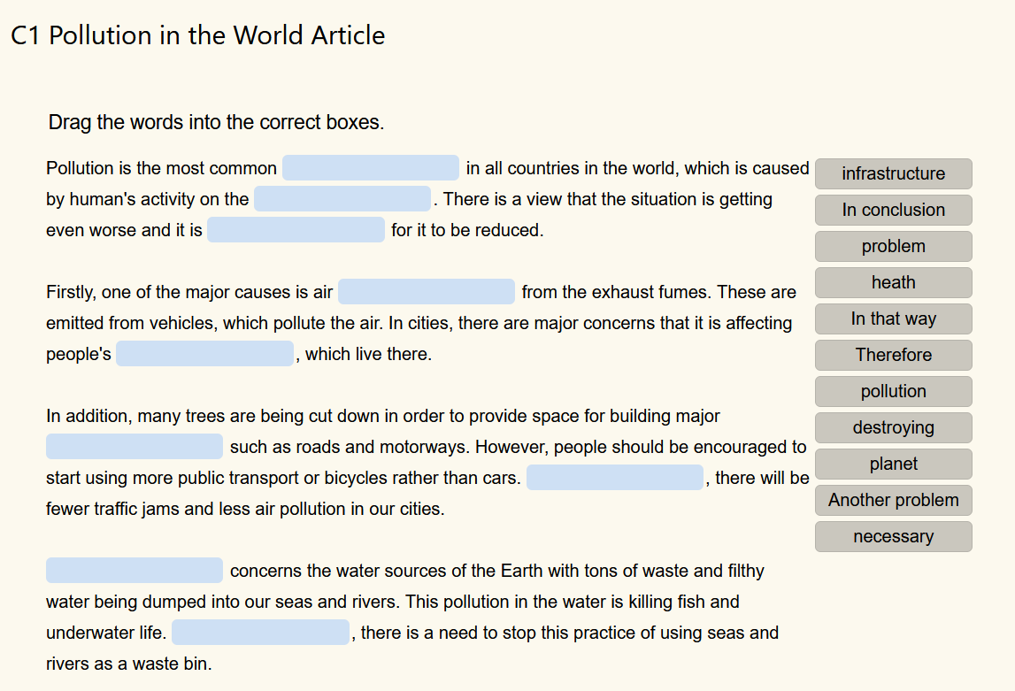

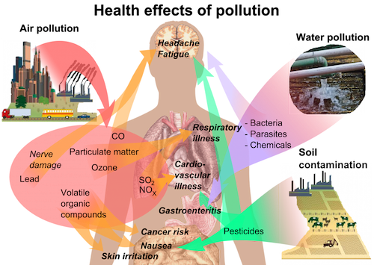


Across
2 the plants of a given region (5)
3 the type of environment in which an organism normally lives (7)
5 a colourless gas that is a screen for ultraviolet radiation (5)
6 when the last members of a species die, the species becomes extinct (10)
7 remove the trees from (8)
9 not covered with forest (10)
10 a group of individuals that belong to the same species, live in the same area, and breed with each other (10)

Down
1 contamination of the natural environment (9)
4 careful management of the environment and natural resources (12)
8 organisms having some common qualities; kind or type (7)

"S.O.S. (Mother Nature)"
by Will.I.Am

[Intro:]
Lord come down and help us out
Send us an …………………., help us out
………………….., help us out
Looking all around and I'm watching the ……………………
[Verse 1:]
People ………………………., people dying, people lying, people blind
People don't see the sign, watching money all the time
Get the pennies, get the dimes, get the dollars is the mindstate
Of the human ………………………., people on the paper chase
The ………………………. is fragile, and we been on the gradual
Declining in a lifetime or lose the battle
Get burned by volcanoes, get blown by tornadoes
Cause ………………………. ………………………. signals, is trying to warn NATO
We got a new terror threat, it's called the weather
More deadlier than chemical and nuclear together
It's hotter in the winter, even hotter in the ……………………….
Jesus, or Buddha, somebody come and help us out
[Chorus 1:]
Lord come down and help us out
Send us an ………………………., help us out
………………………., help us out
Looking all around and I'm watching the ………………………., changing
Open up your eyes, you can see things rearranging
The ………………………. is dying
And if they say it's gonna be alright, them people are ……………………….
[Verse 2:]
People trapped behind the gates, ignorance in their state of mind
Cause they formulate a plan just to penetrate us
You see they stimulate us with fear, ………………………. us
Each year, they dominate dividing us like calculators
And we can't add it up cause calculators do the math for us
And here they come choppering down, chopping down our ……………………….
F**king up our air for us, they don't really care for us
But we can't complain, because the only one to blame is us
The ………………………. is rising up but we keep on filling up
CO2 levels got the whole ………………………. heated up
It's blazing in the winter, even hotter in the ……………………….
Mohammed, Jehovah, somebody come and help us out
[Chorus 2:]
Lord come down and help us out
Send us an ………………………., help us out
………………………., help us out
Looks like we ain't gon' figure it out
Lord come down and help us out
Send us an ………………………., help us out
………………………., help us out
Looking all around and I'm watching the ………………………., changing
Open up your eyes, you can see things rearranging
The ………………………. is ending
And if they say it's gonna be okay, they just ……………………….
[Verse 2:]
When the eskimo gets bit by a ……………………….
Somebody in Miami will get swept by a ……………………….
Rastas in Jamaica will get hit by a ………………………. that
Registers something like 8.8
You see it's situations happening with our planet
Cause, 50 years ago we took it for granted
We should have took advantage, and reversed the ……………………….
Instead of just pumping and selling and slanging the gas
And while we purchased the gas
We was watching soap operas while they steady brainwashed the masses
Cause we could make a vehicle that runs off ashes
But they own a patent for that, and that's exactly what's happening
Corruption and bullshit politics
The ……………………….'s gonna die cause of bullshit politics
It's hotter in the winter, even hotter in the ……………………….
And ain't nobody coming to the rescue to help the
[Outro:]
(The ……………………….)
The, the, the, the, the...
The, the, the, the, the...
(The ……………………….)
The, the, the, the, the...
The, the, the, hope, the...
(The ……………………….)
The, the, the, the, the...
The, the, the, hope, the...
(The ……………………….)
The, the, the, the, the..
Looking all around watching the ………………………...
(The ……………………….)
(The ……………………….)
Looking all around watching the ………………………...
(The ……………………….)
Looking all around watching the ………………………...
(The ……………………….)
Looking all around watching the ………………………...
(The ……………………….)

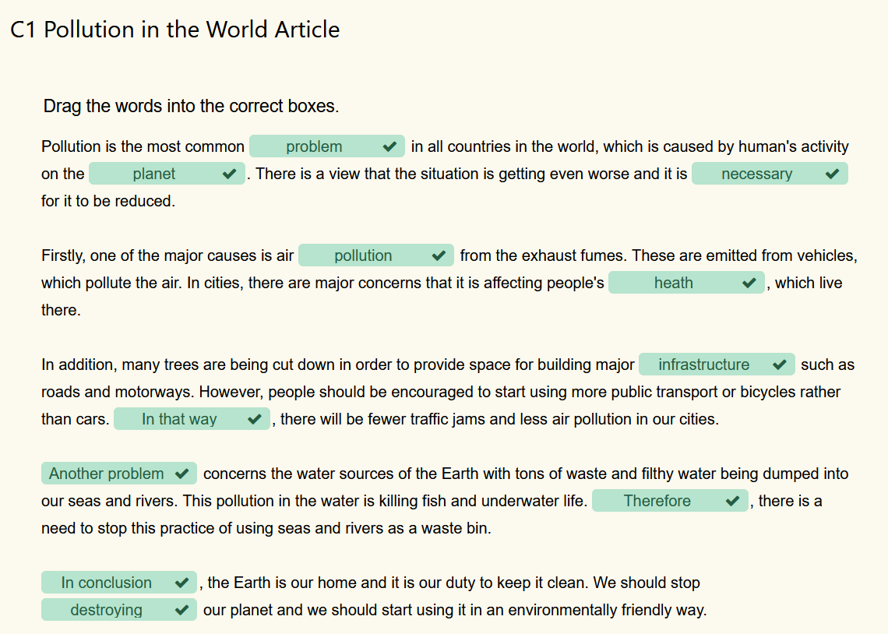

Here are the words from the crossword:
Across
2. flora
3. habitat
5. ozone
6. extinction
7. deforest
9. unforested
10. population
Down
1. pollution
4. conservation
8. species

"S.O.S. (Mother Nature)" by Will.I.Am
[Intro:]
Lord come down and help us out
Send us an angel, help us out
SOS, help us out
Looking all around and I'm watching the world
[Verse 1:]
People killing, people dying, people lying, people blind
People don't see the sign, watching money all the time
Get the pennies, get the dimes, get the dollars is the mindstate
Of the human race, people on the paper chase
The environment is fragile, and we been on the gradual
Declining in a lifetime or lose the battle
Get burned by volcanoes, get blown by tornadoes
Cause mother nature signals, is trying to warn NATO
We got a new terror threat, it's called the weather
More deadlier than chemical and nuclear together
It's hotter in the winter, even hotter in the summer
Jesus, or Buddha, somebody come and help us out
[Chorus 1:]
Lord come down and help us out
Send us an angel, help us out
SOS, help us out
Looking all around and I'm watching the world, changing
Open up your eyes, you can see things rearranging
The world is dying
And if they say it's gonna be alright, them people are lying
[Verse 2:]
People trapped behind the gates, ignorance in their state of mind
Cause they formulate a plan just to penetrate us
You see they stimulate us with fear, manipulate us
Each year, they dominate dividing us like calculators
And we can't add it up cause calculators do the math for us
And here they come choppering down, chopping down our rainforest
F**king up our air for us, they don't really care for us
But we can't complain, because the only one to blame is us
The gas is rising up but we keep on filling up
CO2 levels got the whole planet heated up
It's blazing in the winter, even hotter in the summer
Mohammed, Jehovah, somebody come and help us out
[Chorus 2:]
Lord come down and help us out
Send us an angel, help us out
SOS, help us out
Looks like we ain't gon' figure it out
Lord come down and help us out
Send us an angel, help us out
SOS, help us out
Looking all around and I'm watching the world, changing
Open up your eyes, you can see things rearranging
The world is ending
And if they say it's gonna be okay, they just pretending
[Verse 2:]
When the eskimo gets bit by a mosquito
Somebody in Miami will get swept by a tsunami
Rastas in Jamaica will get hit by a quake that
Registers something like 8.8
You see it's situations happening with our planet
Cause, 50 years ago we took it for granted
We should have took advantage, and reversed the damage
Instead of just pumping and selling and slanging the gas
And while we purchased the gas
We was watching soap operas while they steady brainwashed the masses
Cause we could make a vehicle that runs off ashes
But they own a patent for that, and that's exactly what's happening
Corruption and bullshit politics
The planet's gonna die cause of bullshit politics
It's hotter in the winter, even hotter in the summer
And ain't nobody coming to the rescue to help the
[Outro:]
(The world)
The, the, the, the, the...
The, the, the, the, the...
(The world)
The, the, the, the, the...
The, the, the, hope, the...
(The world)
The, the, the, the, the...
The, the, the, hope, the...
(The world)
The, the, the, the, the..
Looking all around watching the world..
(The world)
(The world)
Looking all around watching the world..
(The world)
Looking all around watching the world..
(The world)
Looking all around watching the world..
(The world)

