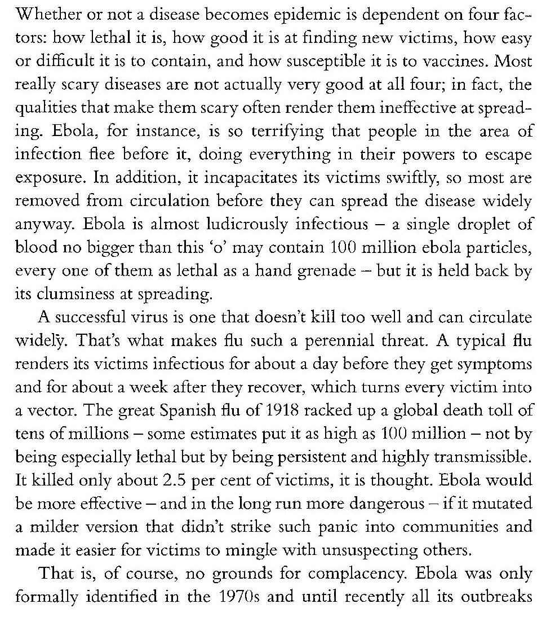
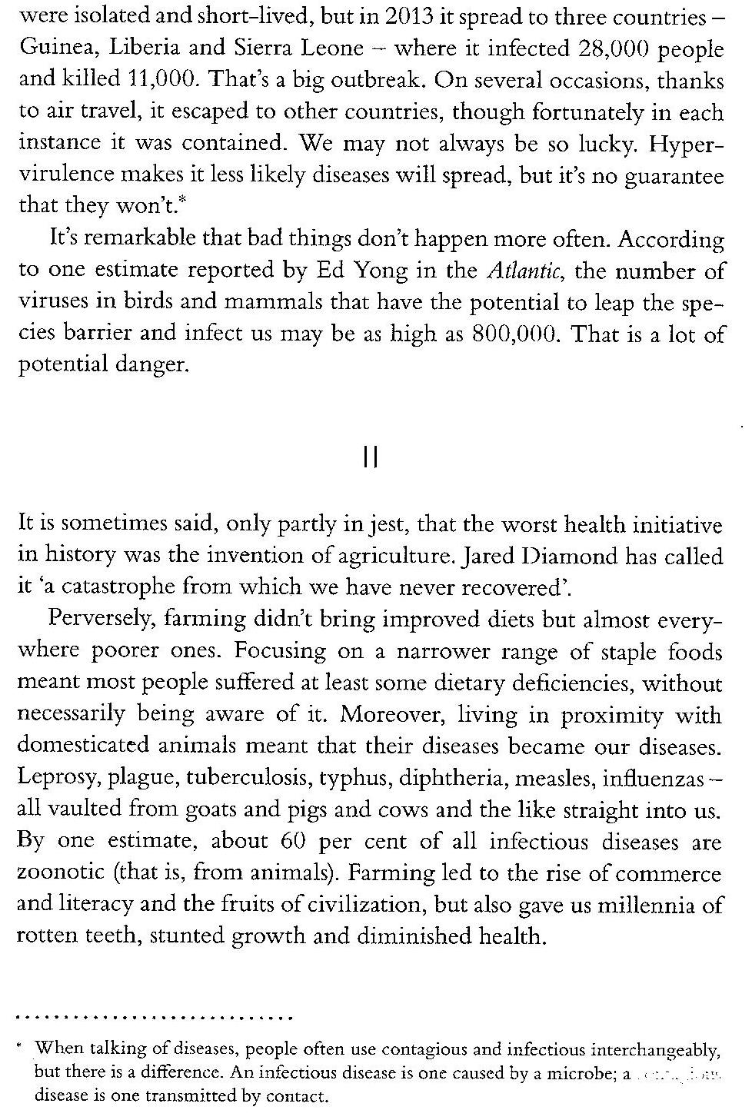
- Say whether the following statements about the text are true (T) or false (F)

1 | Most scary diseases prove good in the four mentioned factors
2 | Ebola victims are isolated before the disease is detected
3 | The most successful virus is not the one which kills more people
4 | If ebola had softer synthons it would be more lethal
5 | Ebola spread widely through air travel

- Find in the text synonyms for the following words:

- Escape: ______________
- Fast: _________________
- Ineptitude: ___________
- Hazard: ______________
- Charge: _____________
- Blend: _______________
- Burst: ________________
- Joke: ________________
- Basic: ________________
- Leap: ________________

Text source “The Body”, Bill Bryson, 2020

