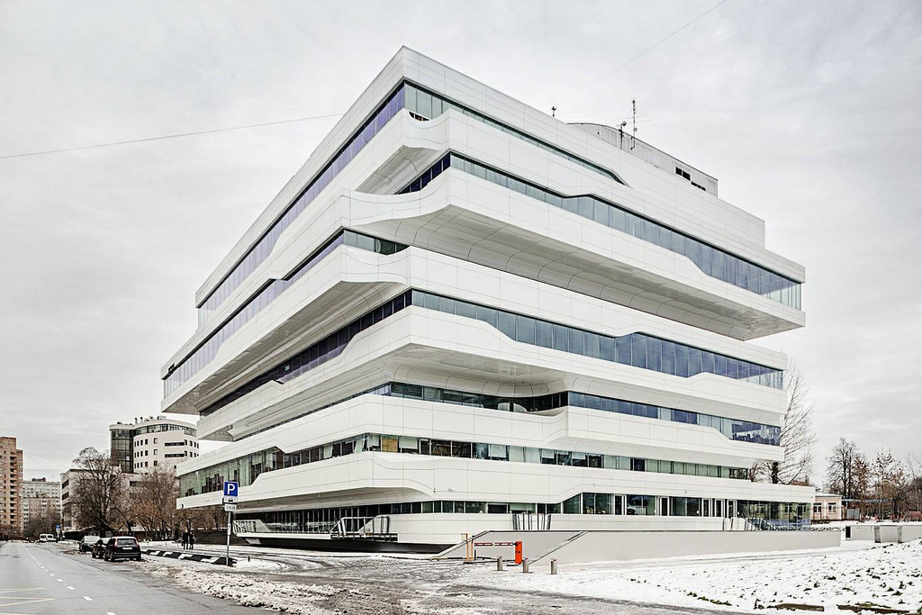
Interview with Zaha Hadid

You are going to listen to part of an interview with the late British architect, Zaha Hadid, the first woman to be awarded the Pritzker Architecture Prize. As you listen, answer the following questions with a maximum of FOUR WORDS.

- According to the journalist, what are Hadid’s creations like?

- What nickname is sometimes given to this generation of artists?

- What happened to her 1990s designs?

- What did she put her creative efforts to at the early age of 9?

- What role can architecture play in society in the artist’s opinion? (write one)

- What does she think architects do by designing buildings like libraries or concert halls?

- What excites her most about other architects’ work?

- How does she describe her home?

- What is missing from her home?

KEY
- According to the journalist, what are Hadid’s creations like?
DISTINCTIVE AND COMPELLING
- What nickname is sometimes given to this generation of artists?
STARCHITECTS
- What happened to her 1990s designs?
NEVER GOT BUILT
- What did she put her creative efforts to at the early age of 9?
ROOMS IN FAMILY HOME
- What role can architecture play in society in the artist’s opinion? (write one)
ALLEVIATE AN OPPRESSIVE SITUATION
ELEVATE CULTURE
- What does she think architects do by designing buildings like libraries or concert halls?
ADD TO THE CULTURE
- What excites her most about other architects’ work?
SPATIAL EXPERIENCE
- How does she describe her home?
LIKE A LOFT / A WHITE APARTMENT
- What is missing from her home?
KITCHEN

