Vocabulary related to art 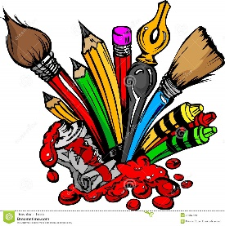
- Match the words to the correct definition.

- bleak

- cluttered

- evocative

- exotic

- flawless

- gritty

- humorous

- iconic

- ironic

- meaningful

- nonsensical

- observant

- playful

- powerful

- raw

- well-composed

____ 1. Interesting, strange or funny because it’s very different from what one expects.
____ 2. Popular; being considered to represent particular opinions or a particular period of time.
____ 3. When the people or things have been arranged well to look good in painting or photograph.
____ 4. Having a great effect.
____ 5. Having a purpose.
____ 6. Showing all the unpleasant, but true details of a situation.
____ 7. Frank and realistic in showing unpleasant facts or situations.
____ 8. Funny and not serious.
____ 9. Too many objects in a small space, usually untidied.
____ 10. Dreary; charmless and inhospitable.
____ 11. Making you laugh.
____ 12. Bringing strong images or feelings to mind.
____ 13. Unusual and exciting because it comes from far away.
_____14. Good or quick at noticing details.
_____ 15. Unintelligible; not reasonable.
_____ 16. Perfect.

- Complete these sentences with the correct words.

alluring carved dazzling easels etch gilt-edged mesmerized pride of place precious priceless showcase still-life
- The artist prefers _______________________ paintings to landscapes.
- The craftswoman _______________________ her initials on the wooden board.
- Venetian artists _____________________ patterns on glass.
- The football team had all its trophies in the _______________________.
- Their children’s photo was given __________________ on the mantelpiece.
- The art students set up their ___________________ on the street and started to paint the buildings in the square.
- The thieves stole __________________ objects from the British Museum.
- This ___________________ Chinese vase is valued at half a million euros.
- My husband has an ______________________ smile in this photo.
- The sunlight was _________________________ that fine, summer morning.
- The Baroque painting had a ________________________ frame.
- We were all ________________________ by her performance last night.

C. Complete these sentences with the correct phrase.
-a sight for sore eyes - turn a blind eye to (something or someone)
- cack-handed - outdo (something or someone)
- back to the drawing board

- Don’t ever put the dishes away again! You are _____________________.
- Sue can ___________ her brother any day.
- The committee rejected our proposal, so it’s ____________________ again.
- Matisse’s paintings are ________________________.
- How can the goverment ________________________all the homeless people in our city?

Vocabulary related to art 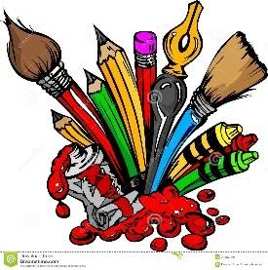
Answer key:
A.
1.i 2. h 3. p 4. n 5. j 6. f 7. o 8. m 9. b 10. a 11. g 12. c 13. d 14. l 15. k 16. e

B.
1. still-life 2. carved 3. etch 4. showcase 5. pride of place 6. easels 7. priceless 8. precious 9. alluriing 10. dazzling 11. gilt-edged 12. Mesmerized

C.
1. cack-handed
2. outdo
3. back to the drawing board
4. a sight for sore eyes
5. turn a blind eye to

