LEAD IN

1) (pre-listening, activation)
You have probably heard this famous quote before:

There are three kinds of lies: lies, damned lies, and statistics

What do you think it means? In pairs, discuss its possible meaning, and how much you agree or disagree with it. Can you think of examples that show it to be true/false? How important do you think basic numeracy is? Do you include in it some knowledge of statistics?

How to spot a misleading graph - Lea Gaslowitz

https://www.youtube.com/watch?v=E91bGT9BjYk

2) (While listening, listening for gist) Watch and listen to this video about how graphs can be manipulated to create false impressions. During the first run, just try to understand what the video is talking about.
In the second run, take some notes and try to explain the different ways which are explained in the video for making a misleading graph.
When you are ready, put those notes in common with your classmates'. Each of you has to individually explain to the class one of the 'tricks' you have learned about.

3) (While listening, listening for detail) We will access the TED-ED worksheet available online:

https://ed.ted.com/lessons/how-to-spot-a-misleading-graph-lea-gaslowitz#review

Using kahoot, we shall listen one last time to the recording and do the multiple choice and open answer questions.

4) (post-listening, production) We continue with the two other activities in the worksheet: Dig Deeper and Discuss. In the first one, we will study some graphs; in the second one, discuss (in groups) the following question:

Should misleading graphs be put in the same category as “fake news"? What is your opinion? Why is it essential that people be wary of this and seek out reliable and relevant sources?

5) (While listening, listening for detail) Watch and listen to the following video:

How statistics can be misleading - Mark Liddell

https://www.youtube.com/watch?v=sxYrzzy3cq8

Check if the following statements are true or false. In both cases, explain why the statements are so.

5.1) The problem with using statistics for decision making is that they all contain 'lurkers'.
5.2) Hospital A is a better overall choice than hospital B.

5.3) Hospital B is only a better choice if you are very sick to begin with.

5.4) Simpson's paradox overall does not take place in the real world.

5.5) In the tobacco test, non smokers were on average older than smokers.

5.6) Florida death sentences are mostly unfair from a racial perspective.

5.7) There are only some proper ways of dividing and classifying data.

6) (Follow-up)

For our next session, find a misleading statistical chart / graph / pie / table and bring it to class. After we give it a look, we'll try to guess what is the issue, and you will explain it to us afterwards.

7) (and a little bit of fun)

"Lurker" is an interesting word (and a nice wikipedia entry! Check it out!), and also used as a verb (check https://www.merriam webster.com/dictionary/lurk). Check this song (https://www.youtube.com/watch?v=pRsK_bGhbR4) which includes very good vocabulary and expressions. Make a little list with some of these and their meaning. Can you make out whatthe song is about ?

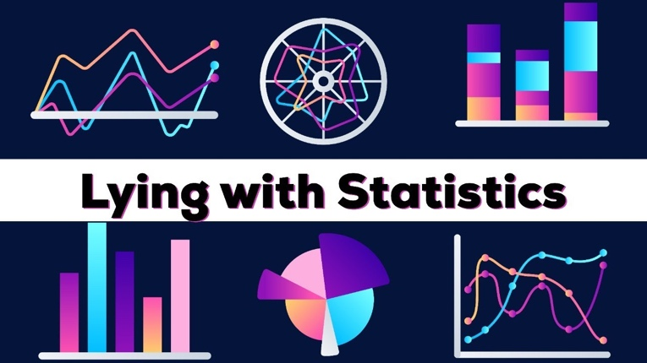

KEY

1) Student's answers
2) In a bar graph, manipulate the y axis by using a very small scale, which will make small differences seem huge when compared to bar size. / Ditto for the x axis, especially in line graphs showing change over time. / Choosing a specific time frame, excluding from before significant events, or specific points, hiding things happening in between them / Leaving out important data (similar to the previous one, but in this case, things like hidden variables) / Presenting a graph that is 'sincere' but where the consequences do not appear clearly (like the warming of seas; 1st graph makes it appear 'small' but the terrible consequences are better reflected in the 2nd graph).
3) Answers online, while doing the quiz
4) Student's anwers
5) 5.1) F 5.2) F 5.3) F 5.4) F 5.5) T 5.6) T 5.7) F
6,7) Student's answers

