Antarctica: the world’s last great wilderness
Look at the chart below. What information does it provide? What does it tell you about the importance of the peninsula?
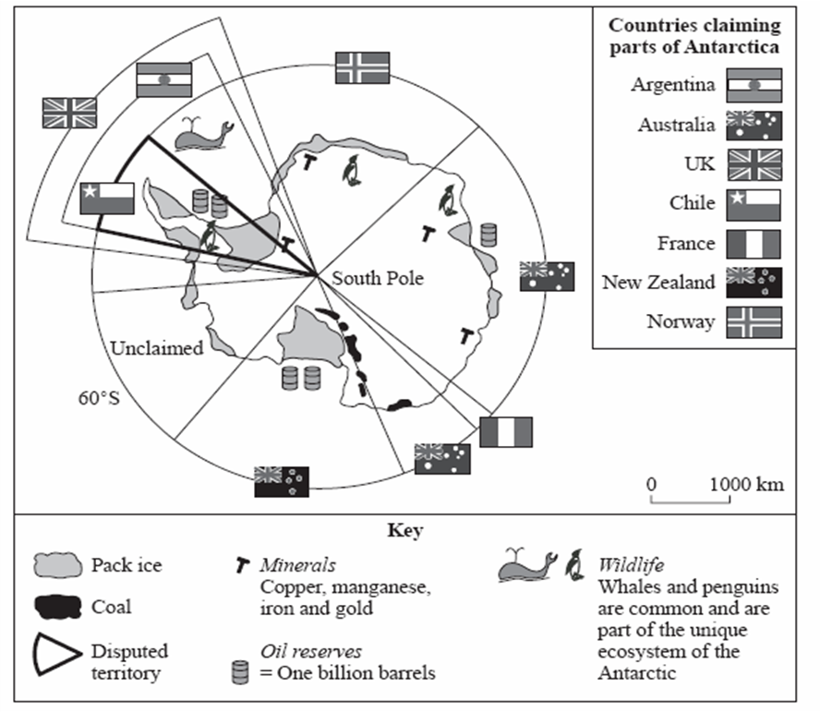
Work with a partner to complete the table entitled “How Might Tourists Impact the Antarctic Environment and Wildlife?”

Now listen to two videos about tourism in Antarctica and take notes. After watching, go back to the table and add any new information you have learned.
Scientists try to minimize impact of tourism on Antarctica | CGTN
https://www.youtube.com/watch?v=w_86FbnOyJU
Watch the video and take notes. Focus on the impacts of tourism on the area.
Vocabulary: pristine; disturb the habitat; combat; assessed; mutually beneficial; put a cap on sth; (government) oversight; surge

Antarctica tourism growing steadily, posing potential ecological threat | Al Jazeera English
https://www.youtube.com/watch?v=Ubvv20FovPk
Watch the video and take notes. Focus on the impacts of tourism on the area.
Vocabulary: pristine; straightforward; swell; gusting; mission aborted; moulting; krill fishing; pace of change; loom on the horizon

Tourists help Antarctica climate change research | CBS This Morning
https://www.youtube.com/watch?v=NhDw2q2hNcY
Watch the video and take notes. Focus on how tourism can help the area.
Vocabulary: subsidize; (a trip for the) intrepid; off the beaten track; paying big bucks; budget cuts; welfare; detrimental (effect); a marriage made in heaven

Now with the help of the Visitor Guidelines, complete the table “What measures can be taken to reduce the environmental impacts on Antarctica?”

You will now write a report about tourism in the Antarctic. You can use the information you have read or listened to to help you.

Further reading and listening:
- From our own correspondent: Antarctica and India https://www.bbc.co.uk/sounds/play/p016tld5
- Antarctica on the edge - earthrise: https://www.youtube.com/watch?v=Ubvv20FovPk
- http://www.natgeotraveller.co.uk/destinations/antarctica/tourism-in-antarctica/
- http://www.coolgeography.co.uk/GCSE/AQA/Tourism/Extreme%20Environments/Extreme%20Impacts.htm
- https://www.nationalgeographic.com/search?q=antarctic+
- https://www.asoc.org/explore/for-teachers
- https://www.bbc.com/news/magazine-30709924
- https://www.bbc.co.uk/sounds/play/p016tld5
- http://www.bbc.co.uk/learningenglish/thai/features/6-minute-english/ep-150212
- https://www.nationalgeographic.com/expeditions/destinations/polar/ocean/antarctica-cruise/

