WRITTEN MEDIATION

TOPIC: HOUSE PRICES

You receive this chart with the results of a survey of house prices:

Salaries and House Prices in the UK
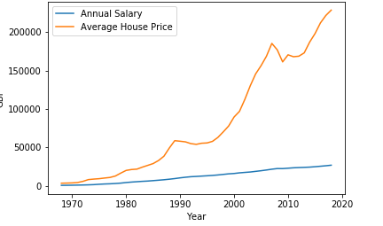
TASK 2. MEDIATION ....../12,5 points
You have approximately 20 minutes to complete this task.
You have been asked to write a summary of the latest results of the survey.
You must write about the following points:
- Explain the results of the survey.
- Highlight the most important findings.
Write between 60 and 70 words.

TASK 3. PRODUCTION ....../12,5 points
You have approximately 45 minutes to complete this task.
You are concerned about the lack of affordable housing in your area and decide to submit an article to a local magazine to raise awareness among the readership.

You must write about the following points:
- Describe the problem as you see it and identify the negative consequences it causes.
- Suggest possible measures to solve or reduce the problem.

Write between 180 and 210 words.

