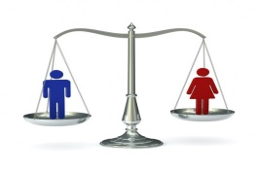
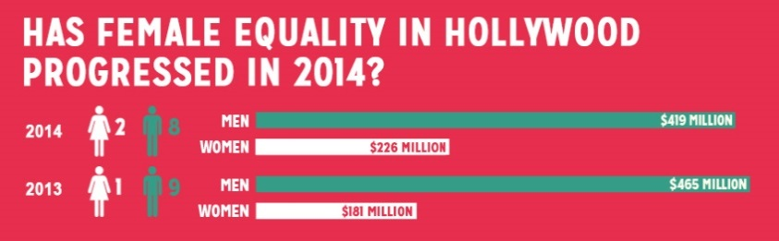
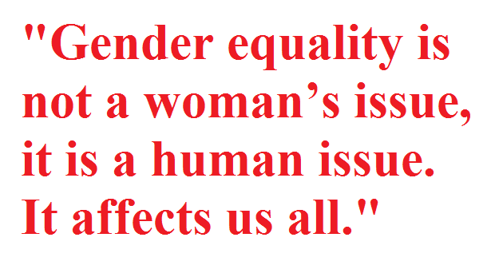
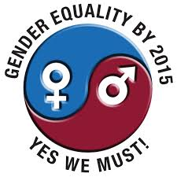
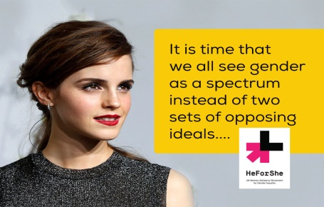
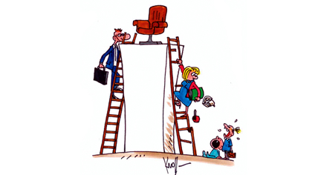

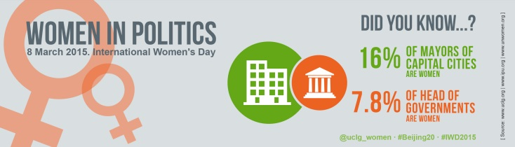
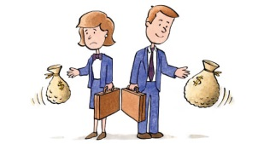

Gender inequality in Hollywood - recent events have forced the issue of disparity in pay between female and male actors into view. As the Sony hack revealed, Jennifer Lawrence—the second highest paid actress of 2014—alongside her co-star Amy Adams, both received lower amounts of the back-end of American Hustle than their male counter-parts.
In addition, two-time Oscar winner Hilary Swank also recently made headlines with her comments regarding the pay gap in Hollywood. According to Swank, “My male counterpart will get paid 10 times more than me—10 times. Not double, but 10 times for the same job.”
https://www.nyfa.edu/nyfa-news/has-female-equality-in-hollywood-progressed-in-2014
4. How do you explain this gap in pay level?
5. Is this the only field where this can happen? Do you know other similar examples?
6. What do you think should be done to reduce the salary gap?
7. What would you do if you were in Swank’s place?
8. Can an employer discriminate against you because of your sex?

Gender equality is a human right. Women are entitled to live with dignity and with freedom from want and from fear. Gender equality is also a precondition for advancing development and reducing poverty: Empowered women contribute to the health and productivity of whole families and communities, and they improve prospects for the next generation.
1. Have you ever discriminated against or felt discriminated because of your gender?

Despite many international agreements affirming their human rights, women are still much more likely than men to be poor and illiterate. They have less access to property ownership, credit, training and employment. They are far less likely than men to be politically active and far more likely to be victims of domestic violence.
2. Do women and men have the same rights and opportunities in your country? Give examples that prove it.
3. Do you know places where this doesn’t happen? Give examples.

Gender equality will be achieved only when women and men enjoy the same opportunities, rights and obligations in all spheres of life. This means sharing equally in the distribution of power and influence, and having equal opportunities for financial independence, education and realizing their personal ambitions.
9. At home do you share the chores with your spouse? Give examples.
10. Did your parents allow you the same things as a sibling of the opposite sex?

The ability of women to control their own fertility is fundamental to women’s empowerment and equality. When a woman can plan her family, she can plan the rest of her life. Protecting and promoting her reproductive rights – including the right to decide the number, timing and spacing of her children – is essential to ensuring her freedom to participate more fully and equally in society.

11. Do women and men have access to sexual education and contraceptive methods in your country? Are these free or do they have to pay for them?

About two thirds of the world’s illiterate adults are women. Lack of an education severely restricts a woman’s access to information and opportunities. Conversely, increasing women’s and girls’ educational attainment benefits both individuals and future generations. Higher levels of women's education are strongly associated with lower infant mortality and lower fertility, as well as better outcomes for their children.
12. Do you know examples of ethnic groups or countries that don’t let girls go to school?
13. Why does that happen?
14. In your opinion which can be the benefits of having access to education?

15.Comment these two quotes.

Debate:Gender Equality

Source:http://www.unfpa.org/gender-eq

VOCABULARY:
- Find these words in context and take turns trying to define them with a partner.

- empowered women
- pay gap / salary gap
- male counterpart
- access to ownership
- victims of domestic violence
- politically active
- women empowerment and equality
- reproductive rights
- ensure freedom
- restrict a woman’s access to information

- Think about 4 or 5 questions suggested in the debate and be prepared to give your take on it.

Adapted from:isl collectives

