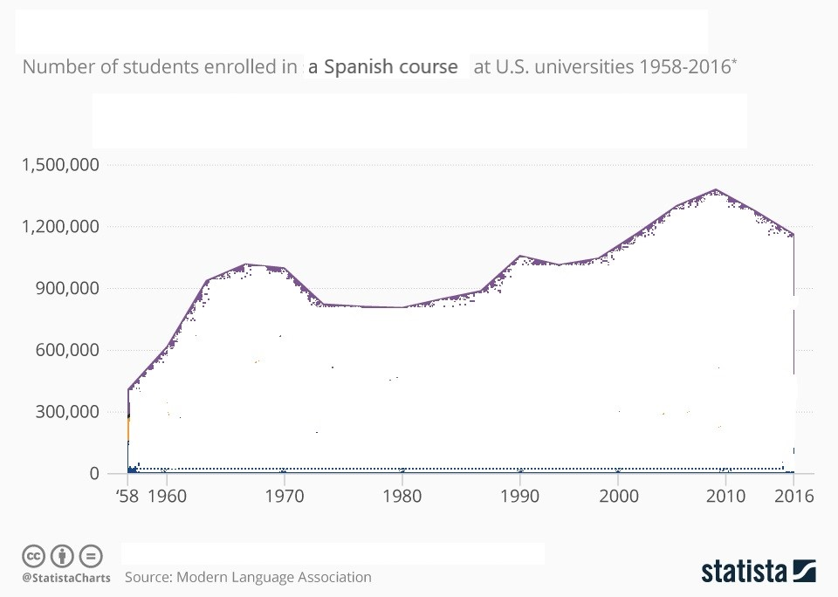

Written Mediation
You work for Instituto Cervantes in the USA and have been asked to write a summary of the results shown in the graph above.

You must write about the two points below:
- explain, in your own words, the data in the graph
- highlight the most important findings

Write between 60 and 70 words.

