TASK 1: MONOLOGUE (PRODUCIÓN E MEDIACIÓN DE TEXTOS ORAIS)
TOPIC: SAVING MONEY
Your classmate has told you that s/he would like to save money.
You found this poster online.
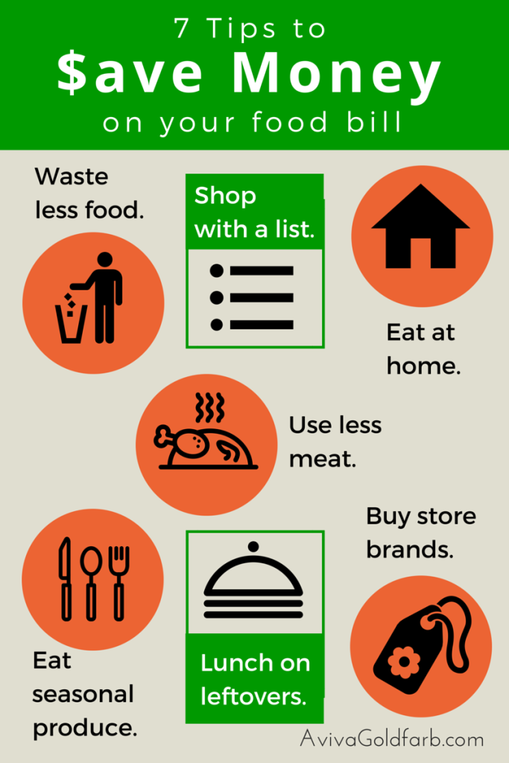
In a conversation with your classmate about saving money, you decide to tell him/her about the poster and the tips you found.
MEDIATION (2 minutes max.):
- Tell your mate about 3 of the tips.
- Explain the tips you chose and the reasons why.
PRODUCTION (3 minutes max.):
- Say which tip is the most useful and why.
- Tell what you do to save money.

