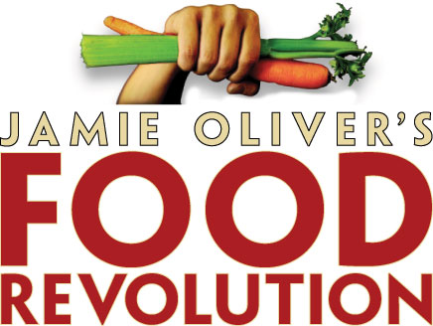

- Watch the trailer for the TV show “Jamie Oliver’s Food Revolution” (https://www.youtube.com/watch?v=oLgmk323H6k)
What do you think about the video?
Compare the situation in Spain to what you have just seen in the video. What are the differences, and are there any similarities?

- Watch again and answer the following questions!

- What are the problems of the people of the City of Huntington, West Virginia?

- What is Jamie Oliver’s mission in Huntington?

- What does Jamie Oliver find out when he gives an interview to a local radio station?

- What are the primary school students given for breakfast?

- What happens when Jamie Oliver shows some tomatoes to the primary school students?

- What does Jamie Oliver show the school kids and employees to convince them that they need to change their eating habits?

ANSWER KEY:

- What are the problems of the people of the City of Huntington, West Virginia?

It’s the unhealthiest city of America: 50% adults are considered obese, incidents of diabetes and heart disease lead the nation

- What is Jamie Oliver’s mission in Huntington?

To inspire and show America that just a little effort can make a massive difference.

- What does Jamie Oliver find out when he gives an interview to a local radio station?

They don’t want to sit around and eat lettuce all day. They don’t think he can change the town.

- What are the primary school students given for breakfast?

Pizza.

- What happens when Jamie Oliver shows some tomatoes to the primary school students?

They think they are potatoes.

- What does Jamie Oliver show the school kids and employees to convince them that they need to change their eating habits?
He shows them the fat consumed by the entire school in one year.

