CANDIDATE A

TOPIC: WORK
Preparation time for both tasks: 3 minutes

Candidate B is stressed about finding a job online. You have a leaflet with advice on effective job searching.



TASK: MEDIATION …../12.5
Speaking time: 1- 2 minutes max. Talk about the following points:
- Tell Candidate B about three of the tips from the leaflet that you think will be helpful.
- Explain these tips to your partner.

TASK 1: PRODUCTION …../12.5
Speaking time: 2- 3 minutes max. Talk about the following points:
- Give your opinion on finding jobs online.
- Describe your experience: (websites or apps you use, difficulties you face, what makes a good candidate.

CANDIDATE B

TOPIC: WORK
Preparation time for both tasks: 3 minutes

Candidate A is finding it difficult to stay productive while working from home. You have a leaflet with advice on managing remote work.

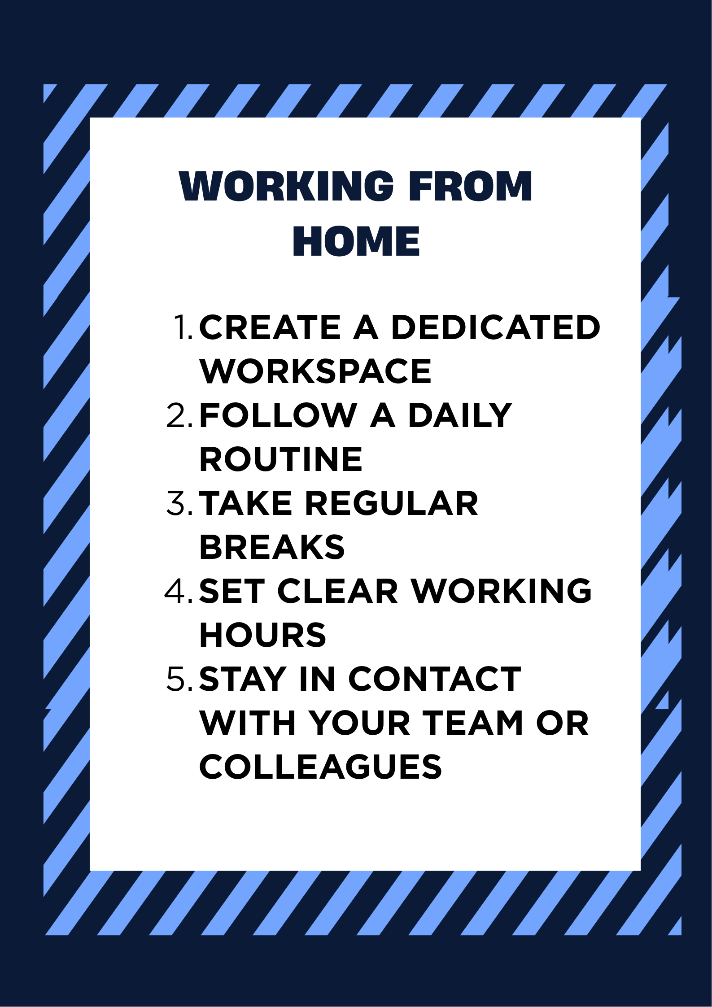

TASK: MEDIATION …../12.5
Speaking time: 1- 2 minutes max. Talk about the following points:
- Tell Candidate A about three of the tips from the leaflet that you think will be helpful.
- Explain these tips to your partner.

TASK 1: PRODUCTION …../12.5
Speaking time: 2- 3 minutes max. Talk about the following points:
- Give your opinion on working from home.
- Describe your experience: your routine, tools you use and challenges you face.

