CANDIDATE A

TOPIC: TRAVELLING
Preparation time for both tasks: 3 minutes

Candidate B is worried about staying safe while travelling using technology. You have a leaflet with tips on safe digital travel habits.

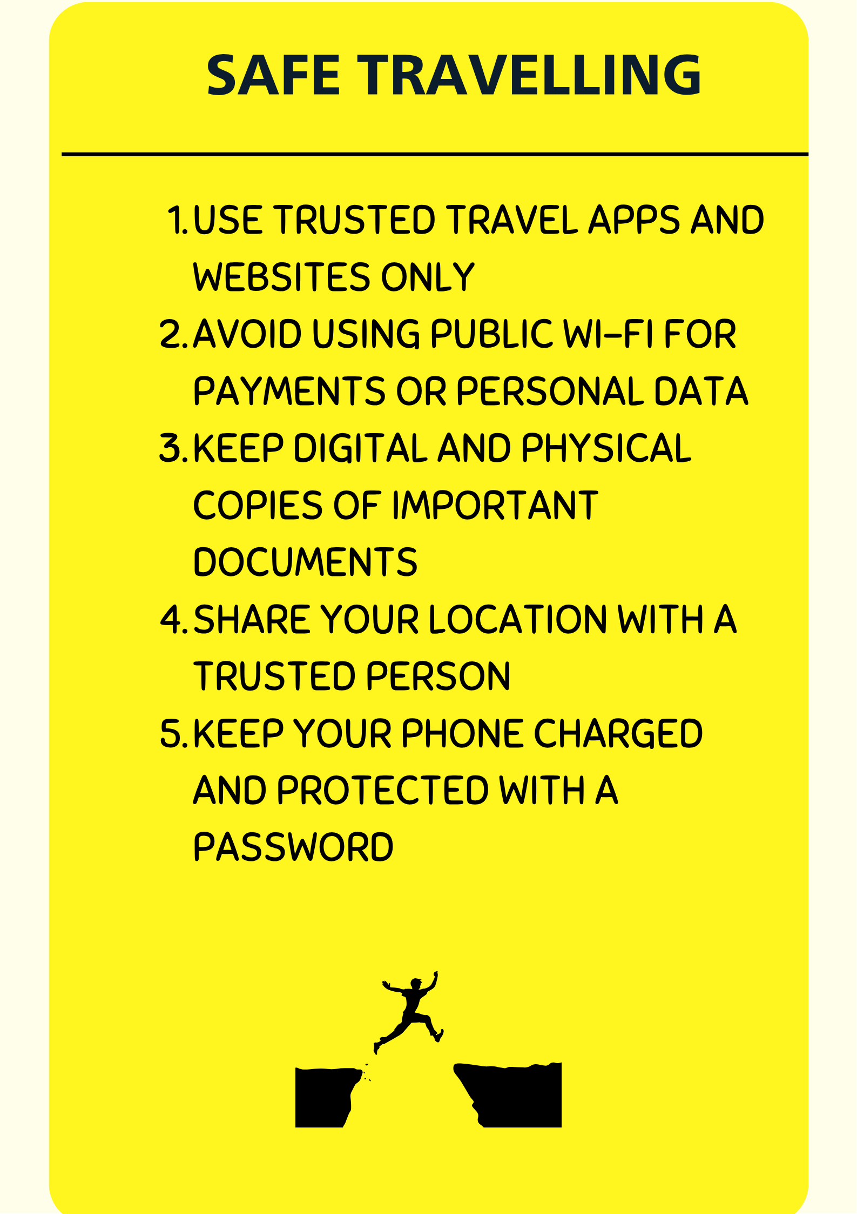

TASK: MEDIATION …../12.5
Speaking time: 1- 2 minutes max. Talk about the following points:
- Tell Candidate B about three of the tips from the leaflet that you think will be helpful.
- Explain these tips to your partner.

TASK 1: PRODUCTION …../12.5
Speaking time: 2- 3 minutes max. Talk about the following points:
- Give your opinion on the importance of using technology for safe travelling.
- Describe your current habits (apps you use, how you stay safe, any problems you have experienced).

CANDIDATE B

TOPIC: EDUCATION
Preparation time for both tasks: 3 minutes

Candidate A feels overwhelmed by too many online learning options. You have a leaflet explaining how to choose and use them effectively.

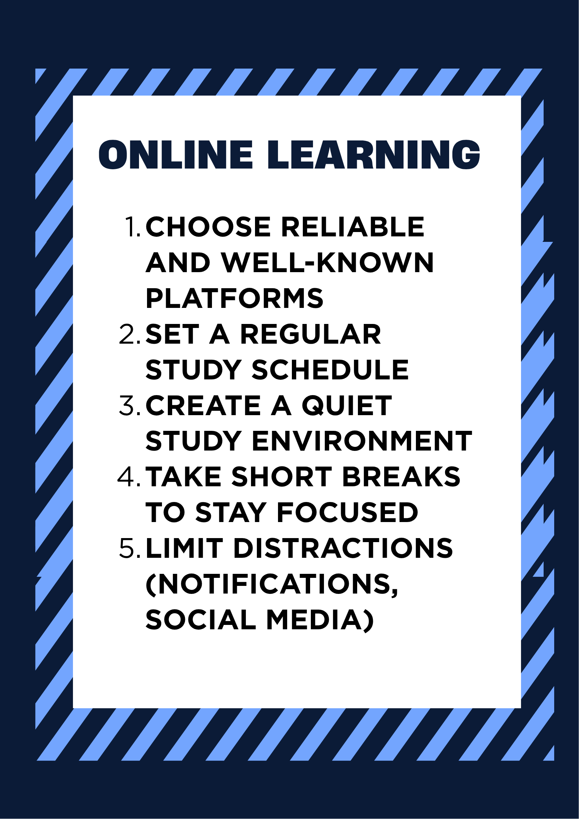

TASK: MEDIATION …../12.5
Speaking time: 1- 2 minutes max. Talk about the following points:
- Tell Candidate A about three of the tips from the leaflet that you think will be helpful.
- Explain these tips to your partner.

TASK 1: PRODUCTION …../12.5
Speaking time: 2- 3 minutes max. Talk about the following points:
- Give your opinion on online learning.
- Describe your experience: platforms you use, advantages and disadvantages and how you stay motivated.

