Preparation time: 1 minute
Speaking time: 4-5 minutes

TOPIC: SHOPPING

You and the other candidate want to illustrate an online article you are writing about the best shopping method.

Talk about the meaning of each of your three photographs and choose one to use for your article. Try to reach an agreement.

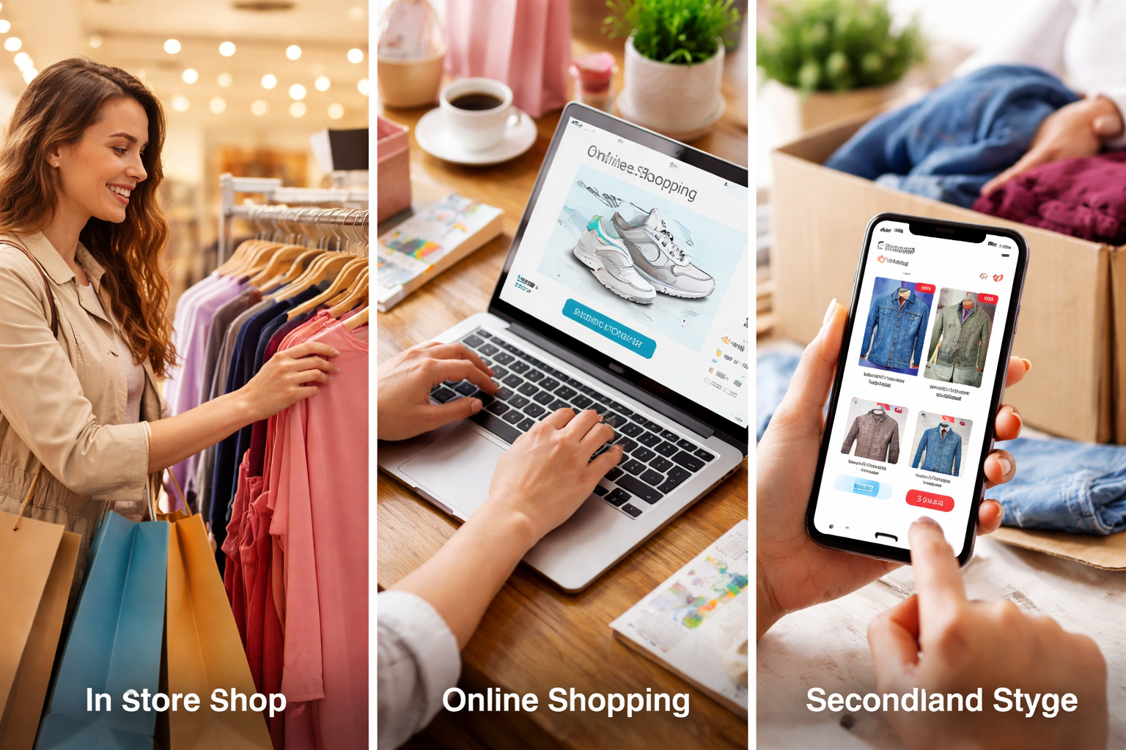
Discuss each option (Bizum, card, cash) considering:
- Convenience (Is it easy to use?)
- Safety (Is it secure?)
- Speed (Is it fast?)
- Popularity (Do people use it a lot?)
- Situations (When is it useful?)

Here’s a useful B2-level vocabulary list for talking about paying by card, Bizum, or cash in English:

💳 Paying by Card
- to pay by card
- credit card / debit card
- to insert / tap / swipe the card
- contactless payment
- PIN (Personal Identification Number)
- to enter your PIN
- card reader / card machine
- transaction
- receipt
- to be declined (e.g. “My card was declined”)
👉 Example:
“I usually pay by card because it’s quick and convenient.”

📱 Paying with Bizum (or mobile payments)
(You can say “Bizum” or more generally “mobile payment”)
- to pay with Bizum
- to send / receive money
- to transfer money instantly
- mobile payment
- banking app
- QR code
- phone number linked to an account
- to split the bill
👉 Example:
“I prefer paying with Bizum when I need to send money to friends.”

💵 Paying in Cash
- to pay in cash
- coins / notes (UK) / bills (US)
- change (money you get back)
- exact amount
- wallet
- cash machine / ATM
- to withdraw money
👉 Example:
“I sometimes pay in cash in small shops

