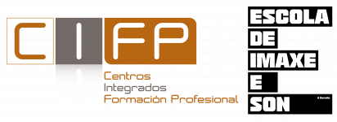



Dear Sir/Madam,

I am writing from A Coruña, Spain, on behalf of the students and staff of CIFP Imaxe e son. My name is Carlos Luis Oro Claro, currently coordinator for international programmes.

CIFP Imaxe e son is a regional government-owned public school that offers short cycle third level education on technical and occupational specific programmes leading to professional qualifications which prepare our students for labour market entry.

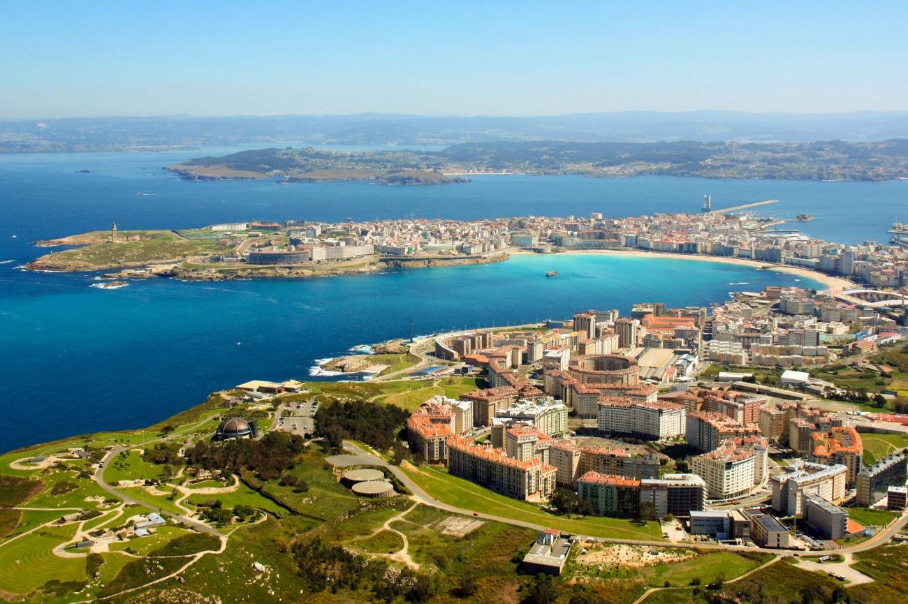
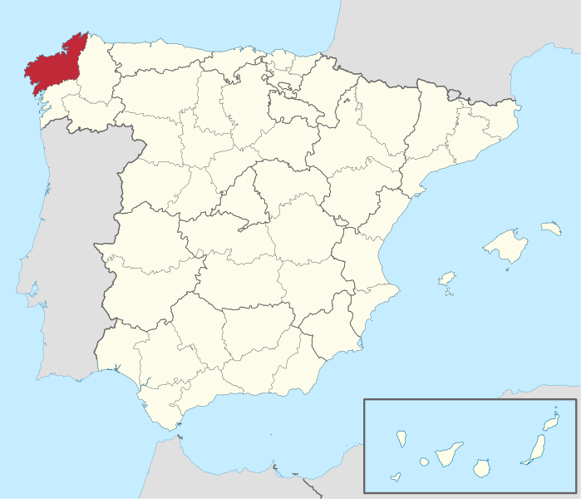
A Coruña (Spain) | CIFP Imaxe e son
https://www.coruna.gal/ | https://cifp.eis.gal/

We are currently looking for equally interested european partners in Erasmus + mobility projects to collaborate with us. Our main aim is to establish contacts with as many european companies linked to the production of audiovisual, scenic and musical projects as we can in which some of our best students could complete their training process.

We are a relatively small school of about 35 teachers and 550 students, approximately. Besides regular vocational education, our school also provides specific vocational courses for unemployed and active workers in the audiovisual sector, as well as official identification, assessment and recognition of professional qualifications, plus dual education integration in vocational training.
All vocational diplomas our school awards are in accordance with Spanish national legislation. The studies leading to this diplomas include a total of 2000 hours of training, of which 384, distributed along 10 weeks, are to be completed as internship experience in a company, and only once the students have succesfully passed all other subjects. Our diplomas are listed below.

The training level our students achieve corresponds to level 5 of ISCED (International Standard Classification of education)

DIPLOMA | Europass  Diploma Suplement
► Higher Technician in Audiovisual and Show Production | Link
► Higher Technician in Production of Audiovisual Projects and Shows | Link
► Higher Technician in 3D Animations, Games and Interactive Environments | Link
► Higher Technician in Sound for Audiovisual Productions and Shows | Link
► Higher Technician in Lighting, Capture and Processing of Images | Link

What's my proposal?

This academic year, from April 1st to May 31st, Catalina Lema van Niekerk a student of Higher Technician in Production of Audiovisual Projects and Shows and Cristina Fan Ye Lin a student of Higher Technician in Audiovisual and Show Production has applied to complete her training in an Italian company. After a selection process in the school, Catalina and Cristina has been granted an Erasmus + mobility scholarship, and now I am in the process of finding a company where them could complete their training with an internship and acquire her diploma. We would like that Catalina or Cristina to be able to do their internship period in your company.

Please, take into consideration that the Erasmus + scholarship fully finances the mobility of our students and furthermore, they are covered for civil liability and accident insurance as well as medical insurance for this period, both issued by our regional government. Students are beneficiaries of a grant and thus, do not receive payment.

Should you be interested to know more about Catalina or Cristina, I would gladly send you her CV and portfolio.

Thank you very much for your attention.

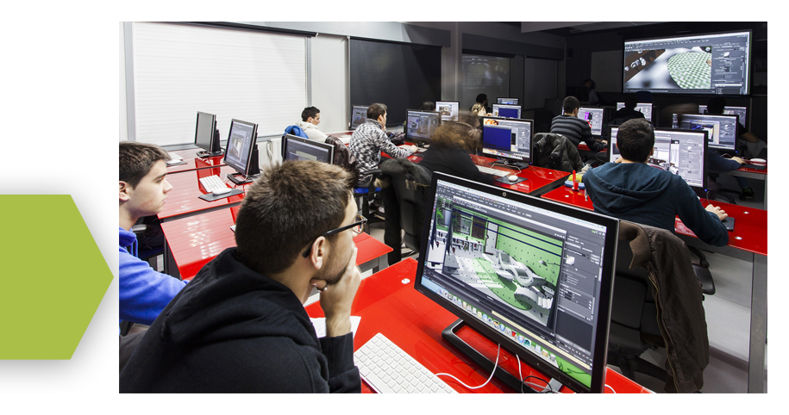
Yours sincerely,

Carlos Luis Oro Claro
International programmes coordinator
CIFP Imaxe e son
A Coruña. Spain
internacional@cifp.eis.gal
(+34) 981173181


