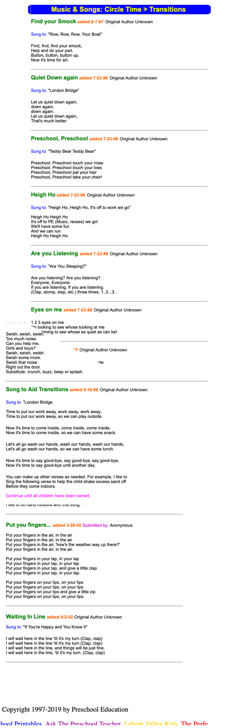

https://www.preschooleducation.com/stransition.shtml

