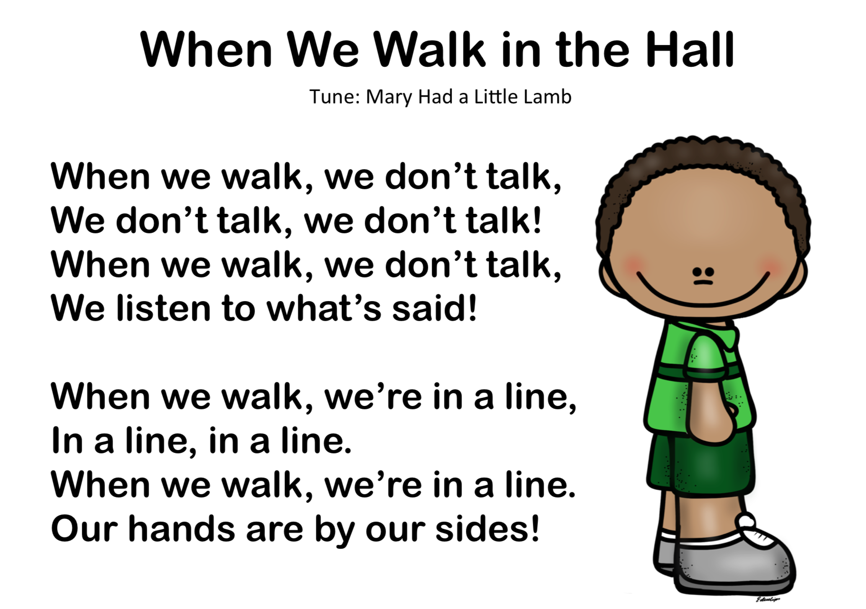

Canción: Mary had a little lamb. https://www.youtube.com/watch?v=ltxSXOYXPss

https://www.youtube.com/watch?v=J5yghPYFoQE

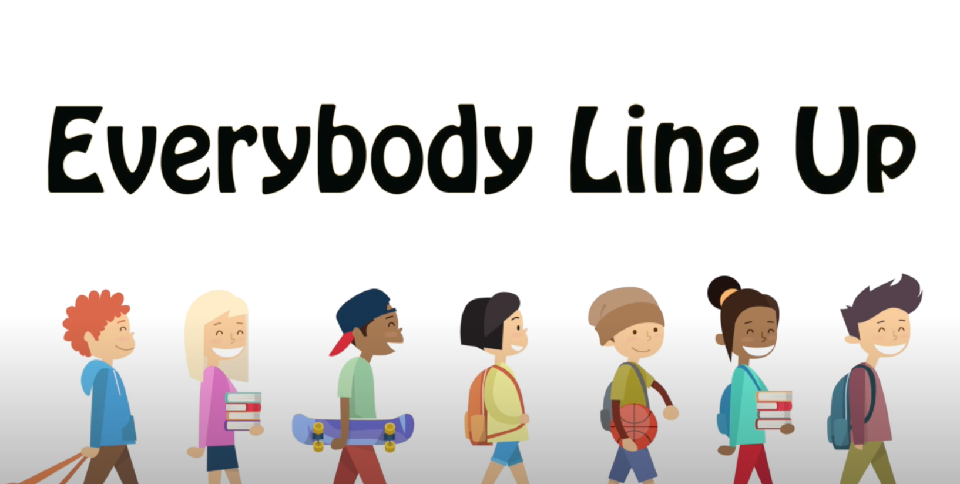

Everybody line up
Let's all get in line
Front, Middle, or the Back
Anywhere is fine
Quietly we stand
Keep our line so neat
Following the leader
Use your walking feet

https://www.youtube.com/watch?v=9rmH-dZ7NG4
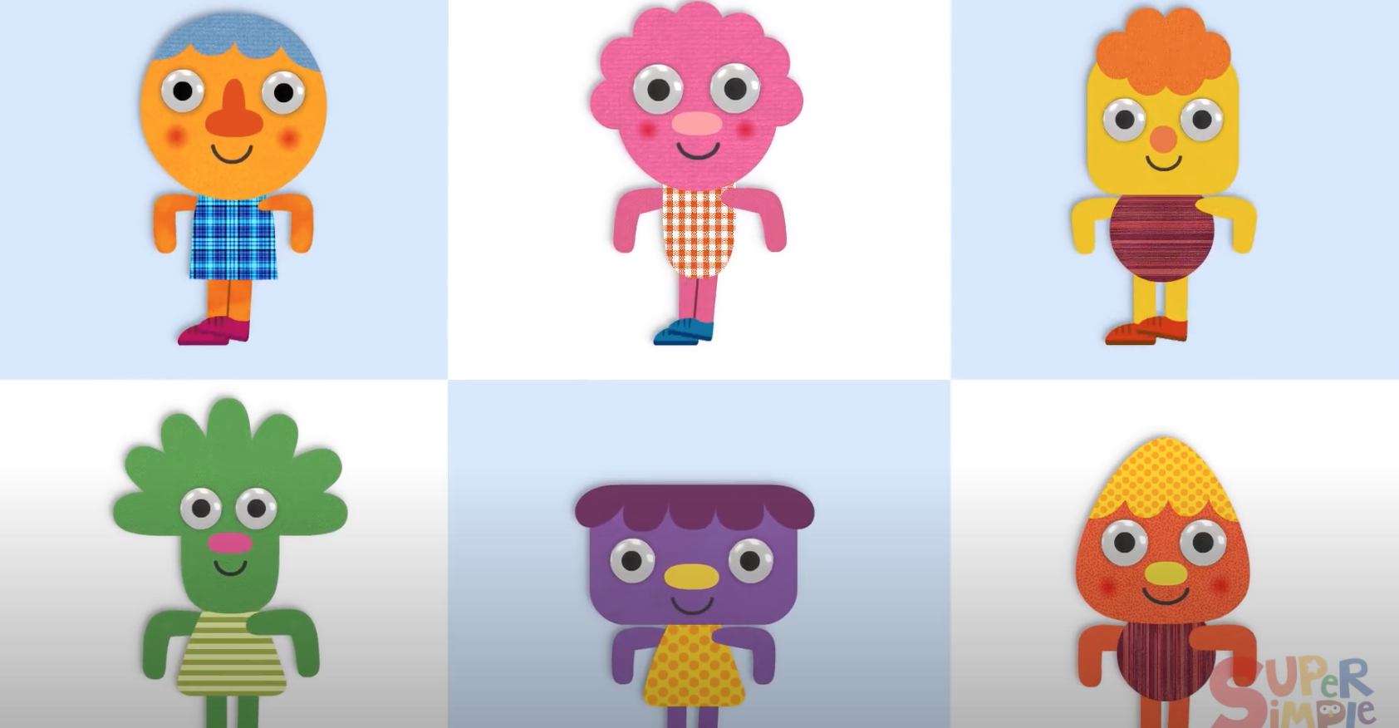

https://www.youtube.com/watch?v=yFrMF0ScN3Q
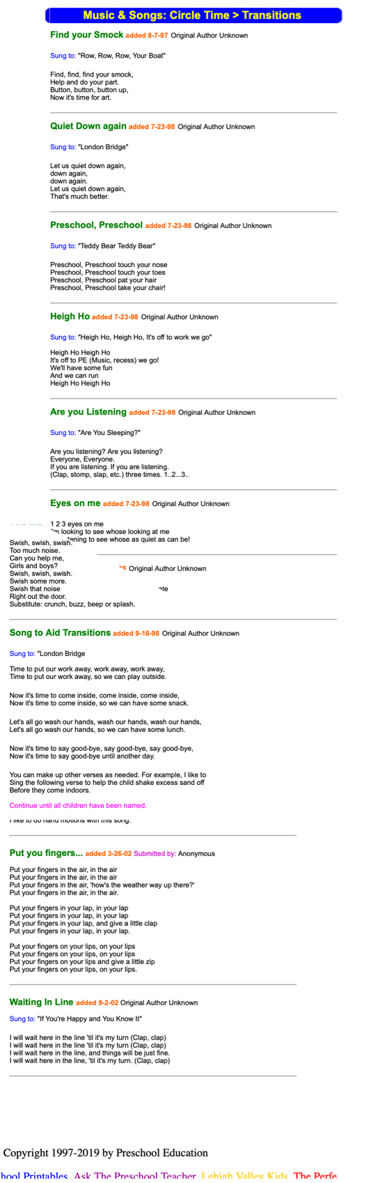

https://www.preschooleducation.com/stransition.shtml

