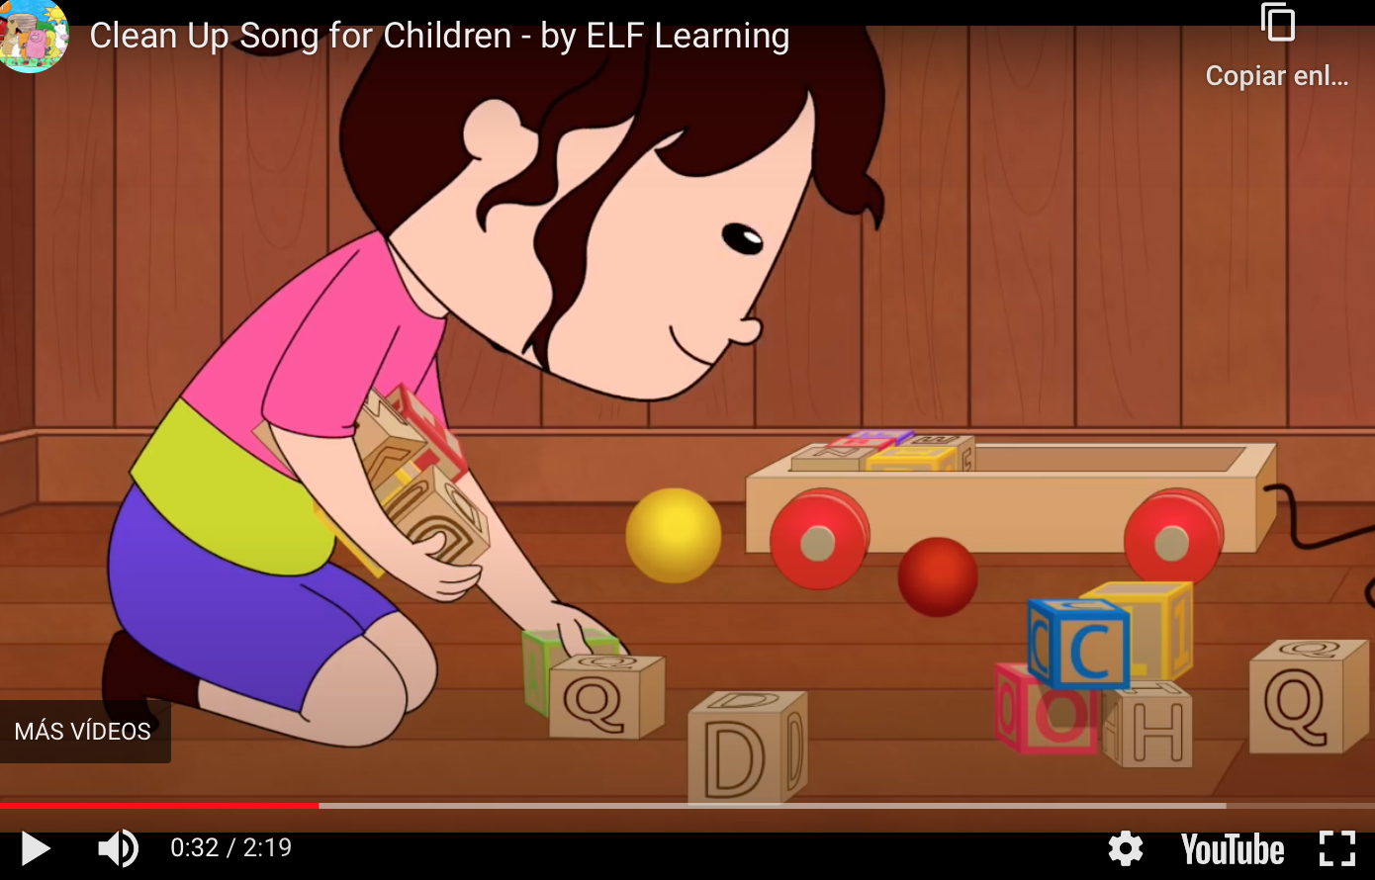

Clean up, everybody clean up, time to clean up
Pick up, everybody pick up, time to pick up
Pick up the toys, put them away, pick up the blocks, put them away
Pick up the books, put them away, put your things away.

https://www.youtube.com/watch?v=oY-H2WGThc8&feature=emb_logo

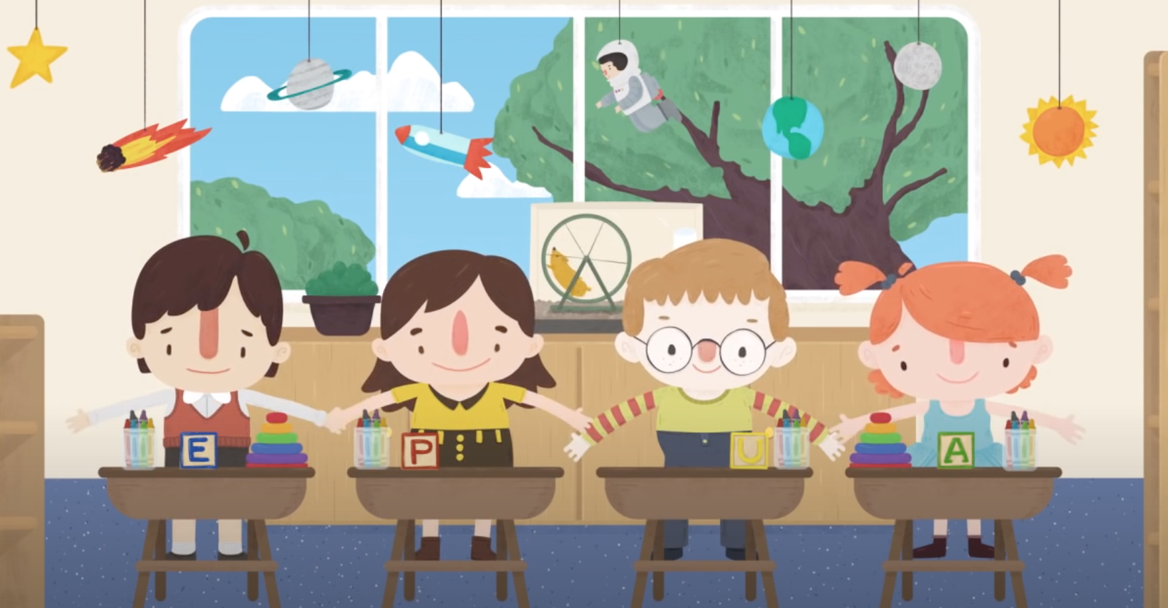

It's time to clean up (clap, clap)
It's time to clean up (clap, clap)
We had a lot of fun, and now that we're done
It's time to clean up (clap, clap)

It's time to clean up (clap, clap)
It's time to clean up (clap, clap)
Girls and boys, put away the toys (clap, clap)
It's time to clean up (clap, clap)

https://www.youtube.com/watch?v=ltJc9NolvaY

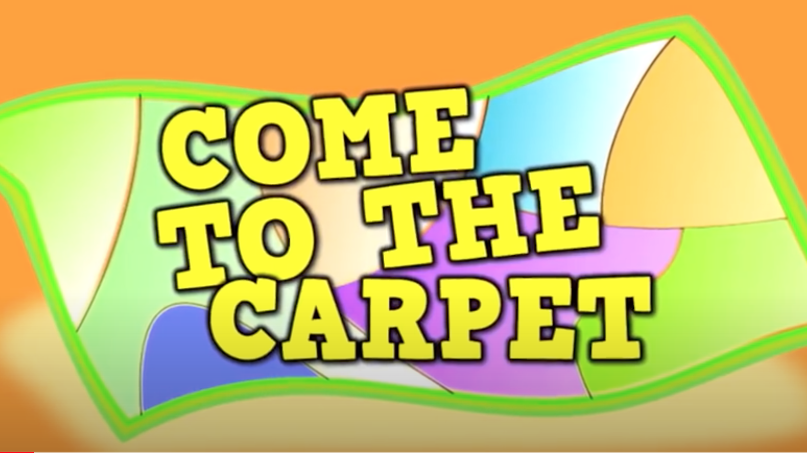

5 6, 7, 8
Come to the carpet
Use your walking feet
Come to the carpet
Moving to the beat
Come to the carpet
Careful not to shout
And don't forget that when you sit
to have a quiet mouth.

https://www.youtube.com/watch?v=N8jsofAj6SY&list=PLcpk5TCg3vzeRadbUxUl60pslFwaqCAiD

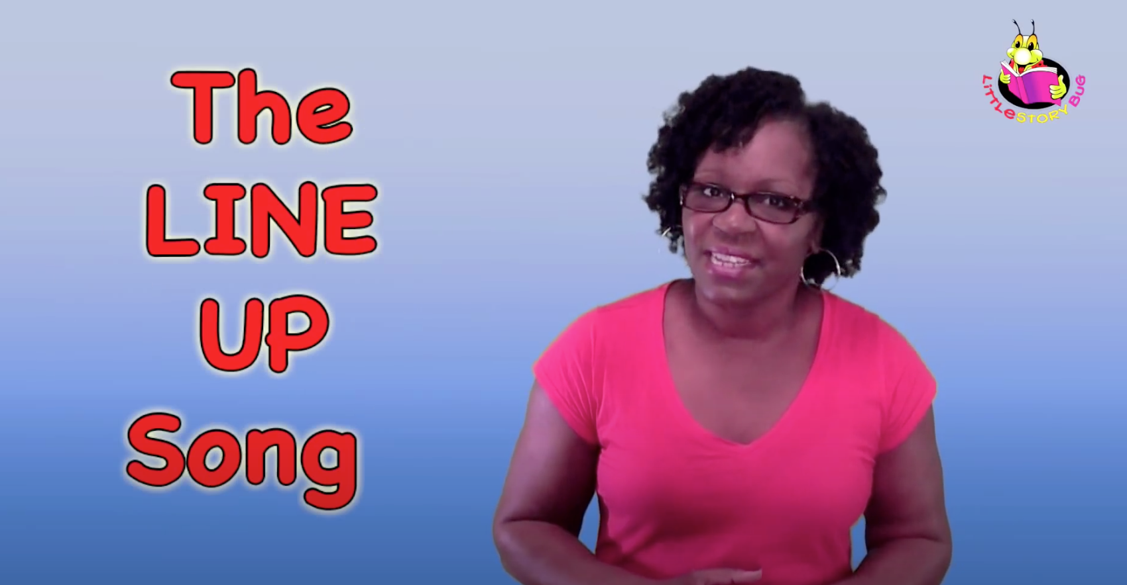

https://www.youtube.com/watch?v=76aSA-qNCpc
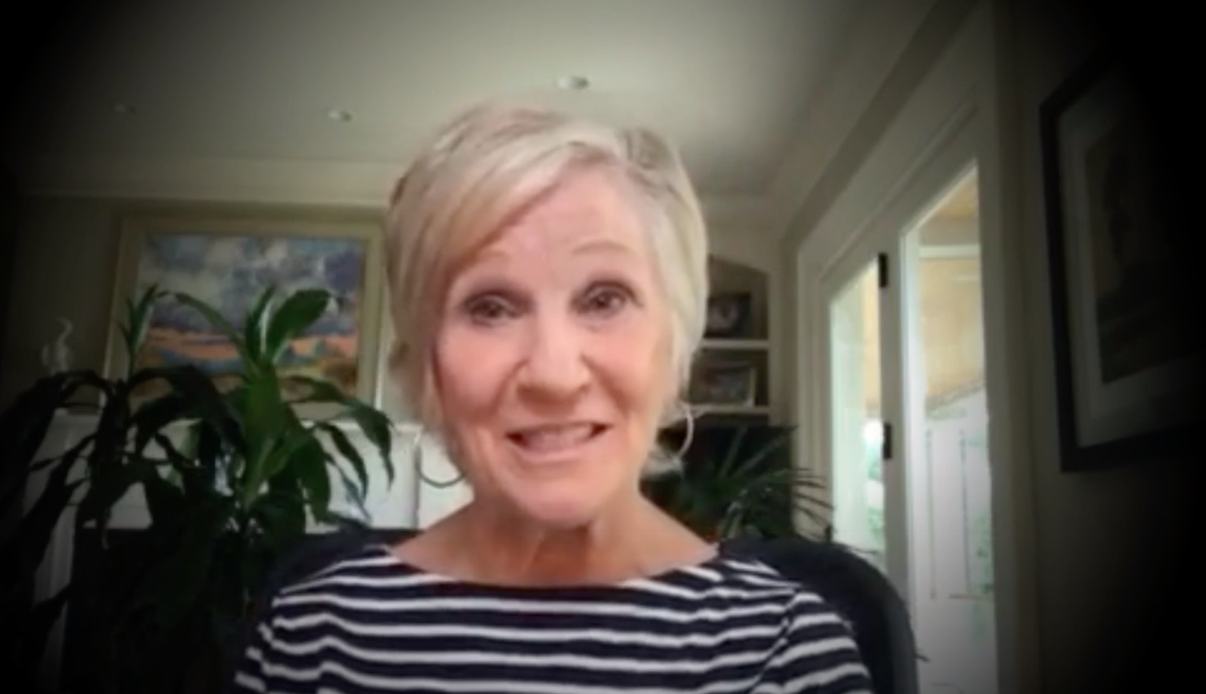

0:31-0:48

Everybody have a seat, have a seat, have a seat
Everybody have a seat on the floor
Not on the ceiling, not on the door
Everybody have a seat on the floor

...Not on the window, not in the air
Everybody have a seat io your chair

1:05-1:25

Put your bottom on the rug uhhuh, uhhuh
Put your bottom on the rug uhhuh uhhuh
Put your bottom on the rug uhhuh uhhuh
Give yourself a little hug
Honey Baby Mine

https://www.youtube.com/watch?v=ERQZVGJkX-c

Try out this transition song for cleaning up, set to “I’m a Little Teapot”:
(https://www.youtube.com/watch?v=mdu5lLpMH_w)
We’re all finished playing (or another activity)
Time to move,
Clean up our area,
Get in the groove!
When we are all cleaned up,
We will start,
Our next activity
And it is (name the activity)!
If you need preschoolers to sit down and pay attention, sing this song to the tune of “Twinkle Twinkle, Little Star”:ç
(https://www.youtube.com/watch?v=yCjJyiqpAuU)
Quiet fingers,
Quiet feet,
Quiet body,
Quiet seat.
Hands on tables, everyone,
So we can do something fun,
Quiet fingers,
Quiet feet,
Quiet body,
Quiet seat.
Another important transition activity is getting ready at home. Parents (and teachers) can try this song out when preschoolers need to get ready to leave, sung to the tune of “Itsy Bitsy Spider”:
(https://www.youtube.com/watch?v=w_lCi8U49mY)
It’s time for us to go now,
What do we need?
Coats on our back,
Shoes on our feet.
Lunch box and backpack (or other supplies they need)
All ready to go.
A hug and a kiss —
Now let’s hit the road!

