Going Outside

1 LOOK AT THE CLOCK
https://www.youtube.com/watch?v=mdu5lLpMH_w
I'm a little teapot

Instrumental
https://www.youtube.com/watch?v=CLPpQd_ASF0

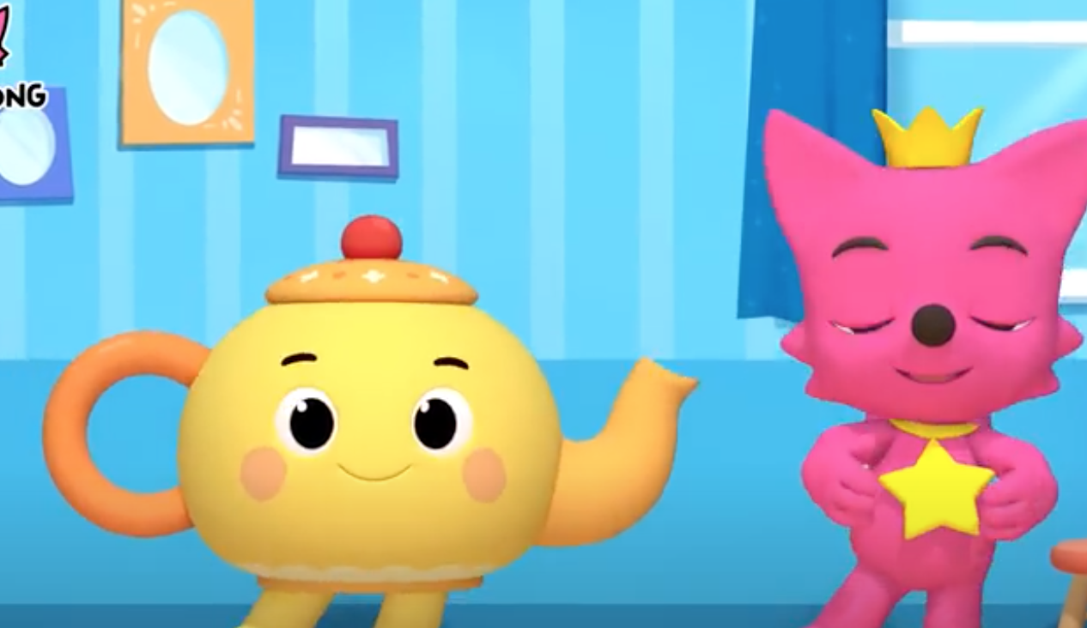

Look at the clock,
It's time to play!
Let's go. outside. It's a beautiful day.
When you get all lined up,
Here me say:
Open the doors, let's go and play!

2 LET'S GO OUTSIDE
https://www.youtube.com/watch?v=2rTZ9UndNeI
It's a Small World

Instrumental
https://www.youtube.com/watch?v=xZ56QLbKFHo



We are walking to the door.
We are walking to the door.
We are walking to the door.
It's time to play.

3 TIME TO GO
https://www.youtube.com/watch?v=3PgNPc-iFW8
Jingle Bells

Instrumental
https://www.youtube.com/watch?v=R1gskElaLNo



Time to go!
Tie to go!
Time to outside.
We line up at the door so nice,
So we can go outside!
Time to go!
Time to go!
Time to go outside!
We can't wait to play with friends,
Let's go to play outside!

Coming Inside

4 COME INSIDE
https://www.youtube.com/watch?v=lMOd8WADZZM
The Muffin Man

Instrumental
https://www.youtube.com/watch?v=X5zwZyC0fMc

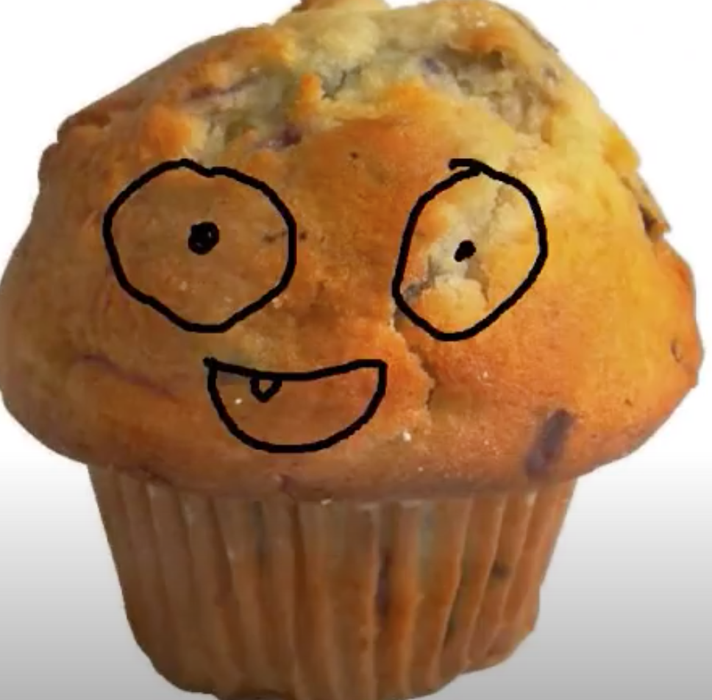

Do you know what time it is?
What time it is? What time it is?
Do you know what time it is?
It's time to go inside.

5 ARE YOU READY TO GO INSIDE?
https://www.youtube.com/watch?v=BSUjPAT4v2c
Finger Family Song

Instrumental
https://www.youtube.com/watch?v=L-lSzWl8JiY



Are you ready? Are you ready?
To come inside.
Yes I am. Yes I am.
My hands are by my side.
Are you ready? Are you ready?
To be silent.
Yes I am. Yes I am.
I'm being very quiet.
Are you ready? Are you ready?
To go to class.
Yes I am. Yes I am.
Outside time has passed.

6 IT'S TIME TO MAKE A LINE
https://www.youtube.com/watch?v=P6n0Y2RyeWE
Baa, baa Black Sheep

Instrumental
https://www.youtube.com/watch?v=UPeX9X5LAQ4

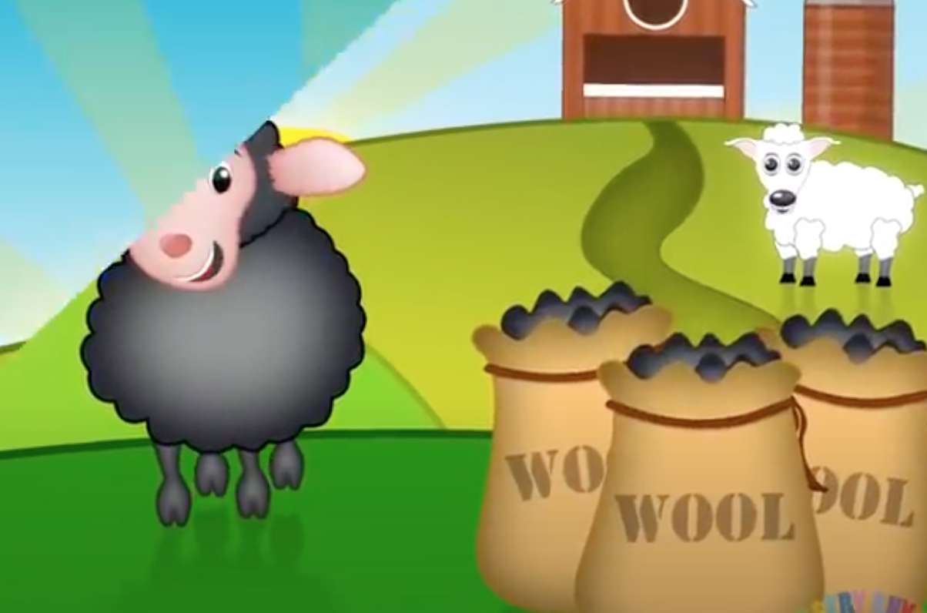

Hello friends, it's time to make a line!
Yes, like that. You're looking fine.
Hands by your hips.
fingers on your lips.
Look right at me.
I'm counting 1, 2, 3. Let's make a line.
It's time to go inside!
Walk quietly, your hands are by your sides.

7 OUT FEET GO MARCHING
https://www.youtube.com/watch?v=Pjw2A3QU8Qg
The ants go marching

Instrumental
https://www.youtube.com/watch?v=7g58sPIVuD8

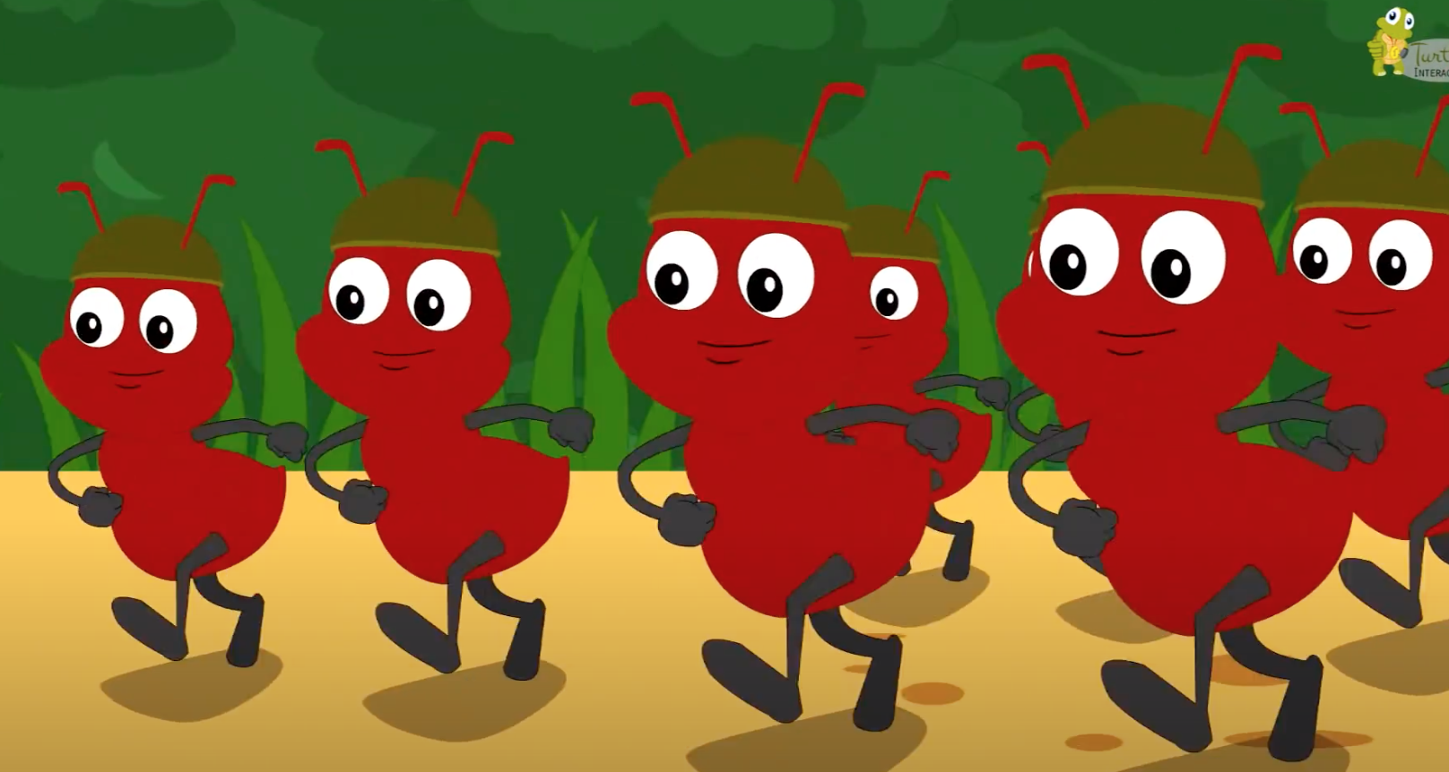

Our feet go marching one by one, hurrah, hurrah.
Our feet go marching one by one, hurrah, hurrah.
We had so much fun in the sun,
But now our playtime is over and done.
So our feet go marching down....the hall..
to go...to our rooms.
Boom, boom, boom.

8 IF YOU'RE READY TO GO IN
https://www.youtube.com/watch?v=71hqRT9U0wg
If you're happy and you know it

Instrumental
https://www.youtube.com/watch?v=LaYNZKdui-w

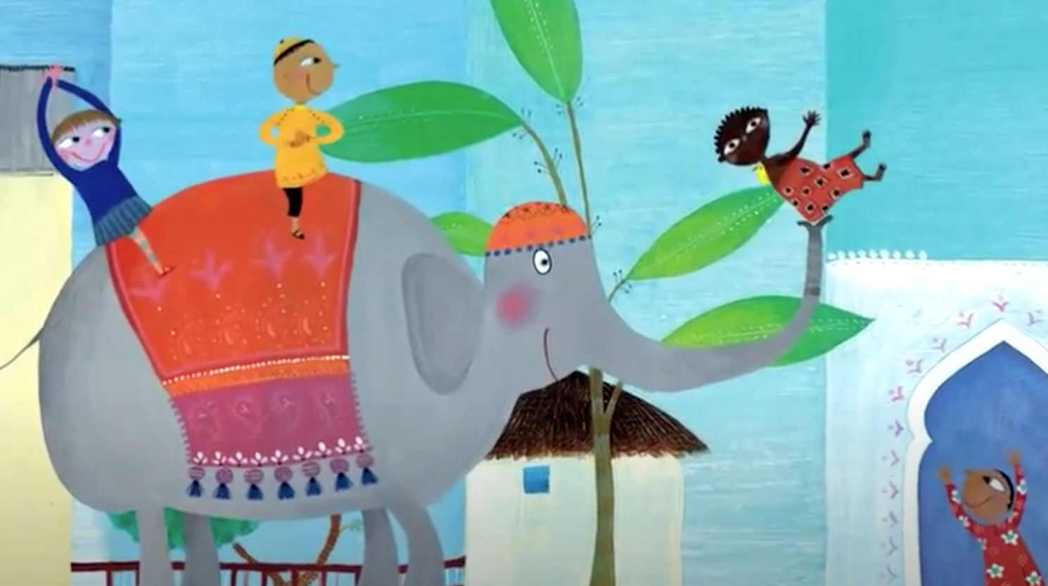

If you're ready to go in, clap with me! (clap, clap)
If you're ready to go in, clap with me! (clap, clap)
If you're ready to go in, then let's see your biggest grin,
If you're ready to go in, clap with me! (clap, clap)

