Cleaning Up

1 WE'RE PUTTING OUR TOYS AWAY
https://www.youtube.com/watch?v=E-krsNziXEw
The Farmer in the Dell

Instrumental
https://www.youtube.com/watch?v=1fjaT615Lho

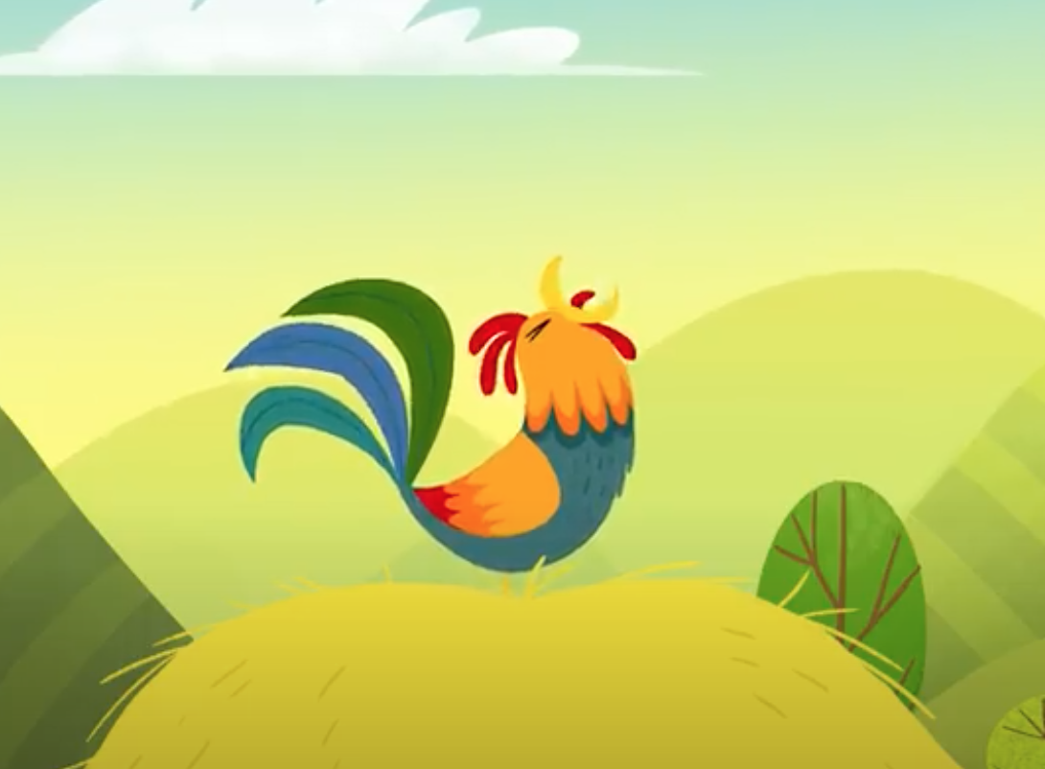

We're putting our toys away,
We hope it won't take all day!
To have more fun, we'll get it done.
We're putting our toys away.

2 IT'S CLEANUP TIME
https://www.youtube.com/watch?v=WX8HmogNyCYHead, Shoulders, Knees and Toes

Instrumental
https://www.youtube.com/watch?v=fAeJhKbrspg

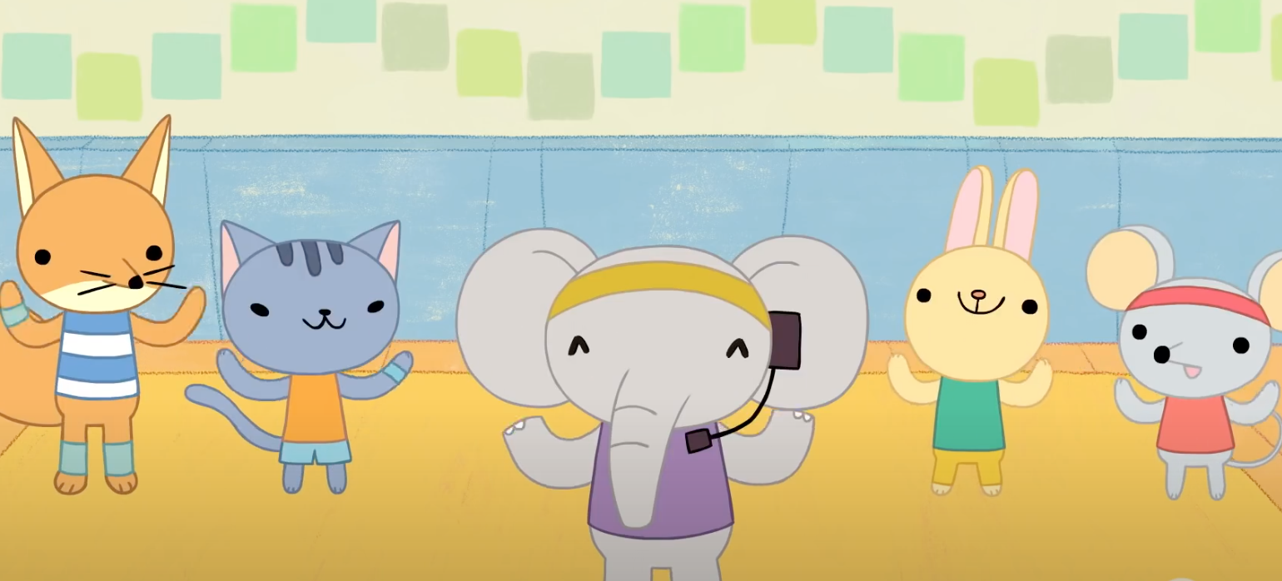

Stop and freeze,
It's clean up time, clean-up time.
Stop and freeze,
It's clean-up time, clean-up time.
Clean your space,
Let's tidy up this place.
Stop and freeze,
It's clean-up time, clean-up time.

3 HEIGH-HO, HEIGH-HO
https://www.youtube.com/watch?v=HI0x0KYChq4
(a partir de 1.21 minutos)
Heigh-Ho, Heigh-ho

Instrumental
https://www.youtube.com/watch?v=LuG17GaYmKs
(a partir del 1.33 minutos)

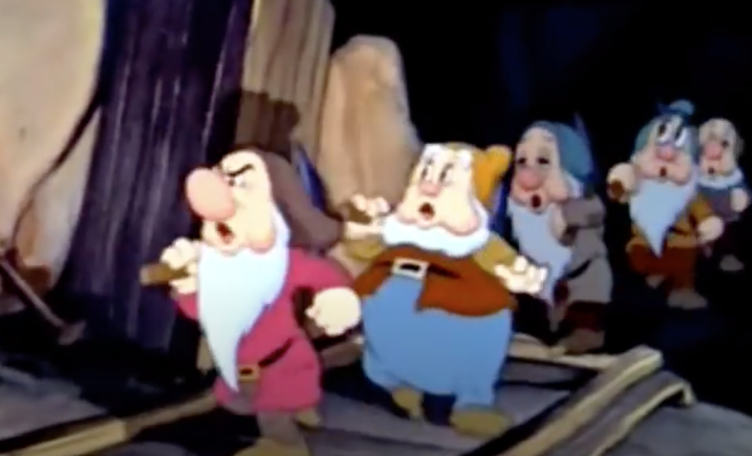

Heigh-ho, heigh-ho,
It's clean-up time you know.
Put the toys away for another day,
Heigh-ho, heigh-ho!

Coming Inside

4 WHERE HAS THE TIME GONE?
https://www.youtube.com/watch?v=UlAgL5fWNOw
Oh where has my little dog gone

Instrumental
https://www.youtube.com/watch?v=dxAy3wSWgG4

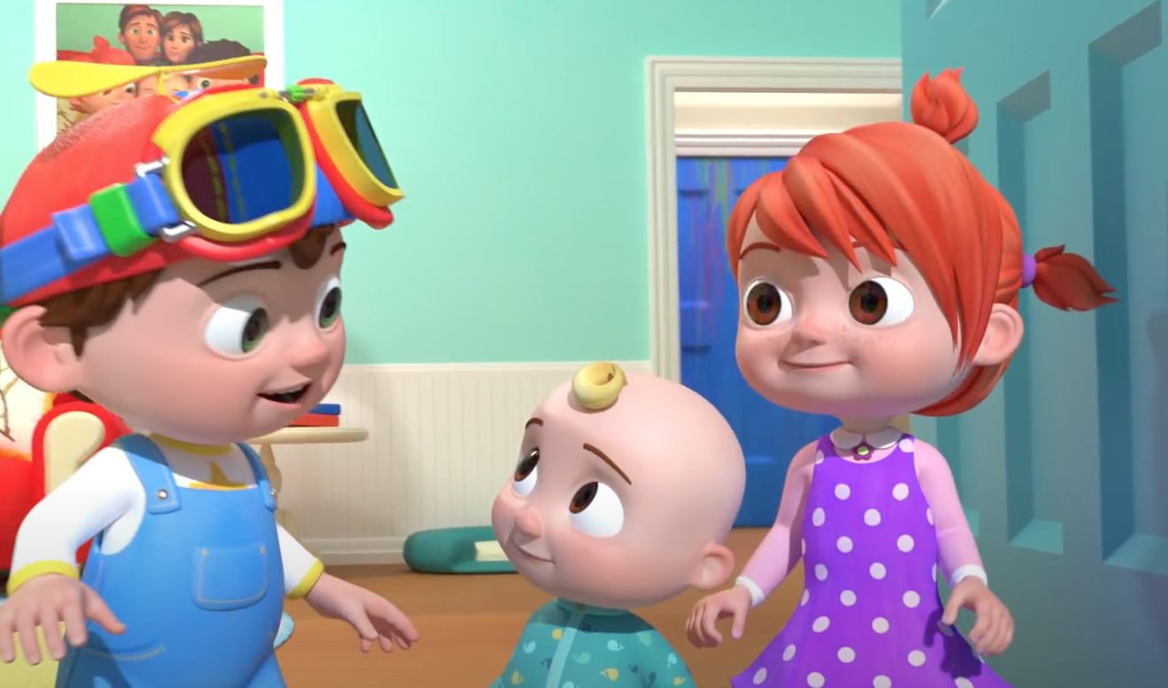

Oh where, oh where has the time gone today?
It's time to clean up the room!
Put your things away and tidy your space.
It's time to clean up the room.

5 STOP AND FREEZE
https://www.youtube.com/watch?v=9--t3zl4NkYThis Old Man

Instrumental
https://www.youtube.com/watch?v=-0He4_IFu7E



Stop and freeze.
Look at me!
Time to clean up, zip-a-dee-dee!
With a quick pick up,
We'll make the room like new!
let's start cleaning 'round the room.

