Circle Time, Handwashing

1 DO YOU KNOW WHAT TIME IT IS?
https://www.youtube.com/watch?v=UFrEVhOPwvc
Here we go 'round the Mulberry Bush

Instrumental
https://www.youtube.com/watch?v=SVKTkJVucHk

This is the way we cross our legs,
Cross our legs, cross our legs,
This is the way we cross our legs, when it's circle time.
This is the way we fold our hands,
fold our hands, fold our hands.
This is the way we fold our hands, when it's circle time.
This is the way we zip our lips,
Zip our lips, zip our lips.
This is the way we zip our lips, when it's circle time.

2 WASHING HANDS SONG
https://www.youtube.com/watch?v=7otAJa3jui8
Row, row, row your boat

Instrumental
https://www.youtube.com/watch?v=QDfYaddvjHo

Wash, wash, wash your hands,
Soap will make them clean!
Scrub the germs 'til they fall off,
They go down the drain.

3 THE MORE WE WASH OUR HANDS
https://www.youtube.com/watch?v=lldmkrJXQ-E
The more we get together

Instrumental
https://www.youtube.com/watch?v=-RrX2XsGaDA

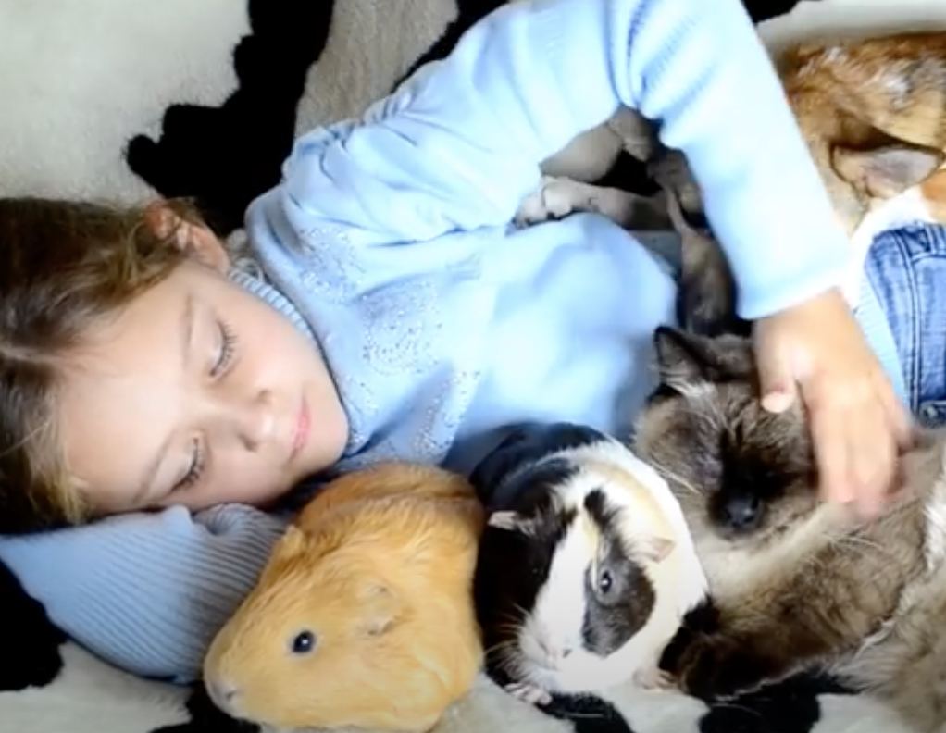

The more we wash our hands, our hands, our hands,
The more we wash our hands, the healthier we'll be
For your friends are my friends
and my friends are your friends.
The more we wash our hands, the healthier we'll be!

4 Cleaning Hands Song!
https://www.youtube.com/watch?v=r5WLXZspD1M
Apples and bananas

Instrumental
https://www.youtube.com/watch?v=J17XtsPIRnw

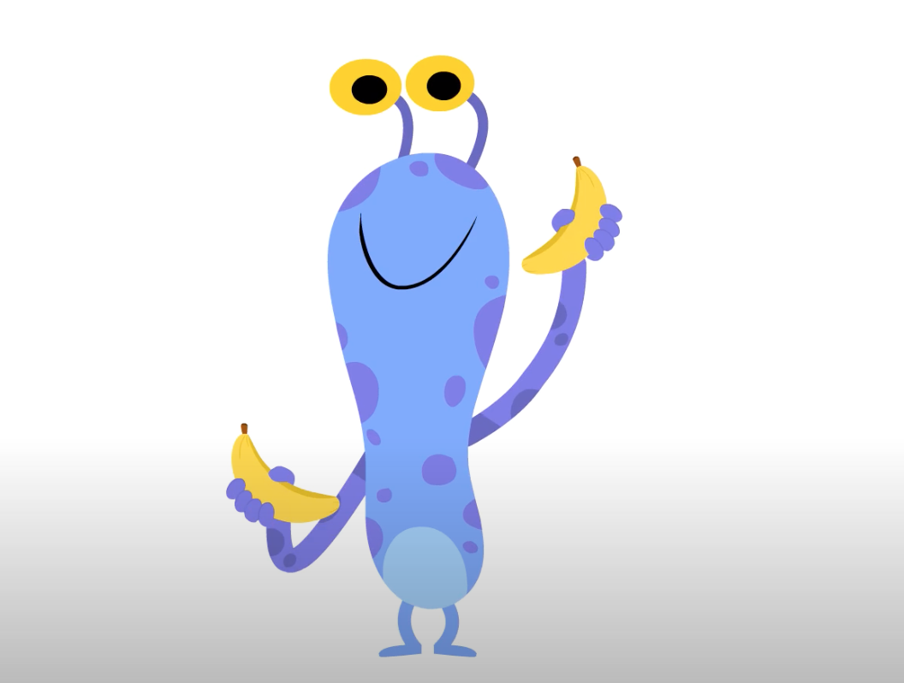

I like to clean, clean, clean, clean my dirty hands.
I like to clean, clean, clean, clean my dirty hands.
I like to wash, wash, wash, wash my hands with soap.
I like to wash, wash, wash, wash my hands with soap.
I like to rinse, rinse, rinse, rinse my hands with water.
I like to rinse, rinse, rinse, rinse my hands with water.
I like to dry, dry, dry, dry my hands with towels.
I like to dry, dry, dry, dry my hands with towels.

5 Soap Song
https://www.youtube.com/watch?v=0-Y7Qi3fMs0
London Bridge is Falling Down

Instrumental
https://www.youtube.com/watch?v=5L6DA6ZwbjY



Water washes dirt away,
Dirt away, dirt away.
Water washes dirt away,
Wash with water.
Soap will make my hands so clean,
Hands so clean, hands so clean.
Soap will make my hands so clean,
Scrub all over.
Rinsing makes the soap come off,
Soap come off, soap come off.
rinsing makes the soap come off.
Now let's dry them.

