Beginning the day

1 DO YOU KNOW WHAT TIME IT IS?
https://www.youtube.com/watch?v=fXFg5QsTcLQ
The Muffin Man

Instrumental
https://www.youtube.com/watch?v=E-rODssFbsc

Do you know what time it is?
What time it is, what time it is?
Do you know what time it is?
It's time to start our day.

2 WHAT COLOUR ARE YOU WEARING?
https://www.youtube.com/watch?v=YE7PiTwhTQk
Mary had a little lamb
Instrumental
https://www.youtube.com/watch?v=g-aDOZDTz9M

If you're wearing red today,
Red today, red today -
If you're wearing red today,
Stand up and shout 'hooray'.

(Repetir con otros colores.)

3 READY FOR THE DAY
https://www.youtube.com/watch?v=l4WNrvVjiTw
If you're happy and you know it

Instrumental
https://www.youtube.com/watch?v=a3WUghQDbiw

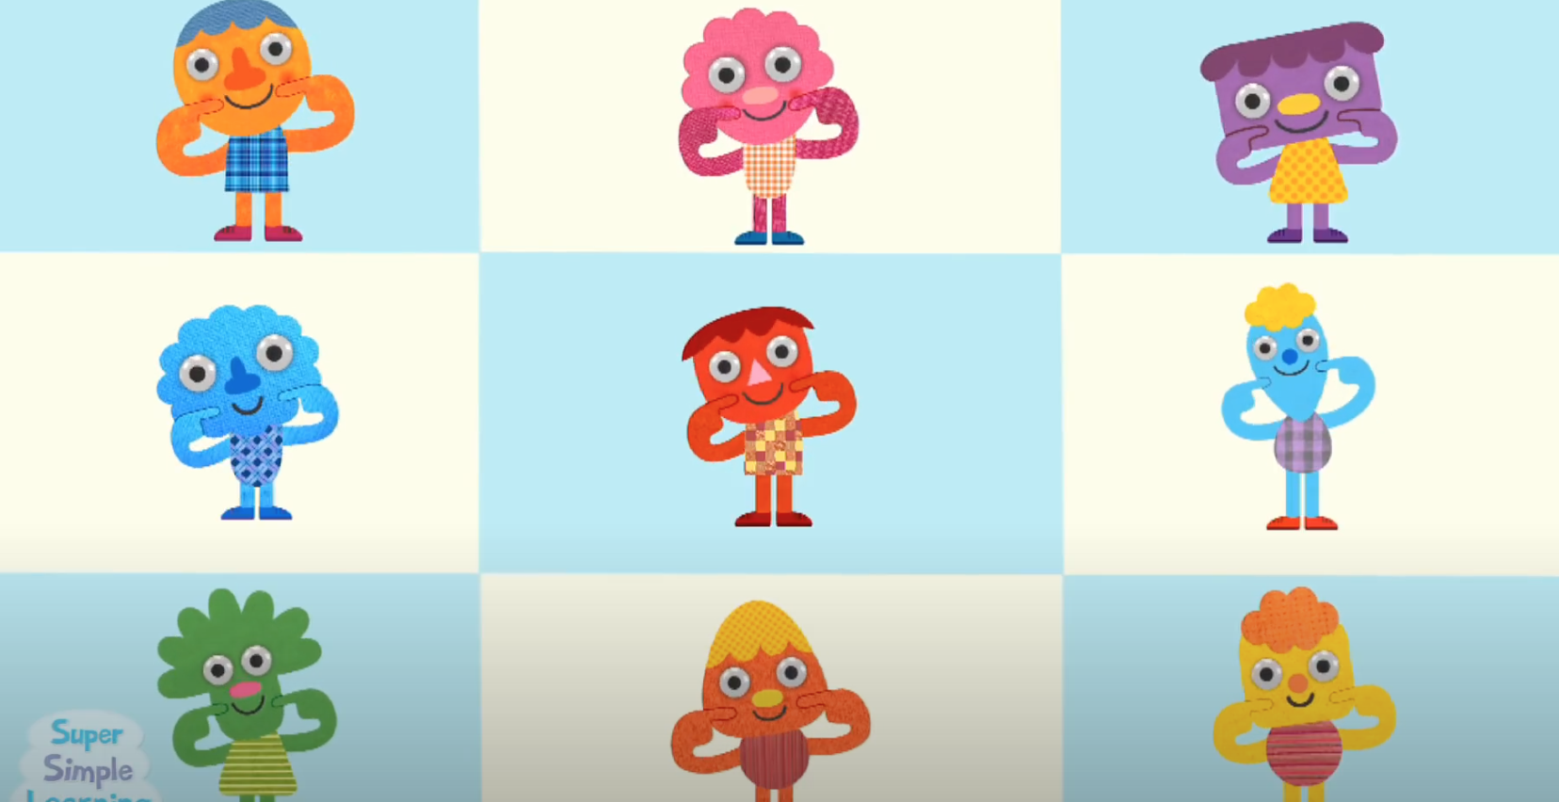

If you're ready for the day, find your seat. (clap, clap)
If you're ready for the day, find your seat. (clap, clap)
Check your hands, check your feet,
If you're ready, find your seat.
If you're ready for the day, find your seat. (clap, clap)

4 WAVE HELLO!
https://www.youtube.com/watch?v=e_04ZrNroTo
Wheels on the bus

Instrumental
https://www.youtube.com/watch?v=KKCj8Y7xKpQ

Hey everybody wave hello,
wave hello, wave hello.
Hey everybody wave hello,
And say good morning to _________ (child's name.)

