9ª Mini-Lesson
In other words, we could say…

In your groups:

- In the left column, look at the images and read the description.

- In the right column, paraphrase de information and include descriptions of the images.

- Afterwards, we’ll watch the video!

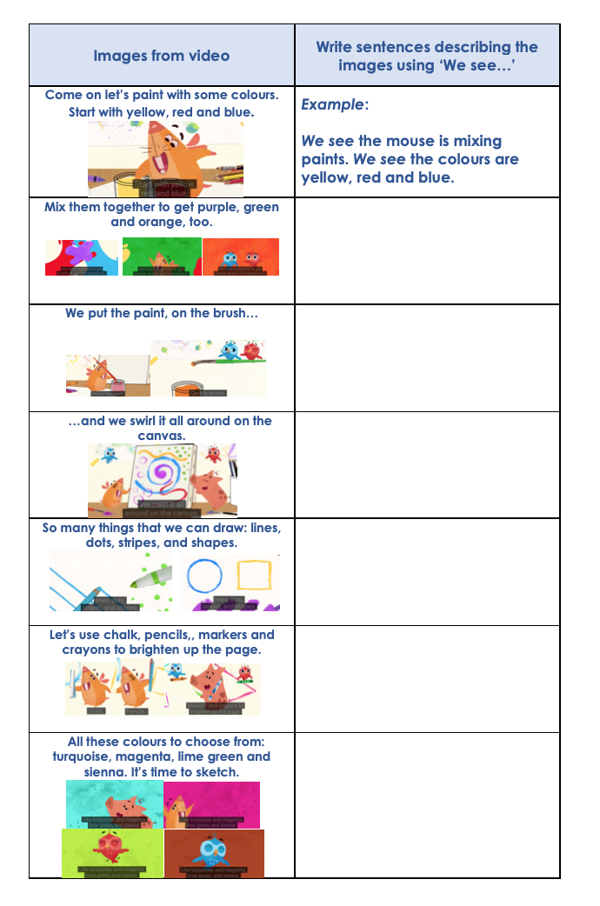
We see…
We see…
We see…
We see…
We see…
We see…

