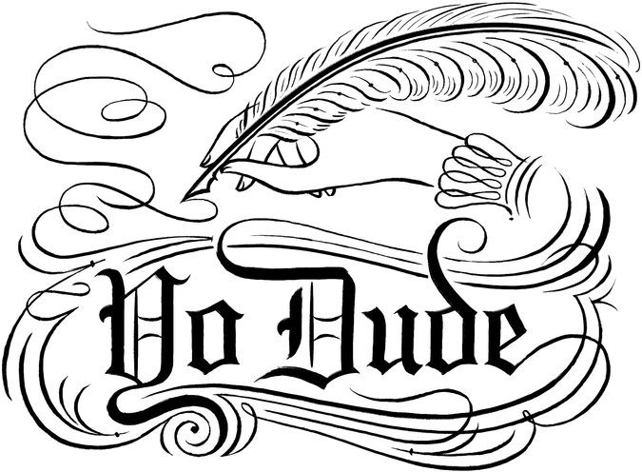
Slang for the Ages
By KORY STAMPER OCT. 3, 2014

EVERYONE knows that slang is informal speech, usually invented by reckless young people, who are ruining proper English. These obnoxious upstart words are vapid and worthless, say the guardians of good usage, and lexicographers like me should be preserving language that has a lineage, well-bred words with wholesome backgrounds, rather than recording the modish vulgarities of street argot.
In fact, much of today’s slang has older and more venerable roots than most people realize.
Take “swag.” As a noun (“Check out my swag, yo / I walk like a ballplayer” — Jay Z), a verb (“I smash this verse / and I swag and surf” — Lil Wayne), an adjective (“I got ya slippin’ on my swag juice” — Eminem), and even as an interjection (“Say hello to falsetto in three, two, swag” — Justin Bieber), swag refers to a sense of confidence and style. It’s slangy enough that few dictionaries have entered it yet.
Swag sounds new, but the informal use goes way back. It’s generally taken to be a shortened form of the verb “swagger,” which was used to denote a certain insolent cockiness by William Shakespeare, O.G. The adjectival use dates to 1640, and seems to have a similar connotation to the modern swag (“Hansom swag fellowes and fitt for fowle play” — John Fletcher and Philip Massinger, in “The Tragedy of Sir John van Olden Barnavelt”). The noun was first used even earlier: One 1589 citation reads like an Elizabethan attempt at freestyle (“lewd swagges, ambicious wretches”).
Nor was Mr. Bieber the first to use the word because he liked how it finished a line. The English playwright William Davies wrote, in 1786, of one of his characters that she moved like a half-full “cask set in motion, swag, swag.”
The website Gawker prophesied in 2012, and Mr. Bieber averred last year, that swag is over. It takes some swag to call time on a piece of slang that goes back centuries; and, in any case, Google Trends shows that the usage is holding steady. Swag is dead; long live swag.
Swag evolved out of standard English, but there’s also slang that is slang born and raised. As it moves through successive generations, it may morph — but without losing its cred.
“Fubar” was first used in print in 1943; it is an acronym whose expanded version I will bowdlerize as “rhymes with trucked up beyond all recognition.” This was slang created by the Greatest Generation as Americans marched to war, a shining example of how G.I.s adapted the custom of military acronyms to their own purposes.
Fubar had its heyday during the war, then fell out of use. But it never disappeared entirely. Decades later, it was appropriated by another kind of acronym-loving grunt: the computer programmer. One of the biggest and earliest employers of programmers was the American military, and the release of home consoles in the ’70s and ’80s meant that middle-aged coders of the military-industrial complex were mingling — and sharing their slang — with college-aged console hackers. Fubar became a placeholder name for files, some of which might contain coding errors.
Was it still slang? Definitely. Restricted to young people? Not so much. Fubar still enjoys slang use among the hip and Internet-savvy: In the last two years, I’ve taken citations for Fubar from Wonkette, Gawker and the A.V. Club.
Speaking of hip, hipsters have been derided as know-it-alls since at least 1941: The word “hipster” was so defined by Jack Smiley in his seminal collection of soda-jerk slang, “Hash House Lingo.” Likewise, the word “dude” predates the Dude of “The Big Lebowski” fame by over 100 years. Cops have been “nailing” suspects since the early 1700s. Even the seemingly up-to-the-minute “bae,” a word that means babe or baby and is so new that most of its written use is in personal communications, has a print trail back to the early 2000s, and is probably a descendant of the reduplicative nickname Bae Bae, a rendering of “baby,” which shows up in print in the 1990s. In some cases, bae is older than the people using it. (It also has its own spurious acronymic etymology, “before anyone else.”)
Slang often falls prey to what linguists call the “recency illusion”: I don’t remember using or hearing this word before, therefore this word is new (often followed by the Groucho Marx sentiment: “Whatever it is, I’m against it”). At the heart of the illusion lies a misbegotten belief that English is a static and uniform language, a mighty mountain of lexical stability. Upon this monument, slang falls like acid rain, eroding and degrading the linguistic landscape.
It’s the wrong metaphor. English is fluid and enduring: not a mountain, but an ocean. A word may drift down through time from one current of English (say, the language of World War II soldiers) to another (the slang of computer programmers). Slang words are quicksilver flashes of cool in the great stream.
Some words disappear, and others endure. One thing is sure: The persistence of slang doesn’t mean that English is Fubar. In fact, it’s swag, bae.
Kory Stamper is a lexicographer and editor for Merriam-Webster dictionaries.
http://www.nytimes.com/2014/10/04/opinion/slang-for-the-ages.html?smid=fb-nytimes&smtyp=cur&bicmp=AD&bicmlukp=WT.mc_id&bicmst=1409232722000&bicmet=1419773522000&abt=0002&abg=0&_r=0
Match the words taken from the first paragraph to their definitions.
A | B
- reckless  - obnoxious  - vapid  - well-bred  - wholesome  - modish | - extremely unpleasant, especially in a way that offends people  - fashionable (sometimes disapproving)  - having or showing good manners; typical of a high social class  - lacking interest or intelligence  - morally good; having a good moral influence  - showing a lack of care about danger and the possible results of your actions

Discussion Questions
- How would you define “slang”?
- Do you teach slang in you English class? Should you?
- What are some difficulties teachers find when teaching slang?
- How do you deal with the following issues?
  - The “singular they” (Somebody left their umbrella in the classroom. / When I greet a friend, I hug them.)
  - Bring or take (Don’t forget to bring your toothbrush!)
  - Who or whom (Who did you go on holiday with?)

Working with a partner or a small group, make an outline for this article.

Key:
1 – f; 2 – a; 3 – d; 4 – c; 5 – e; 6 – b
- Introduction: presents issue and thesis
- Examples to prove point
  - Swag
  - Fubar
  - Hipster, dude, nailing, bae
- Conclusion
  - The recency illusion
  - English is fluid and enduring

Discussion Questions
- Own answers. (a type of language consisting of words and phrases that are regarded as very informal, are more common in speech than writing, and are typically restricted to a particular context or group of people.)
- Own answers.
- Depends on time (groovy), place (shoot the breeze [AmE]), age (hundo p), social class (napkin [U] or serviette [non-U] in the UK), race (nigger) or ethnic group (güey)
- See M-W videos

