Useful tools for teaching songs
- Pictures and games to pre-teach vocabulary. Get the children interested
- Elicit lyrics as you go.
- Have a focal point to help children understand the content of the lyrics. Have an activity that a few students can do at once to give the others incentive to sing well so they will be chosen next to perform the activity. This also means the song will be sung a number of times in order to let all children have a turn at doing the activity hence they get lots of practise and they will want to repeat.
- Actions – they could invent them which also checks they understand the concepts.
- You could make up songs to tunes they already know therefore half the work is done for you.
- Use your classroom assistant or a strong pupil to do rounds (canons).
- If the song is difficult split it into chunks.
- Get them to invent the lyrics.
- Give them an incentive like you are going to record or video them performing the song.
What stops teachers singing in the classroom?
- But I can´t sing – you don´t have to be good at singing you just have to know the song well. Children will actually be more reassured about singing themselves by seeing you make mistakes.
- If you don’t sing they won’t want to either, so even if you are a bit nervous act like it is the most natural thing in the world and they will too.
- I can’t read music – All you need is the lyrics and a recording of the song or just the melody.
- It’s a waste of class time – they really remember the vocabulary/stories/ideas.
- The grammar of the lyrics is too complicated for them to understand eg. we haven’t done the past tense yet. Change it if it is possible and you want to or just go ahead and concentrate on them understanding the more important/key words.

Father William (Traditional)
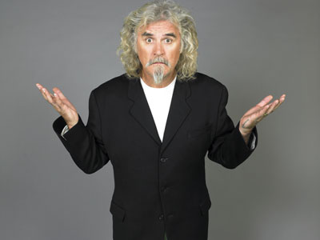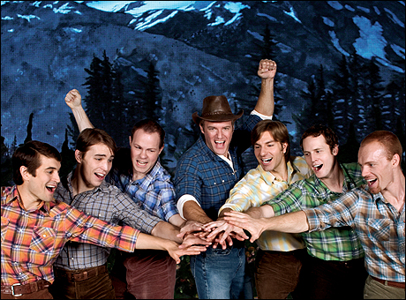

Father William had seven sons.
Seven sons had Father William.
And they ate a lot.
And they drank a lot.
And they all had lots of fun!
Right hand.
Right foot.
Left foot.
Left hand.
Nod your head.

Here is a link to remind you of the tune:
https://www.youtube.com/watch?v=reS6QtWrTwY

Hokey Pokey
- Instructions: right, left, turn around, clap your hands, sit down, stand up, sing a song, be quiet, take a bow.
- Link to the hokey pokey:
http://www.youtube.com/watch?v=_jW3L1dyEfY
- The people who made this video have also made other good one: Super Simple Songs https://www.youtube.com/watch?v=HGgsklW-mtg&NR=1&feature=endscreen
The Walls of Limerick
- Use stretching to revise parts of the body.
- 1,2,3s up and down the room.
- 7s in a circle.
- Change places (doing the steps to warm up).
- Give each child in a pair a different name e.g. oranges on the right and apples on the left.
- Vocabulary needed: partner, pair, take hands, in, out, drop hands, change places, face to face, go to the side, swing.
- Link to the song:
http://www.youtube.com/watch?v=oNi1Mt1y4K8
- Link to the dance: http://www.youtube.com/watch?v=NOrUEPZfAsU
The dance is not exactly the same but it will help you remember.

Popocatépetl
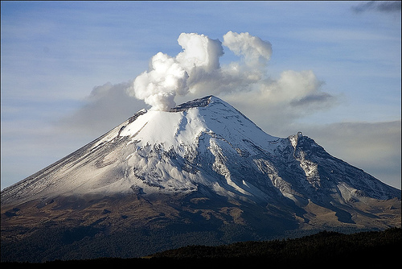
Popocatépetl is a big volcano
Far away in Mexico
Popocatépetl old
Popocatépetl goes
BANG!
SIZZLE, SIZZLE!
BANG!
So you won’t forget that…

- What is it? A volcano (pronunciation of the ‘v’ with the two front teeth on the bottom lip).
- Is it big or small? Big.
- Where is Popocatépetl? In Mexico.
- Is Mexico close like Fene or far away like America? Far away.
- What noise does a volcano make? BANG, sizzle, sizzle, BANG.
- What can you see coming out of the volcano? Smoke. What colour is it?
- What other things can come out of volcanoes? Rocks, lava, ash and gas.
What colour are they?

The Legend

- The great emperor of the Aztecs was very powerful, all the tribes of the valley of Mexico and neighbouring areas had to pay taxes, but not all the tribes were happy with this ... They were tired of their oppressors.
- The Chief of Tlaxcala decided one day that it was time to deliver his people from Aztec domination and start a terrible war between the Aztecs and Tlaxcaltecas.
- Ixtaccíhuatl was the young and beautiful Princess, the daughter of the chief of Tlaxcala. Popocatépetl was one of the leading warriors of his people, he told the Princess he loved her in secret. Before the war, Popocatépetl asked Ixtaccíhuatl’s father if he could marry his daughter, if he won the war. The Chief of Tlaxcala said yes.
- Popocatépetl won every battle, and on his triumphant return to Tlaxcala, the Chief comes to him and tells him that Ixtaccíhuatl had died.
- Popocatépetl was very sad and angry. He took Ixtaccíhuatl in his arms and started climbing the mountain.
- When he got to the highest point of the mountain, close to the sky, he put her down and kneeled beside her with a burning lantern in his hand. Snow covered their bodies, forming the giant volcanoes that are in Mexico valley.
- An animated version of the story with no words only music is available on youtube, which is great for getting the children to explain what is happening: http://www.youtube.com/watch?v=r15ZCCrX5y0
- Watch the news in Mexico and find out what they think. http://www.youtube.com/watch?v=c0HNFvuLF0Q

A Young Austrian
A young Austrian went yodelling.
An avalanche
A grizzly bear.
A St. Bernards dog.
A mountain train.
A Jersey cow.
His true love.
Her father.

On a mountain so high.
When along came an AVALANCHE.
Interrupting his cry.
Yo le de
Yo de le he te-e yo de le he oh (sound effect x2)
Yo de le he te-e yo de le he oh (sound effect x2)
Yo de le he te-e oh

Rounds and Canons
A Pizza Hut MacDonalds
A Pizza Hut MacDonalds
Kentucky Fried Chicken Kentucky Fried Chicken
And a Pizza Hut And a Pizza Hut

- Repeat each part twice with actions (square, chicken and M).

- Group A sing part 1
Group A sing part 1, group B sing part 1
Group A sing part 2, group B sing part 1
Group A sing part 2, group B sing part 2
Group B sing part 2.

- As group B are finishing their second part 2, group A could begin again and the song repeats.

It’s Midnight in the Kitchen
- Show them some kitchen tools and tell or elicit from the children that they work hard all day preparing the food and at night they come out to play and have fun. They try not to wake anyone in the house.
- Mark the beat with any tool as children use two fingers to walk on their hands or use the other kitchen tools.
It’s midnight in the kitchen.
Quiet as a mouse.
Mustn’t wake up Laura.
Sleeping in the house.
1,2,3,4,5,6,7,8.
Clap!
Or
Wake up!
- The child will love pretending to be surprised, then you ask ‘Laura, who is sleeping in the house?’ and they can choose the next person. Ana is sleeping in the house using present continuous.
- The number that you clap or shout wake up on is changed each time to practise loud and quiet (dynamics). You could invent a hand signal for loud and quiet and then have one of the children be the conductor. This also helps them count together.
- The time can be changed to practise time vocabulary.
- The room can be changed to practise house vocabulary.
- You could think of other quiet animals to check their understanding of the word quiet.
- The child that is asleep has to guess what number the other children decided to clap/shout wake up on.

Using the tune of head, shoulders knees and toes


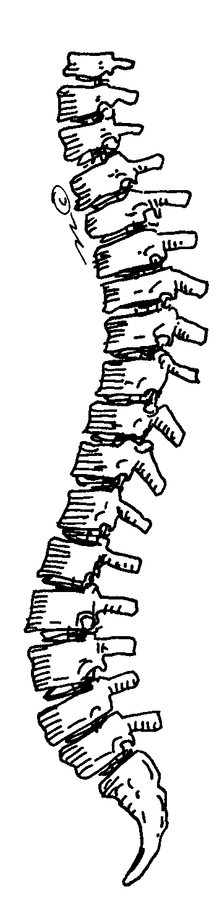

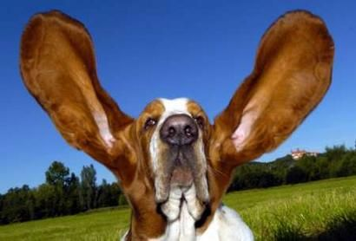



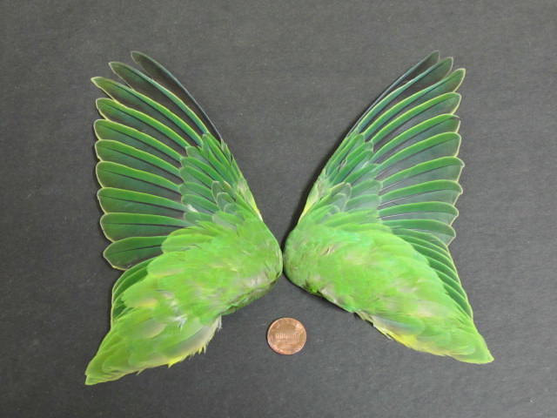

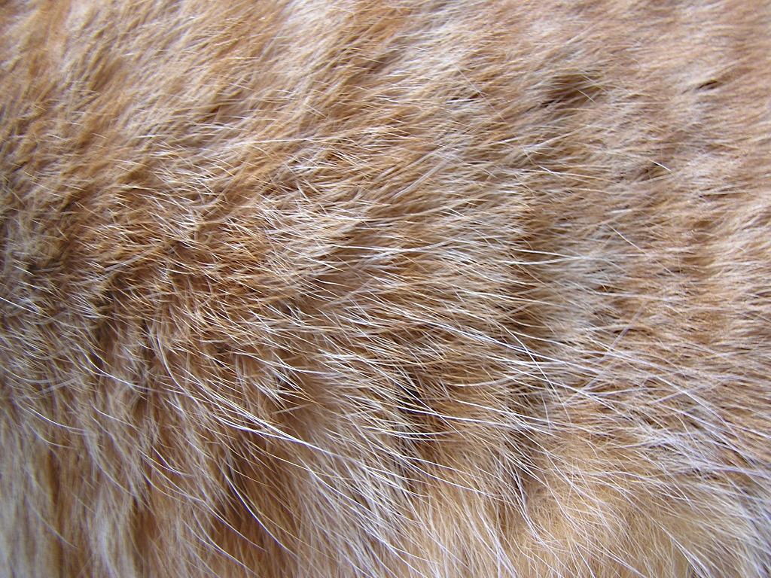
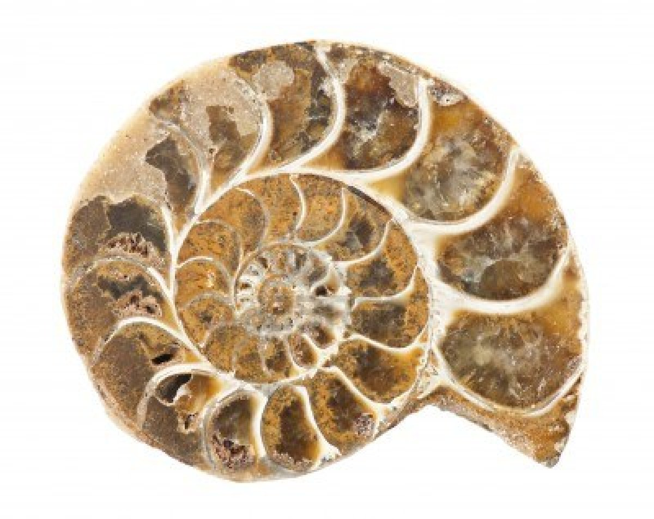



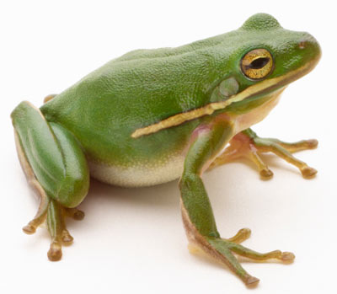

- Ears, backbone, wings and tail, wings and tail.
Ears, backbone, wings and tail, wings and tail.
Shell and hair and feathers, skin and scales.
Ears, backbone, wings and tail, wings and tail.
- Red, yellow, pink and green, pink and green.
Red, yellow, pink and green, pink and green.
Blue, purple, brown and orange, black and white.
Red, yellow, pink and green, pink and green.

Animal Parts Activities
- Sing the song to the melody of head, shoulders, knees and toes with the actions you have agreed on.
- Do a singing competition or ask them to sing different parts or quietly or loudly.
- Cut up the pictures and play:
1. Put the cards in the correct order according to the song.
2. Find a pair (they must say what they pick up).
3. Make a sentence with your card e.g. A parrot has got wings. Extend using different structures e.g. A parrot has got wings, a parrot can fly, a parrot is red, yellow and blue.

Yellow Umbrella


Everyone hold up your umbrella
Underneath the sky
Everyone – with your umbrella
Listen to the rain

Chorus

On a rainy day the umbrella is my house
I can take it with me like a snail´s shell
La la la la la my umbrella
I can take it with me anywhere I go

Everyone spin up your umbrella
Underneath the sky
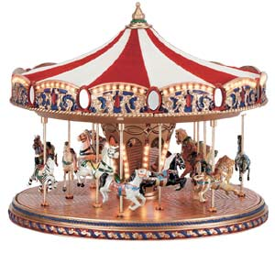
Everyone – spin your umbrella
Like a carousel

Chorus

Everyone put down your umbrella
Underneath the sky

Everyone – fold your umbrella
Feel the shining sun

Chorus

