
FAMILY AND SCHOOL IN ACTION
AIMS
Focused in 4 items: learning, leisure, organization and training.
- To engage families in the learning process of their children.
- Strengthen the relationship between families and teachers regarding values.
- To involve families in organization of the Anual School Project.
- Share time of leisure with parents in order to know each other.
WHO
Families, teachers and students, sharing activities together.
ACTIVITIES AND TIMING
- To engage families in the learning process of their children.
  - Maths Club - based on Abacus and mental calculation.
  - Cooking with my family - Cooking cold easy dishes.
  - Arts and Crafts - Christmas decoration for their home.
  - Mindfulness –Learning to play and enjoy together, relax and breath as well as speak about their emotions.
- Strengthen the relationship between families and teachersregarding values.
  - School of Parents - Parents were instructed and advised about children care: Health,Rules, Technologies, Shopping...
- To involve families in the organization of Anual School Project.
  - Parents Meeting - 2 teachers and a group of 7 parents develop the idea of having different workshops: when, who, where, how. The other families were informed about and were asked to register.
- Share time of leisure with parents in order to know each other.
  - Family Walks - Teachers, parents and children went for a two or three-hour walk.
  - Dance Class–5 Zumba classes were organised by the parents group (one mother was the Zumba instructor)

ASSESMENT
27 teachers (55%) involved in different parts of project: design, development and evaluation. We noticed an increase in staff awareness of the need to listen to parents suggestions and proposals. More teachers are activly involved in engagingfamilies in the life of the school.
53 families (13%) in different workshops. The number of parents involved has increased considerably since the first workshop.
Parents Meetings: Dance Class activity developed and three other different workshops as part of an additional project.
In conclusion, this project helped to realise how important it is to engage families in school life. We are overcoming the traditional teacher-family barriers, creating an atmosphere of mutual support for the benefit of children and school.
Teachers consider families engagement as part of their role. Families engage in learning opportunities with their children in order to improve academic achievement.
Every year, we seek the opinion of families in a satisfaction survey about school life. This information is used to evaluate the impact of projects.

Activities | Teachers | Families
Maths | 3 | 20 + 32
Cooking | 8 | 27 + 36
Arts | 10 | 18 + 23
Mindfulness | 3 | 25
School of Parents | 1 | 11
Family Walks | 6 | 14 (in progress)
Dance Class | 1 | 9
2014-2015 | 2015-2016
Maths Club
Cooking with my family
Arts and Crafts (Christmas time)
School of Parents  (April-May) | Mindfulness  (March)
Parents Meetings
Dance Class  (March-May) | Family Walks (November-April)
2015 2016

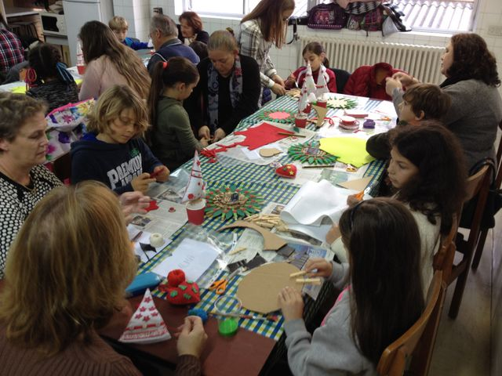
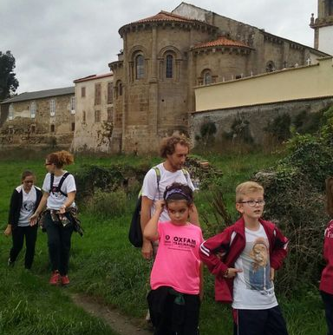
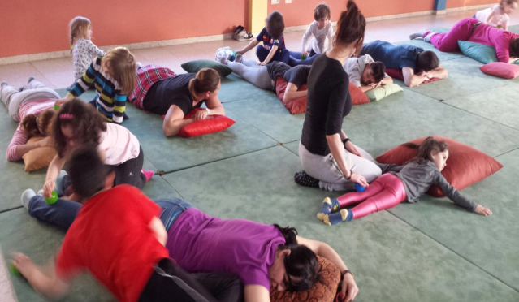

PARENT TRAINING: OUR FAMILIES VOLUNTEER IN INTERACTIVE GROUPS.
RECIPIENTS: School families .
TOTAL PARTICIPANTS: 25
DURATION: 2/3 sessions
TIMELINE: Tuesday from November, from 16:00 to 17:00.
PLACE: at school, School Library.
AIMS:
- Report on the project to be carried out by the interactive groups.
- Show them the importance of their role in student learning.
- Provide them with the necessary to be able to stimulate an interactive group strategies.
- Making them participate in school life.
- Increase parental involvement in school beyond festivals and celebrations.

METHODOLOGY: developed in different sessions with group support audiovisual elements, enhancing the participation of all / and repeating the sessions quarterly way to strengthen strategies, hear tips and make the necessary adjustments.
COMMENTS: The training is carried out by the School Head Team.

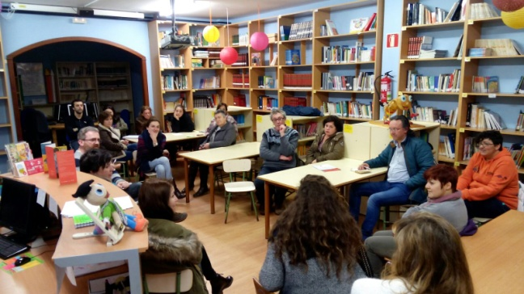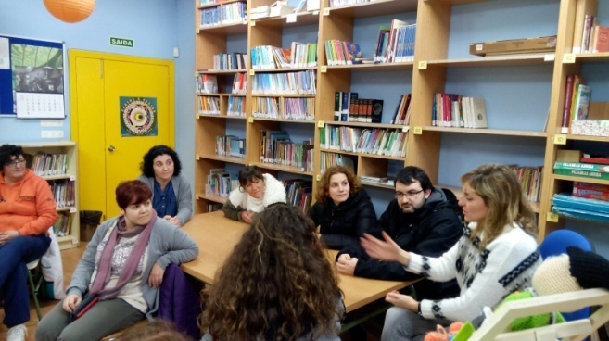

ACTIVITY: INTERACTIVE GROUP IN MATHEMATICS

TIMELINE: Every second week. In the weeks that have interactive groups, there are groups every day in some class, for a total of nine groups.
PARTICIPATS: All teaching staff and non-teaching and around 30 families from the academic year 2014/2015 and 2015/2016.
AIMS:
- Open the doors of our school, in teaching time for families to collaborate in learning in students.
- Develop elementary cognitive operations, such as memory, attention, etc.
- Develop and use the thought mechanisms for solving problems.
- Develop processes of cooperative learning.
- Introduce at classroom all interactions that are necessary for students to learn how necessary to meet the current information society..
ACTIVITIES:
- Work by Interactive group (four per class) where volunteers have a dynamic role in the group. Our students carries out activities as mental arithmetic, problem solving, math manipulative and ICT activities..
- Volunteer Day (end of course) where we do different activities and gifts to families who have exercised the volunteers thanks to their efforts and generosity.
ASSESMENT:
It does a quarterly monitoring activity and fills a survey of satisfaction.
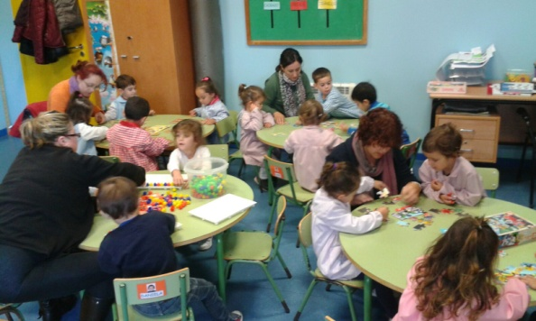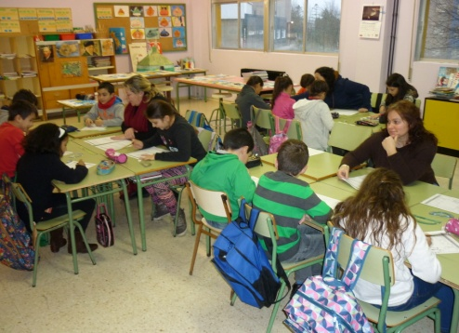
PARENT TRAINING: FAMILY CLASSROOM.
Target group: Families at risk of social exclusion and limited economic resources. These families lack the skills to interact in society and to access to information in general.
TOTAL PARTICIPANTS: 10
DURATION: 5/6 sessions
TIMELINE: Tuesdays from 9:00 to 10:00 a.m.
PLACE: At school, classroom Childhood Education.
AIMS:
- Inform, advise and guide parents on developing, learning and socialization of children.
- Increase parent involvement in different Local Institutions.
- Help solve and prevent problems of families influence in daily life.
- Teaching techniques to promote learning and behavioral control.
- To inform families of different Social Agents of the Community.
- To inform families of different Social Agents of the Community.
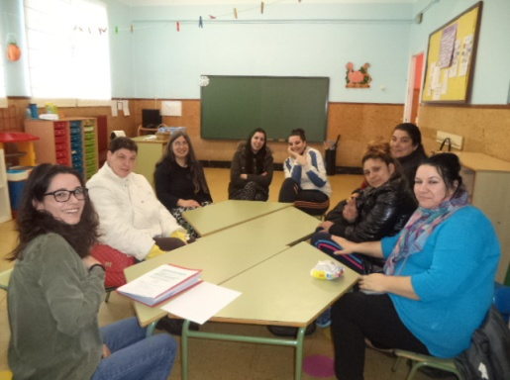
METHODOLOGY: Modules developed according to the needs identified through group dynamics, active and participatory spaces that turn into open, flexible, mutual trust and that promote the exchange of information among the group.
Comments: Action Plan within the social community that is promoting the neighborhood Recimil. This activity is provided by a social educator.
STORYTELLING AND MUSIC WITH FAMILIES
AIMS:
- Open the doors of our school in school time families.
- Promote family participation in order to improve educational quality.
- Raise awareness families in general the positive consequences that involves participation in the education of their children / as.
- Involving families wishing in annual joint project of our school always directed toward the improvement of coexistence.

TOTAL PARTICIPANTS: All teaching staff and non-teaching. and about 20 families: on 2014/2015 (stories) and on 2015/2016 (music).
ACTIVITIES:
- 2014/2015: reading tales, poems, stories, riddles
- 2015/2016: music instruments, music performances, dances
TIMELINE:
The first Monday of each month. Eventually the management team sends a reminder of the activity. Parents communicate with teachers when they watch the teachers and the coordinator of Coexistence.
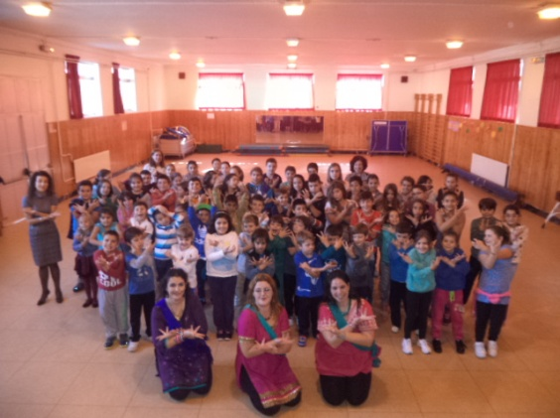
ASSESMENT
Participants fill a survey on the activity, proposals for improvement of the activity and the Coexistence Team assesses all these data quarterly basis.

ACTIVITY: SOLIDARITY CLASSROOM

RECIPIENTS:Families at risk of social exclusion, with limited resources and skills to socially interact and access information in general.
TOTAL PARTICIPANTS: 12 families.
TIMELINE: Throughout the academic year,the volunteer families work weekly, and the users attend quarterly.
PLACE: at school, solidarity class.
AIMS:
- Attend social disadvantaged families.
- Provide their basic needs.
- Make to feel the families who are part of a group, which everybodywork collaboratively.

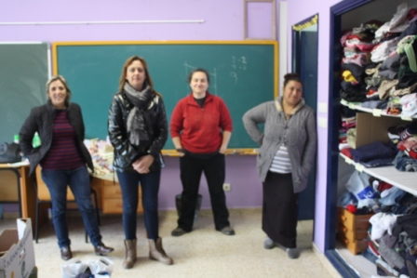
METHODOLOGY: For some time now, we have been detecting very serious economic needs in a large number of families in our school.First, the school took the initiative, along with Parents Association, the starting up a Bank of books to save the costs of course start of our families.This course, to go a step further in this direction, we have introduced the food and clothing bank.The Parents Association contacted with different companies in the area that provide us books, food and clothing, as well as some NGOs and many school families.It takes a regular monitoring of donations. The school issues a voucher to needy families, they present the voucher to Parents Association and they prepare a product batch of different banks.

INTERACTIVE GROUPS

TOTAL PARTICIPANTS: 34 volunteers.
TIMELINE: Once a week every classroom of the school, all year round.
PLACE: at school, all classrooms.
AIMS:
Improve learning and coexistence.

METHODOLOGY:
Through interactive groups, interactions multiply and diversify, while increasing the effective working time. They are characterized for being an inclusion organization in which the students are supported adult people (families and people of community) besides the teacher responsible for the classroom. Thereby, it is possible to avoid segregation and competitiveness that is generated by bringing the students labeled "difficult" or "slow" classroom to apply curricular adaptations and has led to increased school failure (especially of segregated students) and conflicts. In contrast, interactive groups are able to develop, in the same dynamic, accelerated learning for all students in all subjects, values, emotions and feelings like friendship.
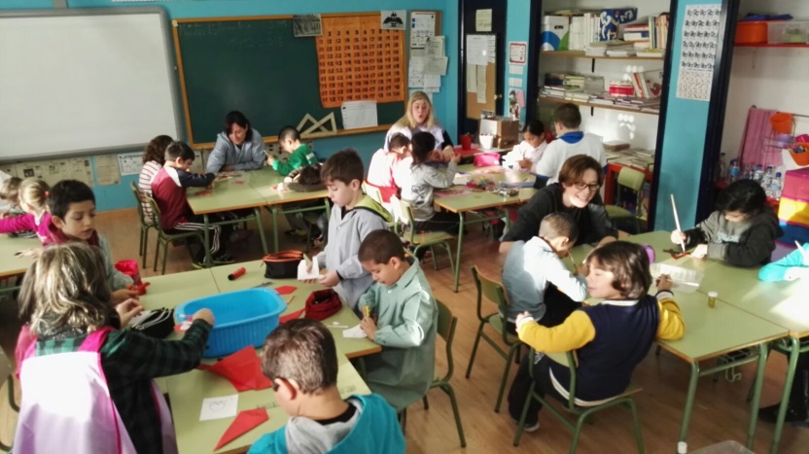
Once a week a session of interactive groups is done in every classroom to work the consolidation of learning in different areas.

