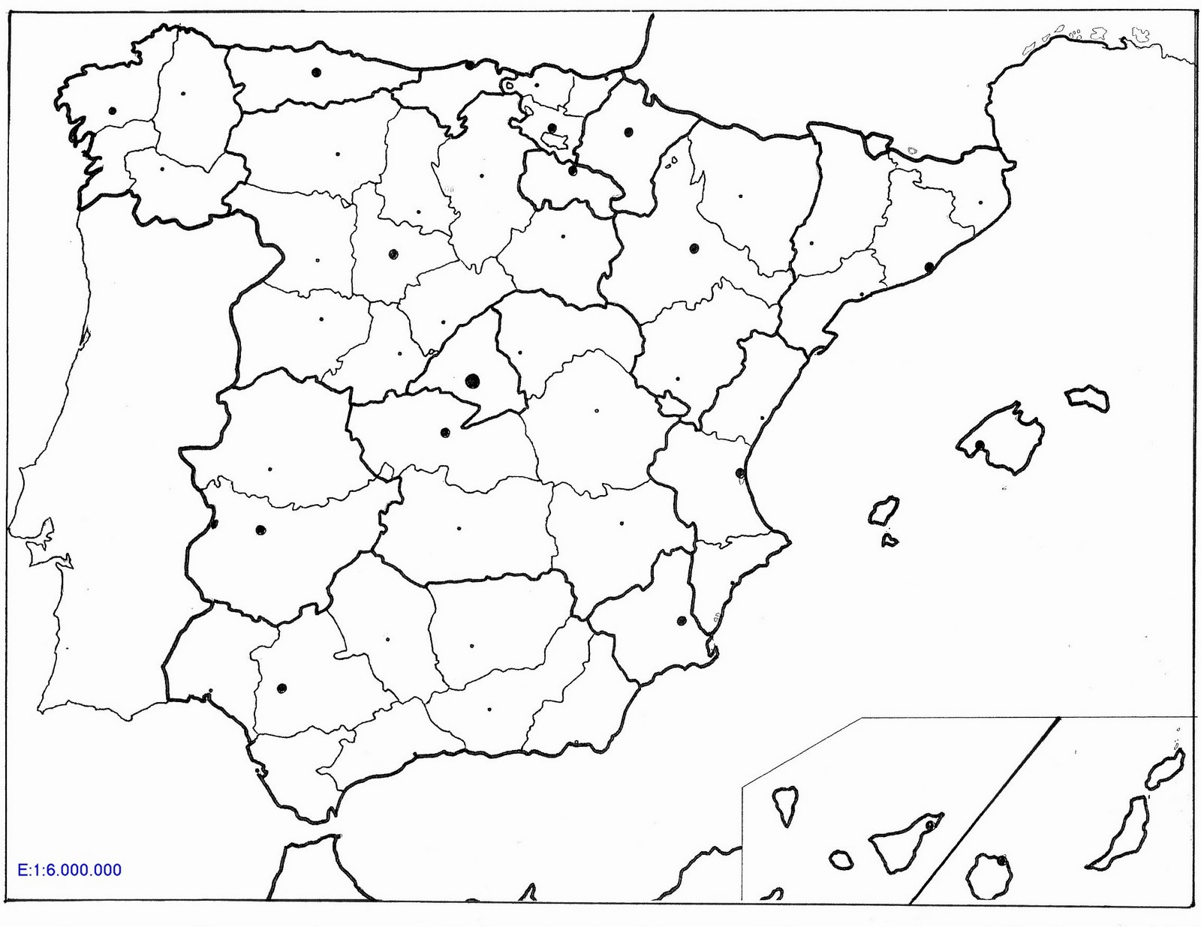
NOME: ______________________________________________________ Data: ______________

