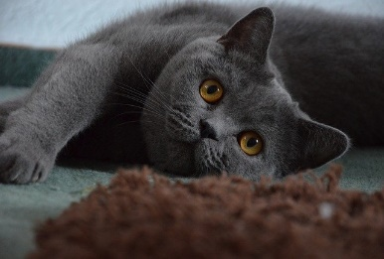

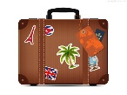

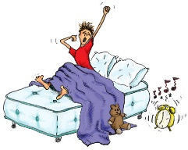



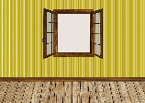





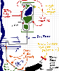

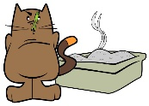



VIDEO ACTIVITIES
CAT LEFT HOME ALONE
Name:________________________________________________
1)Watch and complete the story with the words given and the past form of the verbs. Pictures will help you
https://youtu.be/YCaGYUIfdy4
A boy [BE]_________________ going on____________ . He [TAKE]_________ his cat, ____________ with him.
It [BE] _________________when Grey cat [WAKE UP] _____________________. He [FEEL] ___________________ ____________. He [MISS] the _____________________and [BE] __________________HOME ALONE.
He then [SEE ] two cat ______________through the _______________ . One of the cats [BE] ____________wearing a __________ and a ______________ and the other one [HAVE] ___________a ____________________.They [STEAL] ______________ and a _____________from the neighbour’s house.
So Grey cat [HAVE] a ____________ . He[USE] ____________ ______________, a ________________________and a ____________________.
The birds[HELP] _____________ him. They [POOP]____________ on his owner and Grey Cat [GET] __________time to go on vacation with them!!!

