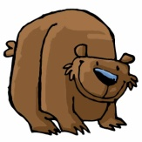
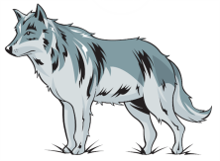

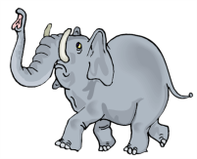
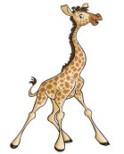

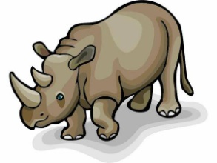
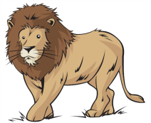
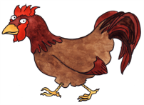
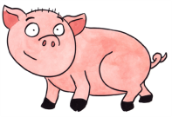
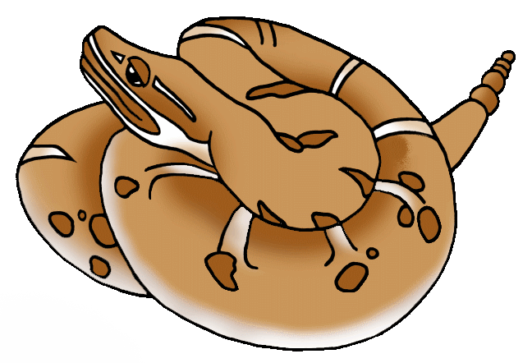
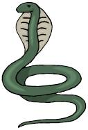
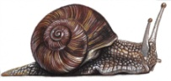
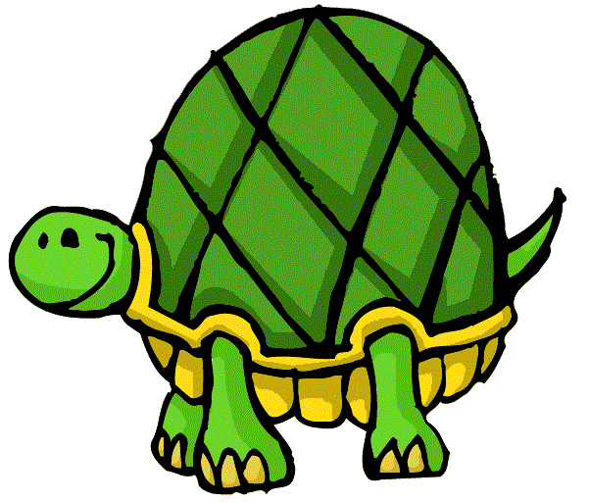
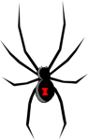
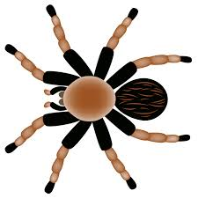
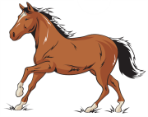
COMPARE ANIMALS
Give your opinion and compare them. Look at the example first.
 | a bear | a wolf | a tiger | an elephant
a giraffe | a monkey | a dolphin | a rhino | a lion
a chicken | a pig | a rattlesnake | a cobra | a snail
a tortoise | a black widow | a tarantula | a horse | a zebra

EXAMPLE:
a bear / a wolf / dangerous → I think a wolf is more dangerous than a bear.

1. a bear / a tiger / aggressive
→ ___________________________________________________________________________________
2. an elephant / a giraffe / tall
→ ___________________________________________________________________________________
3. a monkey / a dolphin / intelligent
→ ___________________________________________________________________________________
4. a rhino / an elephant / heavy
→ ___________________________________________________________________________________
5. a bear / a lion / strong
→ ___________________________________________________________________________________
6. a chicken / a pig / dirty
→ ___________________________________________________________________________________
7. a rattlesnake / a cobra / dangerous
→ ___________________________________________________________________________________
8. a snail / a tortoise / slow
→ ___________________________________________________________________________________
9. a black widow / a tarantula / poisonous
→ ___________________________________________________________________________________
10. a horse /a zebra / fast
→ ___________________________________________________________________________________

