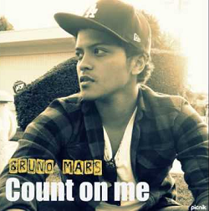
Let’s sing!
1. Complete with the missing words.
Count on me by Bruno Mars
If you ever find yourself stuck on the middle of the _________
I’ll sail the __________ to find you
light – sea - world
if you ever find yourself lost in the dark and you can’t see
I’ll be the________ to guide you

Chorus
Find out what were made of
when we are called to help our friends in _________
friends - count – need-
you can ________ on me like
1 2 3
I’ll be there
and I know when I need it
song - asleep – every day
I can count on you like
4 3 2
and you’ll be there
cause that’s what _________ are supposed to do, ooh yeah! oooh!...

If you’re tossing and your turning and you just can’t fall _________
I’ll sing a _______ beside you
and if you ever forget how much you really mean to me, _________ I will remind you
like – goodbye –
help – cause – cry

Chorus
Find out what we are made of
when we are called to _______ our friends in need
you can count on me _______
1 2 3
I’ll be there
and I know when I need it
I can count on you like
4 3 2
and you’ll be there
_________ that’s what friends are supposed to do
ooooh yeah..! ooooooh oooooh..

You’ll always have my shoulder when you _______
I’ll never let go, never say _________
you can count on me like
1 2 3
I’ll be there and I know when I need it
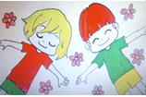
I can count on you like and you’ll be there
4 3 2
cause that’s what friends are supposed to do
oooh yeah! ooooooh, ooooooh

You count on me cause I can count on you.

