Actividades 14 de ABRIL

No exercicio 1
tes que describir a membros da túa familia. Se queres podes pegar fotos ou debuxos na parte da esquerda e escribes a descripción na dereita. Tamén podes imprimir as páxinas, facer as actividades e sacarlles unha foto ou escanealas para enviarmas.

No exercicio 2
Tes que contestas as preguntas fixándote no debuxo. Os números das preguntas correspóndense cos números dos personaxes.
Para contestar usa
Yes, he has / No, he hasn’t
Yes, she has / No she hasn’t

No exercicio 3
Tes que emparellar cada descripción co personaxe ao que se refire.Escribe a letra correspondente ao lado de cada descripción.

1. Draw your family. Describe them as in the example.
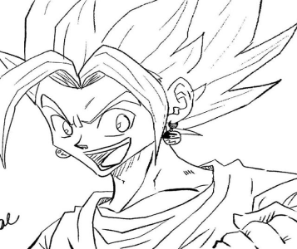 | This is my cousin Goku. He is tall and strong. He’s got long blond hair and black eyes.

2. Answer the questions.
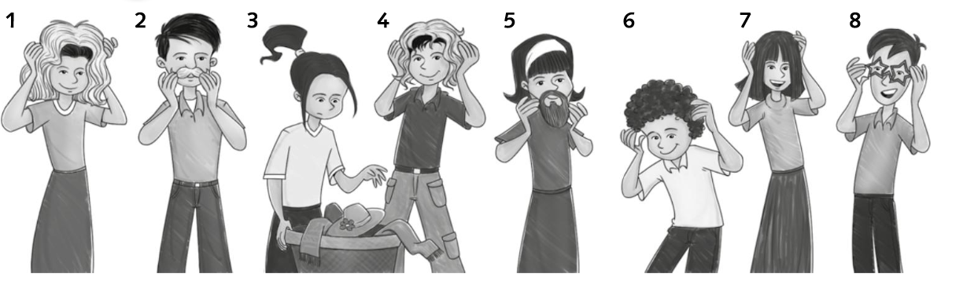

1. Has she got a beard?
2. Has he got black hair?
3. Has she got a ponytail?
4. Has he got blond hair?
5. Has she got a beard?
6. Has he got straight hair?
7. Has she got long hair?
8. Has he got glasses?

3. Match.

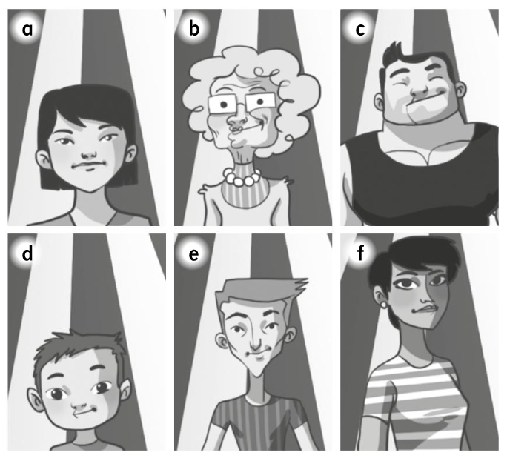
1. He is tall and thin. He’s got straight hair.
2. He is strong. He’s got short black hair.
3. She’s short and young. She’s got straight black hair.
4. He’s very young. He’s got short hair.
5. She’s tall and thin. She’s young. She’s got short black hair.
6. She’s very old. She’s tall and thin. She’s got curly white hair.

