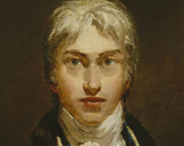
Joseph Mallor William Turner

Born: April 23, 1775 in London ( England )

Died: December 19, 1851 in London

Nationality: English

Profession: Artist, painter

Style: Romantic

Famous works: Fisherman at Sea, Rain, steam and speed, Venice from the Porch of Madonna della Salute, The Fighting Temeraire, Sunset...

Curiosities:
- He started painting when he was a child.Turner exhibited his first works in his father´s shop. His father was a barber.
- He loved watching weather. He once tied himself to a ship´s mast so he could sketch a storm.
- He was fascinated by the ocean and the sun.

