ANDY WARHOL (1928 – 1987)

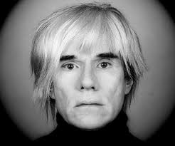

Andy Warhol was born in Pittsburgh, Pennsylvania in 1928. As a young adult he worked for magazines such as Harper's Bazaar and Vogue.

Andy became one of the most important American artists for Pop Art in the 1950's and 1960's. Pop Art uses contemporary and popular things as the art subject. Andy liked to use celebrities in his art works: Marilyn Monroe, Elvis Presley and Elizabeth Taylor.
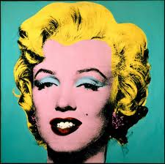

Andy Warhol also used things people use everyday such as Coke bottle tops, Ketchup bottles, and Campbell's soup cans as art. He made hundreds and hundreds of prints of cans, in various colors and flavours. He enjoyed using a technique called silk-screening so he could use the same portrait many times on one piece of canvas.
He died in 1987.

